Mindfulness Meditation to Decrease Stress in Pediatric Nurses
Tara Hommelson
University of Missouri-Kansas City, School of Nursing and Health Studies
N5613: Application of Evidence-Based Practice I
April 17, 2022
In Partial Fulfillment of the Doctor of Nursing Practice
Project Faculty Mentor, Dr. Lindholm
Project Faculty Preceptor, Dr. Pyatt

Table of Contents
Abstract …………………………………………………………………………... 5
Significance ……………………………………………………………………… 6
Local Issue ……………………………………………………………….. 7
Diversity Consideration ………………………………………………….. 7
Problem, Purpose ………………………………………………………………… 8
Facilitators, Barriers ……………………………………………………………… 9
Inquiry …………………………………………………………………………… 10
Review of Evidence ……………………………………………………………….9
Search ……………………………………………………………………. 9
Themes ……………………………………………………………………9
Theory ……………………………………………………………………………20
Methods …………………………………………………………………………. 21
IRB ……………………………………………………………………… 21
Setting, Participants ……………………………………………………... 22
EBP Intervention …………………………………………………………23
Change Process …………………………………………………………. 25
EBP Model ……………………………………………………………… 25
Design ……………………………………………………………………26
Validity ………………………………………………………………….. 26
Outcomes ……………………………………………………………….. 27
Measurement Tools …………………………………………………….. 27
Quality of Data ………………………………………………………….. 29
Analysis …………………………………………………………………. 29
Results ………………………………………………………………..…………. 28
Setting & Participants………………………………………………….… 28
Intervention Course, Actual ……………………………………………... 29
Outcome Data by Subtopic …………………………………………….…30
Discussion ………………………..…………………………………..……….…. 30
Successes……………………………………………………………….… 30
Study Strengths ………………………………………………………….. 30
Outcome Data…………….…………………………………………….…30
Limitations ………………………………………………………………………. 31
Internal Validity Effects……………………………………………….…. 31
External Validity Effects ………………………………………………... 31
Sustainability ……………………………………….………………….…32
Interpretation ………………………………………..………………..……….…. 33
Expected & Actual Outcomes………………………………………….… 33
Intervention Revision…….. ……………………………………………... 33
Expected & Actual Impact on Health System ………………………….…33
Conclusions ………………………………………………………………………. 34
Practical Usefulness of Intervention………………………..………….… 34
Further Study of Intervention…….. ……………………………………... 34
Dissemination ……………………………………………………….….…35
References ………………………………………………………………………… 36
Appendices ………………………………………………………………….…….. 45
PRISMA………….. ……………………………………………………….45
Rating System for Hierarchy of Evidence…………………………………..46
Evidence Table …………………………………………………………… 47
Evidence Diagram ………………………………………………………….57
Evidence Grid ………………………………………………………………58
Definition of Terms ………………………………………………………...60
Theory Application ………………………………………………………... 61
Budget ………………………………………………………………………62
Measurement Tools …………………………………………………………63
Intervention Flow …………………………………………………………...64
Project Timeline …………………………………………………………….65
Logic Model ………………………………………………………………...66
Faculty DNP Approval ……………………………………………………...67
IRB Approval Letter ………………………………………………………...68
Data Collection Template …………………………………………………...69
Outcome to Analysis Template …………………..…………………...……..70
Descriptive Statistics…… …………………………………………………...71
Executive Summary …………………………………………………..……...88

Abstract
Nurses are at high risk for experiencing stress during their careers, and pediatric nurses may experience even higher levels of stress because they care for the patient and the family. Promoting the health and wellbeing of frontline pediatric nurses by reducing stress should be a priority for health care systems. Stress may be managed in part by implementing mindfulness meditation and employing mindfulness meditation utilizing a smartphone mobile application has been gaining popularity due to the physiological and psychological benefits. The purpose of this evidence-based, quasi-experimental, quality improvement project was to implement the use of a mindfulness meditation smartphone application to decrease stress in pediatric nurses over eight weeks at a pediatric hospital in the Midwest. Twenty-four participants were recruited through convenience sampling. Participants completed a pre-intervention perceived stress scale and were encouraged to complete a ten-minute mobile app-guided mindfulness meditation session three days a week for eight weeks. After the eight weeks, four participants completed the post-intervention perceived stress scale, and no difference was found in the perceived stress scale scores. The project assisted the chief nursing officer with a free and easily accessible tool that may lead to a reduction in stress in pediatric nurses. Addressing stress via a mobile mindfulness meditation smartphone application may play a role in decreasing stress and positively impacting healthcare and the mental health of nurses.
Key terms: Nurses, pediatric nurses, stress, nurses stress, stress reduction, mindfulness meditation, smartphone apps

Mindfulness Meditation to Decrease Stress in Pediatric Nurses
The World Health Organization classifies stress as the health epidemic of the 21st century (Healthcare Today, 2019). Stress is a universal human experience. Every person experiences stress and anxiety during their lifetime (Anxiety and Depression Association of America, 2018).
In a Global Emotions Report by Gallup (2018), it was found that Americans report higher stress levels than the overall world average. The American Psychological Association’s Stress in America Survey (2019) discovered that more than 75 percent of adults reported experiencing physical or emotional symptoms due to stress. Additionally, on average, three in five adults reported needing more mental health support in 2018. (American Psychological Association, 2019).
While it is evident that stress exists among the public, stress among health care professionals is even more prevalent (Safi Keykaleh et al., 2018). One study of 120 nurses in a midwestern hospital found that 92% of nurses reported moderate to very high stress levels (Jordan et al., 2016). Pediatric nurses may experience stress at even higher levels because they care for the child and their families (Kellogg et al., 2018).
Stress in registered nurses can be exacerbated by multiple factors including the constant noise in the work environments, interpersonal conflicts, increasing workload demands, being with patients and families during the death and dying process, shortage of resources, and lack of support (Jordan et al., 2016). Stress in nurses can impact work performance (Jordan et al., 2016). The outcomes associated with unaddressed stress could negatively impact patient care, productivity, and job satisfaction (Jordan et al., 2016). Furthermore, stress may lead to more frequent absences from work, increased errors, and ultimately burnout and resigning from the position (Jordan et al., 2016).
The literature reveals a need for change to assist nurses in cultivating healthier coping mechanisms to manage stress. Interventions, such as meditation, are needed to support nurses in developing healthy strategies to decrease the prevalence of stress. Meditation, a strategy to develop mindfulness, involves paying attention in the present moment (Van der Riet et al., 2018). Meditation originated in Asia among the Buddhists. Buddhism embraces a culture of being as opposed to the Western culture of doing (Dundas et al., 2016). Meditation involves staying in the present moment and cultivating stillness (Van der Riet et al., 2018). The regular practice of meditation has been shown to aid in managing anxiety disorders (Dundas et al., 2016). Moreover, meditation has been shown to reduce cortisol levels, anxiety, stress, and depression (Van der Riet et al., 2018).
Meditation also enhances a nurse’s memory in the clinical setting (Van der Riet et al., 2018). It may be impossible to remove all stress from the work environment of a nurse; however, it is essential to employ healthy coping mechanisms to handle work-related stress (Jordan et al., 2016). Regular practice of meditation may have positive outcomes for nurses. Meditation is one tool that has demonstrated positive results in the reduction of reported stress.
Local Issue
According to the National Council on Strength and Fitness (2019), it is believed that 70% of doctor visits and 80% of serious illnesses may be linked to stress. In 2019, a survey by the American Psychological Association reported that 77% of people in the United States regularly experience physical symptoms induced by stress. These symptoms included fatigue, headache, upset stomach, muscle tension, change in appetite, teeth grinding, change in sex drive, and feeling dizzy. Additionally, 73% of people in the United States reported regularly experiencing psychological symptoms attributed to stress including irritability or anger, feeling nervous, lack of energy, and feeling on the verge of crying (American Psychological Association, 2019).
Common causes of stress experienced by nurses include fear of the unknown, working with new equipment, incivility, fear of making a mistake, and communication with staff, colleagues, and patients (Jordan et al., 2016). Stress is associated with several negative health outcomes. Stress can alter human homeostasis and lead to chronic diseases such as cancer and mental health disorders (Jordan et al., 2016). Other major adverse health issues related to stress include risk for heart attack or stroke, hypertension, hyperglycemia, pregnancy-related issues such as preterm labor, asthma exacerbation, eating disorders, and weight gain (National Council on Strength and Fitness Trainer’s Tools, 2019).
Furthermore, nurses who empathize with their patients during traumatic experiences risk suffering severe psychological consequences, resulting in secondary traumatic stress (Partlak Günüşen et al., 2018). Evidence that nurses who work with ill children should be considered a high-risk population for secondary traumatic stress was revealed during this study (Partlak Günüşen et al., 2018). Due to the risk of stress, nurses must be supported with tools for effective coping (Partlak Günüşen et al., 2018). Meditation could be considered one of the necessary tools.
Diversity Considerations
People and groups interpret and react differently to events (Bauer, 2014). Stress can vary among sociodemographic backgrounds (Bedewy & Gabriel, 2015). The project team leader was aware that various cultures may perceive stress coping mechanisms differently and realized that coping mechanisms could be viewed as stigmatizing or non-stigmatizing. All nurses from this Midwest pediatric hospital will be invited to participate in the evidence-based quality improvement project regardless of their race, ethnicity. religion, culture, or gender.
Nurses may be more accepting of meditation because it is often perceived as a skill instead of a mental health intervention (Galante et al., 2018). Conversely, nurses may choose not to participate in mindfulness meditation because they may perceive participation in a stress reduction strategy to be stigmatizing. Meditation may help decrease the negative implications of stress. Meditation is a non-stigmatizing intervention to support mental health in American culture (Dundas et al.,2016).
Problem, Purpose
Problem Statement
Unaddressed stress in nurses is linked to frequent absences from work, increased errors, and ultimately burnout and resignation from the position (Jordan et al., 2016).
Purpose

The purpose of this evidence-based, quasi-experimental, quality improvement project was to implement a mindfulness meditation smartphone application to decrease stress in pediatric nurses over eight weeks in a pediatric hospital.
Facilitators, Barriers, Sustainability

The project leader was the primary team member involved in project development, project implementation, data collection, data analysis, and dissemination of findings. Facilitators and stakeholders included the chief nurse executive and the hospital pediatric RN staff who participated in the project. A lack of support from these key personnel would have been considered a barrier to implementing the project.
Another potential barrier may have been participant access to and comfort level with technology. All aspects of the project were digital, including the mindfulness meditation smartphone application and the Perceived Stress Scale (PSS) given as a pretest and posttest. Participants needed a smartphone, access to the internet, and the ability to navigate the smartphone application. Utilization of the mindfulness meditation smartphone application was required three times a week for ten minutes per session. The time commitment by the participants may have been an additional barrier given the demanding schedule of pediatric nurses caring for children with complex needs.
Sustainability was predicted before implementing the project, throughout the project, and when the project was concluded. The smartphone application was realistic and accessible. The Healthy Minds Program is a mindfulness meditation smartphone application available at no cost for iPhones and Androids and was the intervention utilized for this evidence-based quality improvement project. Implementing a relatively inexpensive project contributed to project feasibility. The feasibility of the project was also highlighted by the intervention, which was accessible from the smartphone. Overall, the project had a simplistic design enhancing sustainability and feasibility.
Review of the Evidence
Inquiry
In pediatric nurses, does mindfulness meditation decrease stress within eight weeks of implementation at a pediatric hospital?
Literature Search Strategies

A comprehensive review of the literature relevant to this inquiry was conducted by the Doctor of Nursing Practice project team leader. The literature search included the search engines of the University of Missouri Kansas City (UMKC) Health Sciences online library and Google Scholar. Databases included CINAHL, EBSCOhost, Proquest, and PubMed. Keywords included nurses, pediatric nurses, stress, workplace stress, stress management, mindfulness, meditation, mindfulness-based stress reduction (MBSR), mobile mental health, digital health, mobile mental wellness, and smartphone apps.
The preferred reporting items for systematic reviews and meta-analysis (PRISMA) were employed to select suitable studies (Moher et al., 2009; Appendix A). Inclusion dates for studies ranged from 2010 to 2021. Other inclusion criteria required studies to be full-text and peer-reviewed. Studies not published in English, duplications, and an irrelevant topic were excluded from the review.
Of the 105 studies reviewed for inclusion, thirty studies were included in the synthesis of evidence. Each of the thirty studies meeting the criteria for review was categorized by level of evidence according to Melnyk and Fineout-Overholt’s (2019) rating system for the hierarchy of evidence found in Appendix B. Two studies met level I evidence representing systematic reviews of randomized controlled trials (RCTs), five studies met level II evidence as randomized controlled trials (RCTs), seventeen studies met level III evidence as quasi-experimental studies, four studies met level IV evidence, and two studies met level VII evidence representing integrative reviews of literature.
Evidence by Themes
This literature review examined the evidence surrounding mindfulness meditation to decrease stress in pediatric nurses. Five key themes emerged during the review: (a) stress in nurses, (b) stress in pediatric nurses, (c) mindfulness meditation and mental health, (d) mindfulness meditation for stress reduction in health care providers, and (e) mindfulness meditation for stress reduction in nurses (See Appendix C; Appendix D; Appendix E; Appendix F).
Stress in Nurses
Stress, an interaction between an individual and their environment, is a complex phenomenon (Bauer, 2014). The Center for Disease Control (2015) defines stress as a physical and emotional reaction experienced when an individual feels threatened or anxious. An individual can experience stress when responding to a threat and then may experience anxiousness when responding to stress. Stress is a universal human experience. Every person experiences stress and anxiety during their lifetime (Anxiety and Depression Association of America, 2018). Stress can lead to biochemical, physiological, and behavioral changes (Anxiety and Depression Association of America, 2018).
Nurses seem to experience stress at higher rates. Gould et al. (2019) state that stress experienced by American nurses, along with other indicators of health, is worse compared to the general population. This study focused on identifying health issues nurses in the United States experience and identified that 60 percent of RNs perceived workplace stress to be the greatest risk nurses encounter while working at the bedside. Jordan et al. (2016) discovered that stress is attributed to the health and work performance of nurses. Also, 92% of nurses rated their on-the-job stress level as moderate to very high (Jordan et al., 2016). Identifying and managing stress through health promotion and disease prevention strategies in the workplace is recommended (Jordan et al., 2016)
Stress in Pediatric Nurses
Stress in pediatric nurses is not as well studied compared to stress among other nursing specialties. The studies that addressed stress in pediatric nurses focused on secondary traumatic stress and stress leading to burnout. Nurses perceived work stress and low mindfulness seem to be associated with burnout (Kellogg et al., 2018; Pradas-Hernandez et al., 2018). Research by Kellogg et al. (2018) found that 50.3% of 350 certified pediatric nurses described moderate, high, or severe secondary traumatic stress. Pradas-Hernandez et al. (2018) conducted a systematic review and meta-analyses regarding the prevalence of burnout in pediatric nurses. The sample size for this review included 1600 nurses and revealed a 31% prevalence for a high level of emotional exhaustion, 21% prevalence for depersonalization, and 39% prevalence for low personal accomplishment. Furthermore, the study discovered that psychological factors, such as exposure to stress and anxiety, are associated with higher levels of burnout. The study concluded that a significant number of pediatric nurses are affected by burnout. Pradas-Hernandez et al. (2018) and Kellogg et al. (2018) recommended factors such as stress be considered when designing coping strategies to ultimately prevent burnout.
Mindfulness Meditation and Mental Health
A study by Jordan et al. (2016) discussed that it is impossible to eliminate all stress from the field of nursing; however, it is essential to develop healthy coping mechanisms. Coping is an ever-changing response to demands (Carver & Connor-Smith, 2010). Coping attempts to prevent or reduce harm and decrease associated distress (Carver & Connor-Smith, 2010). Additionally, coping strategies can impact physical and mental health (Carver & Connor-Smith, 2010). The ability to cope with stress can impact the health and work of nurses (Jordan et al., 2016). A coping strategy, such as mindfulness meditation, may benefit nurses in coping with the demanding and ever-changing nature of healthcare (Van der Riet al., 2018).
The purpose of meditation is to be grounded and present in the moment (Dundas et al., 2016). Perez-Fuentes et al. (2020) explain that the level of mindfulness is modifiable. The Mindfulness Attention Awareness Scale was utilized in multiple studies to measure mindfulness (Gauthier et al., 2015; Ghawadra et al., 2020; Gilmartin et al., 2017; Hallman et al. (2013); Perez-Fuentes et al., 2020). Spijkerman et al. (2016) conducted a meta-analysis reviewing 15 randomized controlled trials on the effects of online mindfulness-based interventions to improve mental health. This meta-analysis discovered the effects of mindfulness meditation on stress are significant (p < 0.01). The study concluded that online mindfulness meditation interventions are relatively inexpensive, accessible, and can improve stress.
Mindfulness Meditation for Stress Reduction in Health Care Providers
Several studies measured the impact of mindfulness on health care professionals. A quasi-experimental design by Munoz et al. (2018) evaluated the impact of mindfulness meditation on hope and stress in 69 social work practice employees. It was found that increasing mindfulness was associated with lower stress levels. Two systematic reviews addressed the effects of mindfulness interventions on health care professionals (Gilmartin et al., 2017; Janssen et al., 2018). A systematic literature review conducted by Gilmartin et al. (2017) evaluated fourteen studies to determine the effects of mindfulness interventions on healthcare providers wellbeing and behavior. The population included in the literature review were nurses, nursing students, physicians, residents, and medical students. Validated tools incorporated were the Perceived Stress Scale, the Maslach Burnout Inventory, Smith Anxiety Scale, and Mindfulness Attention Awareness Scale. In five of the six studies measuring the effects of mindfulness interventions on stress, statistically significant improvement in stress scores were discovered in the review.
Likewise, another systematic review on the effects of mindfulness-based stress reduction and mindfulness-based cognitive therapy on employees’ mental health included twenty-three studies, representing thirteen randomized controlled trials and ten quasi-randomized controlled trials (Janssen et al., 2018). The systematic review mainly enrolled health care professionals. Outcomes, such as stress, were measured utilizing the Perceived Stress Scale. A significant stress reduction was reported after the intervention in eight of the nine studies that measured stress. Decreased levels of emotional exhaustion, psychological distress, depression, and anxiety were also attributed to the mindfulness interventions. Remarkably, a significant increase was seen in personal accomplishment, occupational self-compassion, quality of sleep, mindfulness, and relaxation.
Mindfulness Meditation for Stress Reduction in Nurses
Multiple studies explored the relationship between mindfulness meditation and stress reduction in nurses (Dos Santos et al., 2016; Foureur et al., 2013; Gauthier et al., 2015; Ghawadra et al., 2020; Guillaumie et al., 2017; Hallman et al., 2014; Hatmalyakin et al., 2019; Horner et al., 2014; Lan & Subramanian, 2014; Li et al., 2020; Lin et al. 2019; Mahon et al., 2017; Motaghedi et al., 2016; Pipe et al., 2009; Sanko et al., 2016; and Vivian et al., 2019). A randomized control study by Ghawadra et al. (2020) found that in nurses identifying as having mild to moderate stress levels, a mindfulness-based training intervention that took place over a 4-week time frame had a significant effect on stress (p<.001). Mindfulness levels were also significant (p <.001; Ghawadra et al., 2020). Hatmalyakin et al. (2019) conducted a small quasi-experimental design to evaluate the effects of mindfulness meditation on mental health in nurses. This study enrolled 14 nurses from the ICU and ICCU and discovered that mindfulness meditation can reduce stress in nurses.
The majority of the studies regarding mindfulness meditation as a stress-reduction strategy in nurses focused on measuring stress pre-intervention and immediately post-intervention. However, a randomized controlled trial by Lin et al. (2019) saw a significant decrease in stress immediately after the mindfulness-based intervention and at the three-month follow-up.
Mindfulness meditation plays a role in positively impacting other indicators of health aside from stress. Comparable to the studies by Gilmartin et al. (2017) and Janssen et al. (2018), which found mindfulness interventions to benefit overall wellbeing and stress, studies that focused exclusively on implementing mindfulness interventions in nurses found similar results. A study by Mahon et al. (2017) found that in addition to mindfulness meditation positively impacting perceived stress in 90 nurses working in a university hospital, mindfulness meditation was also found to enhance compassion. Penque et al. (2019) discovered that mindfulness can improve well-being in nurses. Sanko et al. (2016) reported improved stress levels in 27 pre-licensure and post-graduate nurses following mindfulness meditation training. Participants also reported improved concentration, attention, sleep, and empathy. Guillaumie et al. (2017) conducted a mixed-method systematic review studying the effects of mindfulness meditation on nurses and nursing students. The reviewed qualitative studies found that mindfulness meditation was an effective strategy for emotional regulation during stressful situations (Guillaumie et al., 2017). The meta-analysis also reported that mindfulness interventions might reduce anxiety and depression and improve wellbeing (Guillaumie et al., 2017).
Two studies specifically addressed mindfulness-based interventions in pediatric nurses. One quasi-experimental study included 38 pediatric ICU nurses and led to a significant decrease in stress in one month. Hallman et al. (2014) reported similar findings amongst pediatric nurses employed in a child and adolescent psychiatric unit, although the intervention was mindfulness-based stress reduction, not mindfulness meditation alone.
Several studies utilized the Perceived Stress Scale to measure stress pre- and post-intervention (Dos Santos et al., 2016; Gilmartin et al., 2017; Hallman et al., 2014; Huberty et al., 2019; Janssen et al., 2018; Lin et al., 2019; Mahon et al., 2017; Munoz et al., 2018). The Perceived Stress Scale, developed in 1988, is used to measure psychological stress (Lee, 2012). The original scale was a 14-item self-reported questionnaire; however, the PPS was revised in 1988, and the revised version was reduced to a 10-item questionnaire to measure perceived stress in the clinical and research setting (Lee, 2012). This questionnaire has been empirically evaluated (Lee, 2012). In addition, multiple studies concluded more accessible mindfulness programs need to be available to health care workers (Dos Santos et al., 2016; Foureur et al., 2013; Gauthier et al., 2015; Ghawadra et al., 2020; Guillaumie et al., 2017; Hallman et al., 2014; Hatmalyakin et al., 2019; Horner et al., 2014; Li et al., 2020; Lin et al. 2019; Mahon et al., 2017; Motaghedi et al., 2016; Pipe et al., 2009; Sanko et al., 2016; and Vivian et al., 2019). These studies highlight the impact of mindfulness meditation on stress reduction in nurses and validate the use of the perceived stress scale.
Mindfulness Meditation via a Smartphone Application
Literature regarding the effectiveness of a smartphone mindfulness meditation mobile application was limited; however, the evidence derived from the small number of studies is beneficial. A randomized controlled trial by Huberty et al. (2019) studied the effectiveness of utilizing a smartphone mindfulness meditation mobile app, Calm, for eight weeks to reduce stress and increase mindfulness in college students. Post-intervention, the study demonstrated stress reduction, increased mindfulness, and increased self-compassion. The Perceived Stress Scale was used to measure stress pre- and post-intervention in this study. Several limitations were noted in this study including the app is only offered in English, the majority of the 88 participants were young white females, and the amount of time and frequency of mindfulness meditation sessions were not documented. Furthermore, the study participants were college students, not pediatric nurses.
Morrison Wylde et al. (2017) conducted a study among 95 pediatric nurses comparing the use of a smartphone application, Headspace, to traditionally delivered mindfulness intervention courses. The nurses utilizing the smartphone application were significantly more aware of the group receiving the traditional delivery of mindfulness-based training. Remarkably, nurses in the smartphone group also experienced less burnout, more compassion satisfaction, and a lower risk for compassion fatigue. Sanko et al. (2016) found that nurses reported that incorporating mindfulness meditation into their daily routine was an easy transition. The Headspace application and the Calm application smartphone application may be promising smartphone applications to assist pediatric nurses in stress management.
Said and Kheng (2018) complied a review of literature on mindfulness and stress reduction in nurses. The review highlighted some of the recurring gaps seen during the literature review. There does not seem to be a standardized treatment including frequency of mindfulness meditation sessions, duration of mindfulness meditation sessions, or length of mindfulness meditation interventions. Most of the mindfulness meditation programs reviewed were implemented over a one-week to ten-week period. Currently, there is no standardized treatment for mindfulness meditation that is most efficient (Said & King, 2017).
Despite the noted limitations, these findings seem to highlight the impact mindfulness meditation apps may have on stress reduction. Mindfulness meditation delivered via a smartphone mobile app may be a promising intervention to decrease stress in nurses. Smartphone mobile apps are relatively inexpensive and simple methods to deliver mindfulness meditation (Huberty et al., 2019).
Evidence Discussion

A review of the literature supported the need for implementing mindfulness meditation to decrease stress in pediatric nurses. Diversified levels of evidence were reviewed and appraised according to Melnyk and Fineout-Overholt (2019). The evidence in the review contains a mix of Level I thorough Level VII evidence (Melnyk & Fineout-Overholt, 2019). Two systematic reviews were included. Five randomized controlled trials provided support for the inquiry. All the remaining studies were identified as levels III through VII and provided additional support for the project. Studies that incorporated qualitative and quantitative data uphold support for exploring feelings regarding complex concepts such as stress and mindfulness meditation.
Current literature showed the promising effects of implementing mindfulness meditation to reduce stress in nurses (Dos Santos et al., 2016; Foureur et al., 2013; Gauthier et al., 2015; Ghawadra et al., 2020; Guillaumie et al., 2017; Hallman et al., 2014; Hatmalyakin et al., 2019; Horner et al., 2014; Lan & Subramanian, 2014; Li et al., 2020; Lin et al. 2019; Mahon et al., 2017; Motaghedi et al., 2016; Pipe et al., 2009; Sanko et al., 2016; and Vivian et al., 2019). The use of mindfulness meditation via a mobile app is an inexpensive and time-efficient strategy to decrease stress in nurses (Morrison Wylde et al., 2017)
Gaps
Several gaps in the literature were identified. Most of the research focusing on mindfulness meditation to decrease stress in nurses did not address pediatric nurses. Additionally, the concept of mindfulness meditation often overlaps with the concepts of mindfulness-based stress reduction (MBSR) and mindfulness-based cognitive therapy (MBCT) (Huberty et al., 2019). These interventions do show evidence of stress reduction; however, they are often costly and time-consuming to implement (Huberty et al., 2019). Mindfulness meditation is a component of MBSR and MBCT. Mindfulness meditation used alone has been shown to reduce stress; however, there appears to be insufficient evidence to determine the ideal frequency recommended to meditate and the length of time the person should meditate (Huberty et al., 2019).
A systematic review concluded that the effects of mindfulness meditation on employees remain a relatively unexplored area of research (Janssen et al., 2018). Furthermore, literature to reduce stress in nurses by employing mindfulness meditation utilizing a smartphone app is a new research area. One research study specifically addressed a mobile mindfulness meditation app to decrease stress in pediatric nurses. The lack of studies surrounding mindfulness meditation via a mobile app to decrease stress in pediatric nurses represents a neglected area of research. Moreover, no level one studies directly researched smartphone, mobile mindfulness meditation applications to reduce stress in pediatric nurses. The awareness of these gaps in the literature is useful in the project intervention.
Limitations

Limitations in the evidence were identified. Many of the studies available were pilot studies; therefore, smaller sample sizes were present. Most of the studies regarding mindfulness meditation to decrease stress lacked longitudinal studies to determine the long-term implications of the intervention. Overall, many of the studies are predominately female participants and few male participants.
Theory
The Transactional Theory of Stress and Coping
The transactional theory of stress and coping views stress as a system of appraisal, response, and adaptation (Lazarus & Folkman, 1984). Stress is viewed as the product of a transaction between a person and their environment (Walinga, 2010). People evaluate stress initially by determining if the stressor is irrelevant or dangerous. Appraisal plays a crucial role in translating stressors into coping processes (Bliese, Edwards, & Sonnentag, 2017). If the person determines the stressor to be dangerous, it is determined how they will cope. If the person does not have the resources to cope with the stressor, it is appraised as negative stress or a threat (Lazarus & Folkman, 1984). Appraisal is a central element in the conceptualization of stress (Smith & Kirby, 2011).
The degree to which a person perceives stress to be significant depends upon negative consequences occurring due to the stress. Therefore, to prevent negative consequences, interventions must make an individual perceive that coping mechanisms will provide them with a sense of control over situations (Lazarus & Folkman, 1984). According to a study by Smith and Kirby (2011), this model could assist with advancing the study of stress and coping. The application of this model facilitated the identification of stress and explored if a coping mechanism, such as mindfulness meditation, effectively reduces stress in nurses (See Appendix G).
Methods
Institutional Review Board Approval
The University of Missouri-Kansas City served as the Institutional Review Board (IRB) for the evidence-based quality improvement project and determined the project as quality improvement, not human subjects research. Site approval for the project was approved by the project site president and chief executive officer (See Appendix H).
Research Ethics and Ethical Considerations
Major ethical considerations addressed in this project included respect for anonymity and confidentiality, respect for privacy, being aware of vulnerable populations who cannot participate in research, beneficence, competency of the researcher and design, the nature of nursing, advocating for the protection of human rights, and maintaining confidentiality (Fouka & Mantzorou, 2011). All participants in the project were given full disclosure that participation is voluntary. Participants were permitted to discontinue participation in the project at any point during the eight-week time frame. Data were collected and stored on a password-protected computer. Data were presented as aggerate data, and individual participants were not identified. The project leader was not an employee at the project site and had no conflict of interest or financial interest in the project. An ethical consideration relating to the project was the stigma associated with mental health issues that may be a barrier for nurses to seek proper assistance addressing stress; however, mindfulness meditation is a non-stigmatizing intervention to support mental health in American culture (Dundas et al., 2016).
Budget and Funding
The project costs included the print materials to inform staff about the project throughout the facility (Appendix I).
Setting and Participants
This project took place at a Midwest pediatric hospital. This hospital is a 60-bed transitional hospital for children ranging from birth to 21 years of age with complex needs; its mission is to heal children physically, spiritually, mentally, and emotionally. As a pediatric bridge hospital, nurses provide care for children who are well enough to leave the traditional hospital setting but continue to need specialized care before returning home. The goal is to bridge the gap between the hospital setting and the home setting. All registered nurses at the hospital were invited to participate in this evidence-based quality improvement project.
Sampling Method
Convenience sampling was used to offer participation to all nurses via the facility email list. Nurses were informed that their participation choice would not impact performance improvement appraisals. Nurses received an email containing an informational letter explaining the project goals, objectives, procedures, timeline, and expectations.
EBP Intervention
Intervention, Definition
The intervention involved participants utilizing a mindfulness meditation smartphone application to decrease stress in pediatric nurses. The mindfulness meditation intervention was delivered via the free Healthy Minds Program smartphone application. The Healthy Minds Program was developed by a neuroscientist to assist users in cultivating training the mind to be more aware, calm, and focused through brief active and seated meditations.
Procedure
Following site approval and Institutional Review Board approval, pediatric nurses at the hospital were notified of this evidence-based practice project via email and flyers. The project team leader emailed an informational letter explaining the project purpose, benefits, timeline, and mindfulness app use via REDCap. Participants completed a pre-intervention perceived stress scale (PSS) via REDCap (Appendix J). The project required the participants to utilize a mobile-app guided mindfulness meditation program for at least ten minutes, three times a week, over an eight-week time frame.
Participants were instructed to complete the Part 1 Get Started section of the app that includes a healthy minds self-assessment and introduction to the Healthy Minds Program, sitting meditation, and active meditation. The foundation section totaled 20 minutes. Each week, participants were encouraged to utilize the meditations located under Meditations for this moment within the app. Participants could choose any meditation under the Meditations for this moment. During this eight-week intervention, participants were asked to complete at least ten minutes of meditation three times a week. Following the eight-week intervention, participants completed the PSS post-survey and were encouraged to continue using the free Healthy Minds app at their leisure. Due to the demanding schedules of nurses, the project team leader did not emphasize daily meditation.
The project team leader drafted emails to the participants weekly to motivate, encourage participation, and address technical issues with the smartphone app. The CNO sent out the email to all the nurses to keep participants anonymous. Additionally, the project leader communicated with the chief nursing operator biweekly to address questions, concerns, and feedback. Participants completed an electronic PSS post-intervention, and the scores were compared with participants pre-intervention PSS scores (Appendix K; Appendix L; Appendix M)
Change Process, EBP Model
Kotter and Cohen’s Model of Change
Kotter and Cohen’s Model of Change was employed to guide the organizational change process. This eight-step process begins with recognizing a problem and creating a sense of urgency to correct the problem (Small et al., 2016). Forming a team to address this need for change and adopt a new practice took place. The team created a vision for the change based on recent literature and shared the plan to accomplish the vision. The vision to execute the plan was communicated and buy-in was encouraged by promoting staff autonomy. Celebrating quick wins or small achievements was imperative to keep the staff engaged and motivated in the change (Small et al., 2016). The seventh step involves continuing to maintain the overall vision while still building on the change. Lastly, institutionalizing the change to become normal practice within the organization completes Kotter and Cohen’s Model of Change (Small et al., 2016).
The Iowa Model
The Iowa Model was employed as the evidence-based practice model for this project. Utilizing the Iowa model, the decision to make a change is structured into a step-by-step process (Brown, 2014). The Iowa model identifies a knowledge-focused or problem-focused trigger and then determines if the trigger is a priority to be addressed within the organization. If the issue is an organizational priority, formulating a team to review, critique, and synthesize the evidence regarding this trigger is necessary (Brown, 2014). If the literature supports a need for change, then a pilot project would take place in practice. After completion of the pilot project, the data is analyzed, and if the findings are significant, the change may be adopted into practice (Brown, 2014).
Project Design
This project was a quasi-experimental, one cohort, pre-posttest design. The intervention was a smartphone meditation application. The participants received an informational letter describing the project and then completed the Perceived Stress Scale (PSS) survey pre- and post-intervention.
Validity
Internal Validity
Internal validity was fostered by employing a tool with high internal validity and reliability to measure stress, the Perceived Stress Scale. Anonymity was ensured by using unique identifier codes determined by the participant. Internal validity was potentially compromised by a low number of participants, pediatric nurses inaccurately reporting stress, smartphone technology issues, and participants withdrawing from the project.
External Validity, Transfer of the Intervention
The external validity of the project was promoted through the project design and the smartphone application intervention, as both could be transferable to other health care settings such as pediatric clinics. Factors that threatened the external validity or transfer of the intervention to another pediatric setting included the degree of organizational support and lack of buy-in from nurses
Outcomes, Measurement Instrument
The expected outcome was decreased stress in nurses. The Perceived Stress Scale-10 (PSS-10) was utilized to measure the primary concept and outcome measure of stress. The empiric nature of this project seeks to evaluate the effectiveness of mindfulness meditation as an intervention to decrease stress in nurses.
Sheldon Cohen’s Perceived Stress Scale (PSS) questionnaire was used as the evaluation tool for program effectiveness. The PSS is the most widely used metric for the evaluation of perceived stress (Lee & Jeong, 2019). The Perceived Stress Scale measures the extent an individual appraises events in their life as stressful (Cohen, 1994). The questions within the scale are designed to evaluate how unpredictable, uncontrollable, and overloaded people find their lives. The questions are general and can be applied to any subgroup population. Questions focus on how respondents have been feeling over the last month. The original PSS was revised from 14 to 10 questions (Lee & Jeong, 2019). This change increased respondent completion and made scoring easier (Lee & Jeong, 2019). The shorter version (PSS-10) proved to have higher construct validity and internal consistency (Lee & Jeong, 2019). The Perceived Stress Scale (PSS-10) is a screening tool with high validity (Lee & Jeong, 2019). A study by Lee (2012) examined the psychometric evidence of the PSS. Cronbach’s alpha of the PSS-10 was found to be >.70 in all twelve studies reviewed (Lee, 2012).
The PSS-10 has a two-dimensional structure that focuses on perceived stress and perceived control (Nielsen & Dammeyer, 2019). Questions 1,2,3,6, 9, and 10 on the PSS focus on perceived stress (Nielsen & Dammeyer, 2019). The remaining questions concern perceived lack of control. Each question is rated on a 5-point scale with options of never (0), almost never (1), sometimes (2), fairly often (3), and very often (4; Nielsen & Dammeyer, 2019). To accurately score the PSS-10, positively stated questions (4, 5, 7, & 8) scores are reversed (0=4, 1=3, 2=2, 3=1, 4=0; Cohen, 1994). The scores are then summed. The higher the score, the greater the respondents perception of stress (Lee & Jeong, 2019).
Through psychometric analysis, exploratory factor analysis (EFA), and confirmatory factor analysis (CFA), the PSS-10 has been successfully validated as a unidimensional tool to evaluate stress (Lee & Jeong, 2019). The PSS-10 was completed electronically by participants. The survey link was provided to participants in an email drafted by the project team leader and emailed by the CNO. The PSS-10 is in the public domain and does not require permission to use this scale.
Quality of Data
The sample size of this project was expected to be at least 30 participants. The sample size for a power of .8, medium effect, alpha .05, and a two-tailed paired t-test was 34, using G*Power and a priori power calculation (Faul et al., 2009). Data was collected over eight weeks (See Appendix M). The PSS measured baseline data and post-intervention data in one cohort. The pretest established the baseline stress level of pediatric nurses, and the posttest data measured the stress level of pediatric nurses after the smartphone app intervention.
Comparison to Published Data
The results can be compared to multiple research study findings. Measurable reductions in stress require at least four weeks of mindfulness meditation practice (Baer et al., 2012). A study by Economides et al. (2018) explained that ten sessions of the Headspace app led to a reduction in stress. A randomized controlled trial by Huberty et al. (2019) studied the effectiveness of utilizing a smartphone mindfulness meditation mobile app, Calm, for eight weeks to reduce stress and increase mindfulness in college students. Post-intervention, the study demonstrated stress reduction, increased mindfulness, and increased self-compassion (Huberty et al., 2019). The amount of time and frequency of mindfulness meditation sessions are not well documented in the literature (Huberty et al., 2019). In this project, the smartphone guided mindfulness meditation intervention was utilized three times per week, ten minutes per session, over an eight-week time frame.
Statistical Analysis
The Statistical Package for the Social Sciences (SPSS) was used for descriptive statistical analysis of the change in perceived stress. Demographic data included age (See, Appendix P).
Results
Setting and Participants
The primary setting for the project was a 60-bed inpatient pediatric bridge hospital in the Midwest United States. Between August 2021 and October 2022, twenty-four participants completed the pretest and eight completed the posttest. Of the eight who completed the posttest, four had to be excluded because three of the participants never took the pre-test and one post-test ID did not match with the pre-test ID. In the twenty-four who completed the pretest, the average age of the participants was 36.5 years.
Intervention Course, Actual
The project was designed to determine if mindfulness meditation would decrease stress in pediatric nurses. Mindfulness meditation was delivered through use of the free Healthy Minds smartphone app and was implemented from August through October. The project team leader collaborated with the chief nursing officer. Between August 2021 and September 2021, the project leader sent emails to the chief nursing officer, and the chief nursing officer sent these emails to all 100 nurses at the site to recruit participants for the project.
Participants were instructed to access the Healthy Minds app intervention three times per week for eight weeks. Data were collected over an eight-week period. Baseline data and post-intervention data were measured using the Perceived Stress Scale. Twenty-four participants completed the pre-test and eight participants completed the post-test.
Outcome Data
The primary outcome was to determine if a mindfulness meditation via a smartphone app would reduce stress in pediatric nurses. Stress was measured before and after the intervention using the Perceived Stress Scale -10 (PSS-10). The higher the score received on the perceived stress scale, the greater the respondents perception of stress (Lee & Jeong, 2019). The PSS-10 was completed electronically by participants. The survey link was provided to participants in an email sent from the project site CNO.
The pretest data analysis showed that 23 participants had moderate stress, a score of 14-26. One participant had high perceived stress, a score of 27-40, and no participants had low stress, a score of 0-13. Of the four participants who completed both the pretest and posttest, the pretest data revealed that three participants had moderate stress and one participant had high perceived stress. Out of the four participants who completed the post-test, stress levels remained the same from their pre-test results.
Discussion
Successes, Most Important
Twenty-four participants completing the pre-test was a success of this project. The CNO anecdotally reported to the project team leader that a few nurses had reported the mindfulness meditation intervention strategy to be beneficial. Though not included in data collection, the informal participant feedback may support the transfer of utilizing a mindfulness meditation smartphone app within other hospital settings to decrease stress. The use of the Healthy Minds smartphone app may be utilized in a variety of future EBQI projects.
Study Strengths
The most important successes of the project included the strength of evidence for the intervention, support from the project site, and the transferability of the intervention. The CNO at the project site ensured participants were provided with the email the project team leader drafted weekly. The weekly emails encouraged participants to continue using the Healthy Minds application. The CNO was passionate about decreasing stress in pediatric nurses and highly supportive of the intervention. The CNO promptly replied to email communication, educated the nurses about the project during in-services, forwarded all my email communication to the nursing staff promptly, and posted fliers and informational letters at the project site. The CNO understands the ease of implementation of the intervention and is willing to encourage pediatric nurses at the facility to utilize the app again in the future.
Furthermore, the project was designed to be convenient and time efficient for participants. The Healthy Minds smartphone app is free and easily accessible from a smartphone, and many of the meditations can be completed in less than ten minutes.
Results Compared to Evidence in the Literature
A study by Jordan et al. (2016) utilized the Perceived Stress Scale to measure stress in 120 registered nurses. In the study, 67% had moderate stress levels and 25% had very high stress levels. In this current project, due to a small sample size completing the post-test, results were not compared with previous study findings; however, a review of the literature showed that many studies support mindfulness meditation as an effective method to reduce stress. A study employing mindfulness meditation strategies revealed a decrease in stress, anxiety, and burnout in nurses (Ghawadra et al., 2019).
Limitations
Internal Validity Effects
Confounding factors potentially affecting the project data included missing data and a misrepresentation of the pediatric nurse’s stress due to not accurately answering the questions within the PSS, possibly due to embarrassment or being unable to identify underlying stressors. Missing data for the Perceived Stress Scale was the posttest data. Posttests were emailed, and two email reminders were sent following the initial request. Self-reporting and the use of online surveys may have contributed to information bias in this project. The hyperlink provided to complete the pre-test and post-test could have been forwarded to anyone regardless of eligibility.
External Validity Effects
The primary threat to the external validity of the intervention was the sample size. The small sample may be explained by uncontrollable factors such as the COVID-19 pandemic. Nursing units were understaffed and nurses were overworked which may have contributed to less time to utilize the Healthy Minds app. Additionally, decreased participation in completing the posttest had a significant negative impact on data reporting. The inability to compare the pretest and posttest surveys to determine if there was a decrease in stress played a role in the project outcomes. Furthermore, the concept of mindfulness meditation to reduce stress may be easily transferred to other groups of nurses.
Sustainability of Effects and Plans to Maintain Effects
The sustainability of the Healthy Minds mindfulness meditation app is positive. The importance of mindfulness meditation and the use of the Healthy Minds app for pediatric nurses at the project site may be presented to new orientees and at in-services. The site CNO was encouraged to add the Healthy Minds PowerPoint information to the welcome orientation at the hospital. The team leader will follow-up with the CNO on the use of the app during the Fall of 2022. The app is currently freely accessible to anyone with a smartphone. This project may potentially be conducted over a longer period, such as four months, to recruit a larger sample size.
Efforts to Minimize the Study Limitations
Efforts to minimize the study limitations included support from the hospital team and designing the project to be easily reproducible and transferable to other settings. In the future, larger sample sizes are necessary to determine if the intervention is effective in decreasing stress in pediatric nurses.
Interpretation
Expected and Actual Outcomes
The anticipated impact of the mindfulness meditation intervention at the project site was to reduce stress in pediatric nurses. Expected outcomes were not met, as the goal was to see a decrease in perceived stress scores following the intervention. Another expected result was the participation of all nurses who took the pretest to complete the posttest to accurately analyze the ability of the Healthy Minds app to decrease stress. The actual outcome was only four participants accurately completed the posttest, which was not sufficient to provide pertinent data. The underwhelming number of participants who completed the posttest did not allow for valid findings.
Intervention Effectiveness
The project was aimed at reducing stress in pediatric nurses utilizing mindfulness meditation strategies. Due to a small sample size, the statistical effectiveness of the Healthy Minds mindfulness mediation app was unable to be determined. Given a larger sample size, the effect of mindfulness meditation via a smartphone app may become clearer.
Intervention Revision
Intervention modifications that may improve perceived stress would be to initiate the Healthy Minds app when the pediatric nurses begin their orientation at the hospital. This would give them the necessary tools to cope with stress before beginning their careers with this facility and may better equip them for the rigors of a career as a bedside nurse. Additionally, to maintain the validity of the intervention, it would need to be reviewed occasionally to incorporate new evidence regarding mindfulness meditation. Nurses could be provided continuing education on new updates and the importance of mindfulness meditation at in-services.
Expected and Actual Impact to Health System, Costs, and Policy
The cost was expected to be minimal, and this anticipated outcome was met. No unexpected costs arose. The cost of economic sustainability is realistic as the Healthy Minds app is expected to always be offered as a free smartphone application. As the demand for nurses continues to rise, it is vital to offer mindfulness meditation strategies that may reduce stress.
Conclusion
Practical Usefulness of Intervention
Stress and mental health are evolving issues among nurses. One possible strategy for reducing stress in pediatric nurses may be to teach effective methods, such as mindfulness meditation, to cope with stress. The synthesis of evidence supports the need for a better understanding among pediatric nurses to comprehend the implications of stress and employ healthy coping mechanisms. Pediatric nurses must develop and employ strong coping mechanisms to adequately manage stress and prevent stress from becoming hazardous to their mental health and physical wellbeing.
The Healthy Minds Program mindfulness meditation application was utilized as the intervention in this project and may be an asset to pediatric nurses because it is free and easily accessible from a smartphone. The project sought to support the mental health of nurses through evidence-based quality improvement by reducing stress. Stress is inevitable but learning healthy coping mechanisms, such as meditation, may assist in combating stress. Addressing stress via a mobile mindfulness meditation smartphone application may play a role in decreasing stress, but the implementation of mindfulness meditation on health care and nurses’ mental health may be even more profound.
Further Study of Intervention
Further studies of mindfulness meditation to decrease stress in pediatric nurses may employ evaluation of the effectiveness of individual meditations within the smartphone app to discover if a particular meditation is more effective at reducing stress. Moreover, the smartphone app could be translated into multiple languages. The smartphone app could also be combined with an in-person mindfulness meditation course.
Dissemination
Dissemination of this project included a synthesis of evidence in a scholarly poster, presenting the project proposal at a Sigma Theta Tau nursing conference, and submitting the manuscript to a peer-reviewed journal.

References

American Psychological Association. (2019). Stress in America: Stress and current events. .
https://www.apa.org/news/press/releases/stress/2019/stress-america-2019.pdf
Anxiety & Depression Association of America. (n.d.). Stress. Retrieved from s
http://www.adaa.org/understanding-anxiety/related-illnesses/stress.
Aquino-Russell, C. (2015). A book review of compassion fatigue and burnout in nursing: Enhancing professional quality of life by Vidette Todaro-Franceschi. (New York: Springer, 2013). Nursing Science Quarterly, 28(3), 250–252. https://doi.org/10.1177/0894318415585631
Baer, R. A., Carmody, J., & Hunsinger, M. (2012). Weekly change in mindfulness and perceived stress in a mindfulness-based stress reduction program. Journal of Clinical Psychology, 68(7), 755–765. https://doi.org/10.1002/jclp.21865
Bauer, J. S. (2014). The use of stress-reducing techniques in nursing education. Western
Journal of Nursing Research,36(10), 1386-1386. https://doi.org/10.1177/0193945914540097
Bedewy, D., & Gabriel, A. (2015). Examining perceptions of academic stress and its sources
among university students: The Perception of Academic Stress Scale. Health Psychology Open, 2(2). https://doi.org/10.1177/2055102915596714
Brown, C. G. (2014). The Iowa model of evidence-based practice to promote quality care: An illustrated example in oncology nursing. Clinical Journal of Oncology Nursing, 18(2), 157–159. https://doi.org/10.1188/14.cjon.157-159
Bliese PD, Edwards JR, Sonnentag S. (2017). Stress and wellbeing at work: A century of
empirical trends reflecting theoretical and societal influences. Applied Psychology. 2017 March; 102 (3): 389-402. https://doi: 10.1037/apl0000109.
Carver, C. S., & Connor-Smith, J. (2010). Personality and coping. Annual Review of
Psychology, 61(1), 679–704. https://doi.org/10.1146/annurev.psych.093008.100352
Centers for Disease Control. (2015). Coping with stress. Retrieved from
http://www.cdc.gov/violenceprevention/pub/coping_with_stress-tips.html
Clarke, J., & Draper, S. (2020b). Intermittent mindfulness practice can be beneficial, and daily practice can be harmful. An in depth, mixed methods study of the “Calm” app’s (mostly positive) effects. Internet Interventions, 19, 100293. https://doi.org/10.1016/j.invent.2019.100293
Cohen, S. (1994). Perceived stress scale.
https://www.northottawawellnessfoundation.org/wp-content/uploads/2018/04/PerceivedStressScale.pdf
Dundas, I., Thorsheim, T., Hjeltnes, A., & Binder, P. E. (2016). Mindfulness based stress
reduction for academic evaluation anxiety: A naturalistic longitudinal study. Journal of College Student Psychotherapy, 30(2), 114–131. https://doi.org/10.1080/87568225.2016.1140988
Economides, M., Martman, J., Bell, M. J., & Sanderson, B. (2018). Improvements in stress, affect, and irritability following brief use of a mindfulness-based smartphone app: A randomized controlled trial. Mindfulness, 9, 1584–1593. https://doi.org/10.1007/s12671-018-0905-4
Faul, F., Erdfelder, E., Buchner, A., & Lang, A.-G. (2009). Statistical power analyses using
G*Power 3.1: Tests for correlation and regression analyses. Behavior Research Methods, 41, 1149-1160.
dos Santos, T. M., Kozasa, E. H., Carmagnani, I. S., Tanaka, L. H., Lacerda, S. S., & Nogueira-Martins, L. A. (2016). Positive effects of a stress reduction program based on mindfulness meditation in Brazilian nursing professionals: Qualitative and quantitative evaluation. EXPLORE, 12(2), 90–99. https://doi.org/10.1016/j.explore.2015.12.005
Fouka, G., & Mantzorou, M. (2011). What are the major ethical issues in conducting research? Is there a conflict between the research ethics and the nature of nursing? Health Science Journal, 5(1), 3-12.
Foureur, M., Besley, K., Burton, G., Yu, N., & Crisp, J. (2013). Enhancing the resilience of
nurses and midwives: Pilot of a mindfulness-based program for increased health, sense of coherence and decreased depression, anxiety, and stress. Contemporary Nurse : A Journal for the Australian Nursing Profession, 45(1), 114–125. http://www.proquest.com/docview/1470789320/abstract/6964D2EF719841B9PQ/1
Galante, J., Dufour, G., Vainre, M., Wagner, A. P., Stochl, J., Benton, A., … Jones, P. B. (2018).
A mindfulness-based intervention to increase resilience to stress in university students (the Mindful Student Study): A pragmatic randomized controlled trial. The Lancet. Public Health, 3(2), e72–e81. https://doi.org/10.1016/S2468-2667(17)30231-1
Gallup 2018 Global Emotions Report. Retrieved November 24th, 2019, from
Gallup.com website: https://www.gallup.com/analytics/241961/gallup-global-emotions-report-2018.aspx
Gauthier, T., Meyer, R. M. L., Grefe, D., & Gold, J. I. (2015). An on-the-job mindfulness-based
intervention for pediatric ICU nurses: A pilot. Journal of Pediatric Nursing, 30(2), 402–409. https://doi.org/10.1016/j.pedn.2014.10.005
Ghawadra, S. F., Lim Abdullah, K., Choo, W. Y., Danaee, M., & Phang, C. K. (2020). The effect
of mindfulness-based training on stress, anxiety, depression, and job satisfaction among ward nurses: A randomized control trial. Journal of Nursing Management, 28(5), 1088–1097. https://doi.org/10.1111/jonm.13049
Gilmartin, H., Goyal, A., Hamati, M. C., Mann, J., Saint, S., & Chopra, V. (2017). Brief
Mindfulness practices for healthcare providers – A systematic literature review. The American Journal of Medicine, 130(10), 1219.e1-1219.e17. https://doi.org/10.1016/j.amjmed.2017.05.041
Gould, L., Carpenter, H., Farmer, D. R., Holland, D., & Dawson, J. M. (2019). Healthy Nurse,
Healthy NationTM (HNHN): Background and first year results. Applied Nursing Research, 49, 64–69. https://doi.org/10.1016/j.apnr.2019.04.001
Guillaumie, L., Boiral, O., & Champagne, J. (2017). A mixed-methods systematic review of the effects of mindfulness on nurses. Journal of Advanced Nursing, 73(5), 1017–1034. https://doi.org/10.1111/jan.13176
Hallman, I. S., O’Connor, N., Hasenau, S., & Brady, S. (2014). Improving the culture of safety on a high-acuity inpatient child/adolescent psychiatric unit by mindfulness-based stress reduction training of staff. Journal of Child and Adolescent Psychiatric Nursing, 27(4), 183–189. https://doi.org/10.1111/jcap.12091
Hatmalyakin, D., Utami, Y., & Wihastuti, T. (2019). The effect of mindfulness meditation on mental illness among nurses in ICU and ICCU. Research Journal of Life Science, 6(1), 66–71. https://doi.org/10.21776/ub.rjls.2019.006.01.8
Healthcare Today. (November 18th, 2019). Stress, the “health epidemic of the 21st century.”
https://hcatodayblog.com/2019/04/30/stress-the-health-epidemic-of-the-21st-century/
Horner, J. K., Piercy, B. S., Eure, L., & Woodard, E. K. (2014). A pilot study to evaluate mindfulness as a strategy to improve inpatient nurse and patient experiences. Applied Nursing Research, ANR, 27(3), 198–201. https://doi.org/10.1016/j.apnr.2014.01.003
Huberty, J., Green, J., Glissmann, C., Larkey, L., Puzia, M., & Lee, C. (2019). Efficacy of the mindfulness meditation mobile app “Calm” to reduce stress among college students: Randomized controlled trial. JMIR MHealth and UHealth, 7(6), Article e14273. https://doi.org/10.2196/14273
Janssen, M., Heerkens, Y., Kuijer, W., van der Heijden, B., & Engels, J. (2018). Effects of mindfulness-based stress reduction on employees’ mental health: A systematic review. PLOS ONE, 13(1), Article e0191332. https://doi.org/10.1371/journal.pone.0191332
Jordan, T. R., Khubchandani, J., & Wiblishauser, M. (2016). The impact of perceived stress and coping adequacy on the health of nurses: A pilot investigation. Nursing Research and Practice, 2016, Article 5843256. https://doi.org/10.1155/2016/5843256
Kellogg, M. B., Knight, M., Dowling, J. S., & Crawford, S. L. (2018). Secondary traumatic stress in pediatric nurses. Journal of Pediatric Nursing, 43, 97–103. https://doi.org/10.1016/j.pedn.2018.08.016
Lan, H. K., & Subramanian, P. (2014). The effects of mindfulness training program on reducing stress and promoting well ‐ being among nurses in critical care units. /paper/The-effects-of-mindfulness-training-program-on-and-Lan-Subramanian/a94a51a5e99427fd90b02268016a5f6f1b355336
Lazarus, R. S., & Folkman, S. (1984). Stress, appraisal, and coping. Springer.
Lee, E.-H. (2012). Review of the psychometric evidence of the perceived stress scale. Asian Nursing Research, 6(4), 121–127. https://doi.org/10.1016/j.anr.2012.08.004
Lee, B., & Jeong, H. I. (2019). Construct validity of the perceived stress scale (PSS-10) in a
sample of early childhood teacher candidates. Psychiatry and Clinical
Psychopharmacology, 29(1), 76–82. https://doi.org/10.1080/24750573.2019.1565693
Li, Y.-F., Sun, W.-X., Sun, X.-J., Sun, J., Yang, D.-M., Jia, B.-L., & Yuan, B. (2020). Effects of mindfulness meditation on anxiety, depression, stress, and mindfulness in nursing students: A meta-analysis and trial sequential analysis of randomized controlled trials. Frontiers of Nursing, 7(1), 59–69. https://doi.org/10.2478/fon-2020-0001
Lin, L., He, G., Yan, J., Gu, C., & Xie, J. (2019). The effects of a modified mindfulness-based stress reduction program for nurses: A randomized controlled trial. Workplace Health & Safety, 67(3), 111–122. https://doi.org/10.1177/2165079918801633
Melnyk, B.M.& Fineout-Overholt., E. (2019). Evidence-based practice in nursing and healthcare. Philadelphia Lippincott Williams & Wilkins.
Mahon, M. A., Mee, L., Brett, D., & Dowling, M. (2017). Nurses’ perceived stress and compassion following a mindfulness meditation and self-compassion training. Journal of Research in Nursing, 22(8), 572–583. https://doi.org/10.1177/1744987117721596
Moher, D., Liberati, A., Tetzlaff, J., Altman, D.G., The PRISMA Group (2009). Preferred reporting items for systematic reviews and meta-analyses: The PRISMA statement. PLoS Medicine 6(7), Article e1000097. doi:10.1371/journal.pmed1000097
Morrison Wylde, C., Mahrer, N. E., Meyer, R. M. L., & Gold, J. I. (2017). Mindfulness for novice pediatric nurses: Smartphone application versus traditional intervention. Journal of Pediatric Nursing, 36, 205–212. https://doi.org/10.1016/j.pedn.2017.06.008
Motaghedi, H., Donyavi, R., & Mirzaian, B. (n.d.). Effectiveness of mindfulness based cognitive therapy on the distress tolerance of nurses and job burnout. Journal of Nursing and Midwifery Sciences, 3 (4): 3 – 12. https://doi.org/10.18869/acadpub.jnms.3.4.3
Munoz, R. T., Hoppes, S., Hellman, C. M., Brunk, K. L., Bragg, J. E., & Cummins, C. (2018). The effects of mindfulness meditation on hope and stress. Research on Social Work Practice, 28(6), 696–707. https://doi.org/10.1177/1049731516674319
Nielsen, T., & Dammeyer, J. (2019). Measuring higher education students’ perceived stress: An
IRT-based construct validity study of the PSS-10. Studies in Educational Evaluation, 63, 17–25. https://doi.org/10.1016/j.stueduc.2019.06.007
Partlak Günüşen, N., Üstün, B., Serçekuş Ak, P., & Büyükkaya Besen, D. (2018). Secondary traumatic stress experiences of nurses caring for cancer patients. International Journal of Nursing Practice, 25(1), e12717. https://doi.org/10.1111/ijn.12717
Penque, S. (2019). Mindfulness to promote nurses’ wellbeing. Nursing Management, 50(5), 38–44. https://doi.org/10.1097/01.NUMA.0000557621.42684.c4
Pipe, T. B., Bortz, J. J., Dueck, A., Pendergast, D., Buchda, V., & Summers, J. (2009). Nurse leader mindfulness meditation program for stress management: A randomized controlled trial. The Journal of Nursing Administration, 39(3), 130–137. https://doi.org/10.1097/NNA.0b013e31819894a0
Pérez-Fuentes, M. del C., Gázquez Linares, J. J., Molero Jurado, M. del M., Simón Márquez, M. del M., & Martos Martínez, Á. (2020). The mediating role of cognitive and affective empathy in the relationship of mindfulness with engagement in nursing. BMC Public Health, 20(1) https://doi.org/10.1186/s12889-019-8129-7
Pradas-Hernández, L., Ariza, T., Gómez-Urquiza, J. L., Albendín-García, L., De la Fuente, E. I., & Cañadas-De la Fuente, G. A. (2018). Prevalence of burnout in paediatric nurses: A systematic review and meta-analysis. PLoS ONE, 13(4). https://doi.org/10.1371/journal.pone.0195039
Safi Keykaleh, M., Safarpour, H., Yousefian, S., Faghisolouk, F., Mohammadi, E., & Ghomian, Z. (2018). The Relationship between nurse’s job stress and patient safety. Open Access Macedonian Journal of Medical Sciences, 6(11), 2228–2232. https://doi.org/10.3889/oamjms.2018.351
Said, Z., & Kheng, G. L. (2018). A review on mindfulness and nursing stress among nurses. ANALITIKA, 10(1), 31 - 45. https://doi.org/10.31289/analitika.v10i1.1589
Sanko, J., Mckay, M., & Rogers, S. (2016). Exploring the impact of mindfulness meditation training in pre-licensure and post graduate nurses. Nurse Education Today, 45, 142–147. https://doi.org/10.1016/j.nedt.2016.07.006
Small, A., Gist, D., Souza, D., Dalton, J., Magny-Normilus, C., & David, D. (2016). Using Kotter’s change model for implementing bedside h ‘/ andoff. Journal of Nursing Care Quality, 31(4), 304–309. https://doi.org/10.1097/ncq.0000000000000212
Smith, C. A., & Kirby, L. D. (2011). The role of appraisal and emotion in coping and
adaptation. In R. J. Contrada & A. Baum (Eds.), The handbook of stress science: Biology, psychology, and health (pp. 195–208). Springer Publishing Company.
Spijkerman, M. P. J., Pots, W. T. M., & Bohlmeijer, E. T. (2016). Effectiveness of online mindfulness-based interventions in improving mental health: A review and meta-analysis of randomised controlled trials. Clinical Psychology Review, 45, 102–114. https://doi.org/10.1016/j.cpr.2016.03.009
The Impact of Stress on Health and Performance. Online Articles: National Council on
Strength and Fitness Trainer’s Tools. (2019). Retrieved November 27, 2019, from https://www.ncsf.org/enew/articles/articlestheimpactofstressonhealthandperformance.asp
van der Riet, P., Levett-Jones, T., & Aquino-Russell, C. (2018). The effectiveness of mindfulness meditation for nurses and nursing students: An integrated literature review. Nurse Education Today, 65, 201–211. https://doi.org/10.1016/j.nedt.2018.03.018
Vivian, E., Oduor, H., Arceneaux, S. R., Flores, J. A., Vo, A., & Madson Madden, B. (2019). A cross-sectional study of perceived stress, mindfulness, emotional self-regulation, and self-care habits in registered nurses at a tertiary care medical center. SAGE Open Nursing, 5. https://doi.org/10.1177/2377960819827472
Walinga, J. (2010). Introduction to Psychology: 1st Canadian Edition. BCcampus

Appendix A

PRISMA


PRISMA 2009 Flow Diagram
Studies included in quantitative synthesis
(n = 28 )
Studies included in qualitative synthesis
(n = 2 )
Full-text articles assessed for eligibility
(n = 105 )
Records excluded
(n = 805 )
Records screened
(n = 910 )
Records after duplicates removed
(n =910 )
Additional records identified through other sources
(n = 798 )

Identification

Eligibility

Included

Screening
Records identified through database searching
(n = 2043 )

Full-text articles excluded, with reasons (did not meet inclusion criteria)
(n = 75 )

From: Moher D, Liberati A, Tetzlaff J, Altman DG, The PRISMA Group (2009). Preferred Reporting Items for Systematic Reviews and Meta-Analyses: The PRISMA Statement. PLoS Med 6(7): e1000097. doi:10.1371/journal.pmed100009

Appendix B

Rating System for the Hierarchy of Evidence

Rating System for the Hierarchy of Evidence
For an Interventional Inquiry
(Additions* by Dr. Lindholm for course N5555 and N5613)
Evidence Level | Study Designs
Level I | - Systematic review or meta-analysis of all relevant RCTs.  - Evidence-based clinical practice guidelines based on systematic reviews of RCTs and other quantitative designs*.
Level II | - Well-designed RCT.  - Quantitative systematic review of well-designed controlled trial without randomization.
Level III | - Well-designed controlled trial without randomization (quasi-experimental).  - Quantitative systematic review of case-control, cohort, or correlational studies.
Level IV | - Well-designed case-control or cohort study or cross-sectional study.
Level V | - Systematic review of quantitative descriptive (no relationships to examine) or systematic review of qualitative studies.
Level VI | - Single quantitative descriptive (no relationships to examine in the study) or single qualitative study
Level VII | - Opinion of authorities and/or reports of expert committees, clinical practice guidelines based mostly on expert opinion, integrative reviews, review of literature

Melnyk, B.M.& Fineout-Overholt., E. (2015). Evidence-based practice in nursing and healthcare. Philadelphia Lippincott Williams & Wilkins,
Appendix C
Synthesis of Evidence Table
First author, Year, Title, Journal | Purpose | Research Design¹, Evidence Level² | Sample & Sampling, Setting | Measures & Reliability (if reported) | Results & Analysis Used | Limitations & Usefulness
Subtopic:
Stress in Nurses
Gould, 2019, Healthy Nurse, Health Nation (HNHN): Background and first year results | current state of nurses’ health in US  address areas for improvement | Level III | 9117 nurses: 95% are female | analyses of variance (ANOVA), cross tabulation analysis (chi-square tests of independence), OLS (least squares) regression, and descriptive statistics (frequencies, means) | Workplace stress (60%) is the single greatest risk nurses perceive on the job.  large sample sizes  was significant at a p < .05 level. | U.S. Nurses report -  High levels of stress, workplace violence, lack of rest breaks, and insufficient nutrition and exercise
Jordan, 2016, The Impact of Perceived Stress and Coping Adequacy on the Health of Nurses: A Pilot Investigation | Relationship between stress, coping on health and work performance | Cross-sectional observational study  Level IV | 177 full time and part time nurses in a hospital setting | A valid and reliable questionnaire as completed by 120 nurses  Internal reliability coefficients were assessed  stress assessed by PHQ 4 Cronbach’s Alpha = 0.79 | 67% of nurses – stress levels as moderate  25% - stress levels as high to very high  92% - stress levels of moderate to very high range | Stress influences the health and work performance of nurses
Subtopic:
Stress in Pediatric Nurses
Kellogg, 2018, Secondary Traumatic Stress in Pediatric Nurses, Journal of Pediatric Nursing | statistical relationship between secondary traumatic stress with age of nurse, years of experience, and coping resources | Cross-sectional study  Level IV | Survey was emailed to a random sample of 6000 Certified Pediatric Nurses  350 participants completed the survey | Demographic form  Secondary Traumatic Stress Scale (STSS)  Brief COPE  Marlow-Crowne Social Desirability-Short Form | Moderate, high, or severe secondary traumatic stress affected over half the sample (50.3%)  pediatric nurses reported higher secondary traumatic stress scores than other specialties | Limitations – Correlational design,  Discusses the Transactional Model of Stress and Coping ––  More research needed to determine which coping mechanisms support pediatric nurses managing stress
Pradas-Hernandez (2018), Prevalence of burnout in paediatric nurses: A systematic review and meta-analysis, PLOS One | Examine burnout characteristics in pediatric nurses | Systematic Review & Meta-Analysis  Level I | 34 studies  1600 pediatric nurses | Sensitivity analysis  Egger’s linear regression test | Pediatric nurses have moderate -to -high levels of emotional exhaustion  Pediatric nurses are at risk for burnout  Stressful situations may contribute to burnout | Pediatric nurses need better strategies to cope with their environment
Subtopic:
Mindfulness Meditation and Mental Health
Munoz, (2018), The Effects of Mindfulness Meditation on Hope and Stress, Research on Social Work Practice | Evaluate MM as tool to reduce stress and increase hope | Quasi-experimental design  Level III | 46 in MM group and 23 in comparison group | Adult Hope Scale (AHS)  Perceived Stress Scale (PSS) | MANCOVA  Three- variable path analysis  Meditation group = significantly higher hope and lower stress than comparison group | MM is associated with lower stress and higher hope  Limitations – small study
Spijkerman, 2016, Effectiveness of online mindfulness-based interventions in improving mental health: A review and meta-analysis of randomized controlled trials, Clinical Psychology Review | effectiveness of online (MBIs) | Meta-analysis  2360 participant total; 1211 participants in experimental and 1149 in control  Level I | 15 RCTs were included comparing mindfulness-based interventions to control conditions | independently assessed by two authors utilizing 7 criteria based on the Jadad scale and the Cochrane Collaboration’s tool for assessing risk of bias | Meta-regression analysis  Fail-safe N  Effects on stress are significant p < 0.01  Significant moderate effect size for stress | Potential to improve mental health outcomes – most significantly stress  Online MBI’s provide an easily accessible to many and low cost  Small number of RCTs included
Subtopic:
Mindfulness Meditation for Stress Reduction in Health Care
Gilmartin, 2017, Brief Mindfulness Practice for Healthcare Providers – A systematic Literature Review, The American Journal of Medicine | Effects of brief mindfulness interventions on provider wellbeing and behavior | Systematic Literature Review,  Level III | 14 studies total. 7 were RCTs. Sample sizes ranged from 10 – 45 participants.  MM interventions to nurses, nursing students, physicians, medical students/residents. | Inter-rater reliability for study abstraction was excellent (Cohen’s K = 0.91)  Perceived Stress Scale, the Maslach Burnout Inventory, Smith Anxiety Scale, Connor-Davidson Resilience Scale, and Mindfulness Attention Awareness Scale were used. | MM improved stress in 5 studies and anxiety in 4 studies  A narrative synthesis was conducted.  5 of 6 studies reported statistically significant improvements in stress | Most studies were of moderate quality due to omission of frequency and duration of MM – limiting generalizability and reliability of results.
Janssen, 2018, Effects of Mindfulness-Based Stress Reduction on employees’ mental health: A systematic review, PLOS ONE | gain insight into effects of MBSR and MBCT on mental health of employees | Systematic Review,  Level III | Included RCT and quasi RCT. 23 studies (13 were RCTs, 10 were quasi-RCTs)  Health care Professionals | Perceived Stress Scale (PSS).  8 of the 9 studies reported a significant reduction in stress level | decreased level of emotional exhaustion, stress, psychological distress, depression, anxiety, and occupational stress.  Significant increase in mindfulness, personal accomplishment, occupational self-compassion, quality of sleep, and relaxation | Limitations: Meta-analysis was not preformed
Subtopic:
Mindfulness Meditation for Stress Reduction in Nurses
Perez-Fuentes, 2020, The mediating role of cognitive and affective empathy in the relationship of mindfulness with engagement in nursing | Health professionals have high levels of stress  Strategies, such as mindfulness, are important for nurses | Cross- sectional descriptive and correlational design  Level IV | 1268 Spanish nurses between 22 and 62 years old | Utrecht Labor Engagement Scale  Mindfulness Attention Awareness Scale  Basic Empathy Scale | Bivariate correlations  Increased mindfulness can contribute to increasing empathy | Level of mindfulness is modifiable; can increase wellbeing  Limitations – did not specifically measure stress reduction
Li, 2020, Effects of mindfulness meditation on anxiety, depression, stress, and mindfulness in nursing students: a meta-analysis and trial sequential analysis of randomized controlled trials, Frontiers of Nursing | effectiveness of MM on anxiety, depression, stress, and mindfulness in nursing students | Meta-Analysis and trial sequential analysis  Level I | Five RCTs with 257 nursing students | Meta-analysis  TSA confirmed meta-analysis results | Mindfulness meditation could reduce anxiety and stress in nursing students  Stress 95% CI; P < 0.001 | MM had a large significant effect in reducing stress level in nursing students  Limitations -  Study focused on nursing students and not RNs
Ghawadra, 2020, The effect of mindfulness-based training on stress, anxiety, depression and job satisfaction among ward nurses: A randomized control trial | 4-week mindfulness-based training intervention on stress, anxiety, depression and job satisfaction | RCT | Nurses identified as having mild to moderate level of stress, anxiety, or depression | Depression, Anxiety & Stress Scale  Job Satisfaction Scale  Mindful Attention Awareness Scale | Descriptive statistics  Chi-square test  Independent t-test  Intention-to-treat  Generalized estimating equation  Effect size | stress (p <.001)  anxiety (p = .001) depression (p < .001) and mindfulness levels (p < .001)  MM incorporated into hospital policy
Hatmalyakin, 2019, The Effect of Mindfulness Meditation on Mental Illness among Nurses in ICU and ICCU, Research Journal of Life Science | MM therapy in reducing stress on nurses in ICU and ICCU | Quasi-experimental  Level III | 14 nurses from ICU and ICCU | DASS 21 questionnaire | Post hoc Wilcoxon test | Mindfulness meditation can reduce nurse stress  Limitations:  Small sample size
Penque, (2019) Mindfulness to promote nurses; wellbeing, Nursing Management | effects of MBSR on mindfulness, self-compassion, empathy, serenity, and work satisfaction | Quasi-experimental  Level III | 83 RNs working at a tertiary care hospital | Brief Freiburg Mindfulness Inventory  Self-Compassion Scale  Brief Serenity Scale  Interpersonal Reactivity Index  Index of Work Satisfaction  Maslach Burnout Inventory | Paired t-tests  Mindfulness, self-compassion, empathy, and serenity improved after the MBSR intervention | May be an effective method to improve several psychosocial aspects of health and nurses’ wellbeing  May aid with retention  Nurses need tools to manage clinical stress  Limitation: The study did not specifically address stress
Vivian, 2019, A Cross-Sectional Study of Perceived Stress, Mindfulness, Emotional Self-Regulation, and Self-Care Habits in Registered Nurses at a Tertiary Care Medical Center, SAGE Open Nursing | Determine if statistical relationships between nurses’ perceived stress, frequency of stressors, mindfulness, emotional self-regulation, self-care habits, and patient satisfaction scores | Correlational, cross-sectional  Level IV | 340 participants in Dallas hospital | Perceived Stress Scale | One-way ANOVA | MBSR led to significantly decreased perceived stress
Lin, 2018, The Effects of a Modified Mindfulness-Based Stress Reduction Program for Nurses  A Randomized Controlled Trial, SAGE Workplace health & Safety | Effectiveness of MBSR program on the levels of stress, affect, and resilience among nurses | RCT | 90 nurses at tertiary-level hospitals | Perceived Stress Scale  Positive and Negative Affect Schedule  Connor-Davidson Resilience Scale  The McCloskey/Mueller Satisfaction Scale | t-test  chi=square test  ANOVA  Significant difference was found in perceived stress, positive affect, and negative affect between the two groups immediately after the intervention and at the 3-month follow-up (p<0.5) | Need more accessibility of mindfulness programs for health care providers experiencing stress
Van der Riet, 2018, The effectiveness of mindfulness meditation for nurses and nursing students: An integrated literature review, Nurse Education Today | Critically appraise the literature r/t mindfulness meditation programs for nurses and nursing students | Integrative Review  Level VII | 20 studies | the critical appraisal skills program checklist for qualitative papers  McMaster’s Critical appraisal form was used for quantitative papers  16 studies were included in the final review | Whittemore and Knafl’s framework for integrated reviews  MM has a positive impact on nurses and nursing student stress, | Majority of papers were small scale, limited generalizability  MM may be an effective strategy for managing workplace stress and burnout
Mahon, 2017, Nurses’ perceived stress and compassion following a mindfulness meditation and self-compassion training | Effects of mindfulness meditation on nurses’ perceived stress and compassion | Quasi-experimental pre-test/post-test design  Level III | 90 nurses from 3 university teaching hospitals | Perceived Stress scale and compassion scale; | ANOVA  Before the intervention, mean PS score was 21.57 (SD = 4.77)  21.57 represents high PS | MM can impact positively on nurses’ perceived stress and enhance nurses’ compassion  Mindfulness-based training is an effective stress management intervention
Said, 2017, A review on mindfulness and nursing stress among nurses, | Justify the recommendation of mindfulness training for the nursing field | Review of Literature  Level VII | 19 research papers from 1994 till present | 19 research papers reviewed | Mindfulness is effective in reducing nurses’ stress and improving wellbeing | No standardized treatment  Programs lasted 1 -10 weeks  Format and dosage of meditation that is most cost and time effective is needed
Sanko, 2016, Exploring the impact of mindfulness meditation training in pre-licensure and post graduate nurses, Nurse Education Today | Explore mindfulness training  Many study findings support mindfulness | Level III  Time series, two group interventional design | 45 participants  (34 pre-licensure nurses and 11 post-graduate nurses) | Freiburg Mindfulness Inventory (FMI)  Defining Issues Test (DIT) of moral judgement version 2 | ANOVA  Paired t-tests  Descriptive statistics  Mindfulness improves stress | May be benefits of mindfulness training for nurses  MM is easy to incorporate into routine
Motaghedi, 2016, Effectiveness of mindfulness based cognitive therapy on the distress tolerance of nurses and job burnout, Journal of Nursing and Midwifery Sciences | Distress has effects on nurses and patients.  MBCT effects on the distress tolerance of nurses with job burnout | Quasi-Experimental Study  Level III | 202 female nurses employed at Hospital in Sari, Iran | Maslach Burnout Inventory (MBI)  Simons and Gaher’s Distress Tolerance Scale (DTS) | Analysis of covariance | MBCT may support distress with nurses experiencing job burnout  Nurses had to qualify for job burnout to participate in study  Long term effects no addressed
Lan, 2014, The effects of mindfulness training program on reducing stress and promoting wellbeing among nurses in critical care units, Australian Journal of Advanced Nursing | Effectiveness of MM training on critical care nurses | Quasi-Experimental Study  Level III | 41 critical care unit nurses in Malaysia | Perceived Stress Scale | Paired sample t-test  MBCT is effective in reducing stress | Limitations – small study, focuses on critical care nurses not pediatric nurses
Guillaumie, 2016, A mixed-methods systematic review of the effects of mindfulness on nurses | Effects of mindfulness meditation on RNs and nursing students | Mixed-method systematic review  Level III | 32 studies  17 controlled designs  11 pre-post designs  4 qualitative designs | Meta-analysis  Chi-Square test  Thematic analysis of qualitative data was done using QDA Miner 4 software | Meta-analysis  MM may significantly reduce anxiety and depression | Limitations - Small number of RCTs  Most studies in U.S.  Positive effects on anxiety and depression
Dos Santos, 2016, Positive Effects of a Stress Reduction Program Based on Mindfulness Meditation In Brazilian Nursing Professionals: Qualitative and Quantitative Evaluation, Journal of Pediatric Nursing | effects of Stress Reduction Program including mindfulness and loving kindness meditation | Pilot study with mixed methods  Level III | 13 nursing professionals –  Hospital in Brazil | Perceived Stress Scale (PSS)  Maslach Burnout Inventory (MBI)  Beck Depression Inventory (BDI)  State-Trait Anxiety Inventory (STAI)  Satisfaction with Life Scale (SWLS)  Self-Compassion Scale (SCS)  WHOQOL-BREF quality of life assessment  Work Stress Scale (WSS)  Qualitative data were collected via a group interview | P < .05 for perceived stress, burnout, depression, and anxiety  Qualitative - improvement in attentive perception,  greater attention and awareness | Significant reduction in depression, perceived stress, burnout, anxiety-trait, and in increase in quality of life  Limitations – small study and lack of control group
Gauthier, 2015, An On-the-Job Mindfulness-based Intervention For Pediatric ICU Nurses: A Pilot | 5-minute mindfulness meditation for PICU nurse  investigate change in stress, burnout, self-compassion, mindfulness, and job satisfaction | Quasi-experimental  Level III | 38 nurses completed the scales at baseline and one month after | Nursing Stress Scale  Maskach Burnout Inventory  Mindfulness Attention Awareness Scale  Self-compassion scale | ANOVAs  Independent sample t-tests  High stress levels were reported at baseline (M = 78.92, SD = 13.71).  significant decrease in stress | Pediatric nurses  Significant decrease in stress in 1 month  Brief MM intervention may be beneficial for pediatric nurses  Limitations – lack of control group, self-report questionnaires
Hallman, 2014, Improving the Culture of Safety on a High-Acuity Inpatient Child/Adolescent Psychiatric Unit by Mindfulness-Based Stress Reduction Training of Staff, Journal of Child and Adolescent Psychiatric Nursing | Reduce interprofessional staff stress and improve patient and staff safety with a brief MBSR | Quasi-experimental  Level III | Child/Adolescent Psych Unit staff | Toronto Mindfulness Scale  Perceived Stress Scale | One-way repeated ANOVAto compare scores on the PSS  Wilks’ lambda = .35, F(2,10) = 9.246, p < 0.5  Decrease in PSS = Decrease in Stress | Brief MBSR training decreased stress  Limitations – small sample size, self-selection by study participants
Horner, 2014, A pilot study to evaluate mindfulness as a strategy to improve inpatient nurse and patient experiences, Applied Nursing Research | Impact of mindfulness training on mindfulness, compassion satisfaction, burnout, and stress | Quasi-experimental study  Level III | 43 employees from the medical -surgical unit | 2-tailed t-test  One-way ANOVA | Professional Quality of Life (ProQOL) Scale Version 5 and the Mindful Attention Awareness Scale (MAAS)  Mindfulness training assisted in reducing stress | Small sample size  No employee could attend every session
Foureur, 2013, Enhancing the resilience of nurses and midwives: Pilot of a mindfulness-based program for increased health, sense of coherence and decreased depression, anxiety and stress, Contemporary Nurse | Effectiveness of an adapted mindfulness-based stress reduction intervention on the psychological wellbeing of nurses and midwives | Pilot study  Level III | 20 midwives and 20 nurses meditated daily for 8 weeks | General Health Questionnaire (GHQ-12)  Sense of Coherence (SOC)  Depression, Anxiety, and Stress Scale (DASS)  Qualitative findings supported the acceptability of the intervention | Statistically significant differences for GHQ12, SOC-Orientation to life, and Stress subscale of the DASS  Better general health, a more positive orientation to life, and lower stress levels | Significant improvement in general health, coherence, and experience of stress  Effect sizes achieved were substantial  Small study
Pipe, (2017) Nurse Leader Mindfulness Meditation Program for Stress Management A Randomized Controlled Trial, 2009, The Journal of Nursing Administration | Brief (4 week) stress management intervention for nurse leaders | RCT  Level II | 33 nurse leaders from healthcare system in US | Symptom Checklist 90-Revised  Caring Efficiency Scale | Two-sample t-test  Univariate analysis of covariance  Stress, anxiety, and mood at postintervention improved | Limitations – focuses on nurse leaders; limited ability to monitor frequency and duration of mediation practice
Subtopic:
Mindfulness Meditation Via a Mobile App
Morrison Wylde, 2016, Mindfulness for Novice Pediatric Nurses: Smartphone Application Versus Traditional Intervention, Journal of Pediatric Nursing | Effects of traditional mindfulness intervention compared to a smartphone delivered mindfulness intervention | Level III | 95 novice nurses | The Compassion Fatigue Self-Test  The Life Events Checklist  Posttraumatic stress disorder Checklist – Civilian Version  Five Facet Mindfulness Questionnaire | Preliminary chi-squared analyses  Bivariate correlations  Post-hoc power analyses (G power)  Smartphone interventions provide more benefits than traditional mindfulness  SDM = increased compassion satisfaction and decreased burnout compared to TDM | Smartphones mindfulness app is easily accessible  Used the Headspace app  Limitations – small study
Huberty, 2019, Efficacy of the Mindfulness Meditation Mobile App “Calm” to Reduce Stress Among College Students: andomized Controlled Trial | Efficacy of an 8-week mindfulness meditation mobile app compared to a wait-list control on stress, mindfulness, and self-compassion | RCT  Level II | 88 College Students | Perceived Stress Scale  Five Factor Mindfulness Questionnaire  Self-Compassion Survey Short Form | Significant stress reduction was seen post intervention and at follow-up | Calm reduced stress is college students  Limitations- study was completed with college students, not pediatric nurses

Appendix D
Theme Finding
- Nurses experience stress at higher levels than the general population

Theme Finding
- Effective delivery medium for mindfulness meditation
- Cost-effective
- Time-efficient
- Tool to reduce stress

Theme Finding
- Stress is high in nurses
- Mindfulness Meditation can reduce stress in nurses

Evidence sub-topic: Stress in Pediatric Nurses

2 studies
Theme Finding
- Improves mental health and well-being
- Stress-management intervention
Theme Finding
- Pediatric nurses care for the patient and parents
- May experience stress at higher level than other nurses
Inquiry:
In pediatric nurses, does the implementation of mindfulness meditation via a mobile app decrease stress within 8 weeks at a pediatric hospital?
Evidence Diagram

Evidence sub-topic: Stress in Nurses

3 studies
Evidence sub-topic: Mindfulness Meditation via a Mobile App
2 studies

Evidence sub-topic: Mindfulness Meditation and Mental Health

2 studies
Evidence sub-topic: Mindfulness for Stress Reduction in Nurses

19 studies

Evidence sub-topic: Mindfulness Meditation for Stress Reduction in HealthCare Providers
2 studies.

Theme Finding
- Stress is high in health care providers
- Mindfulness meditation can reduce stress
Appendix E
Evidence Grid
Themes | Stress in Nurses | Stress in Pediatric Nurses | Mindfulness Meditation & Mental Health | Mindfulness Meditation for Stress Reduction in Health Care Providers | Mindfulness Meditation for Stress Reduction in Nurses | Mindfulness Meditation via a Mobile App
Studies
Perez-Fuentes (2020) | X |  |  |  | X
Li (2020) | X |  |  |  | X
Ghawadra (2020) |  |  |  |  | X
Gould (2019) | X
Hatmalyakin (2019) | X |  |  |  | X
Huberty (2019) |  |  |  |  |  | X
Hwang (2019) |  |  |  |  |  | X
Vivian (2019) | X |  |  |  | X
Janssen (2018) | X |  |  | X
Kellogg (2018) |  | X
Lin (2018) | X |  |  |  | X
Mahon (2017) | X |  |  |  | X
Said (2017) | X |  |  |  | X
Economides (2018) |  |  |  |  |  | X
Munoz (2018) |  |  | X
Van der Riet (2018) | X |  |  |  | X
Gilmartin (2017) | X |  |  | X | X
Dos Santos (2016) | X |  |  |  | X
Guillaumie (2016) | X |  |  |  | X
Hersch (2016) | X
Jordan (2016) | X
Motaghedi (2016) | X |  |  |  | X
Sanko, (2016) | X |  |  |  | X
Wylde (2016) | X | X |  | X |  | X
Spijkerman (2016) |  |  | X
Hevezi (2015) | X |  |  |  | X
Gauthier (2015) | X | X |  |  | X
Horner (2014) | X |  |  |  | X
Lan (2014) | X |  |  |  | X
Foureur (2013) | X |  |  |  | X

Appendix F

Definition of Terms

Stress: Stress, an interaction between an individual and their environment, is a complex phenomenon (Bauer, 2014).

Meditation: Meditation is a strategy to develop mindfulness (Van der Riet et al., 2018).

Mindfulness Meditation: Mindfulness Meditation involves paying attention in the present moment and cultivating stillness (Van der Riet et al., 2018).

Appendix G

Transactional Theory of Stress and Coping

Appendix H

Costs Table

Item | Item Description | Quantity | Unit Cost | Anticipated Cost
Print materials | Printed colored flyers for QI project advertisement throughout the facility | 20 | $30.00 | $30.00
Smartphone Mindfulness Meditation Application | App program will give pediatric nurses access to free mindfulness meditation sessions |  | $0 | $0
Measurement | Perceived Stress Scale | N/A | $0 | $0
Student Time | Creating orientation reviewing the project’s purpose, risk/benefits, education, and training; creation of electronic documents including informational welcome letter, PSS-10 scales, mindfulness meditation app step-by-step instructions for usage, timeline; weekly follow-up with participants, and biweekly follow-up with CNO | Estimated 60 hours | N/A | N/A
Project Site CNO Time | Review project’s purpose, risk/benefits, and provide education on use of smartphone app at orientation for new hires twice a year and quarterly at in-services | Estimated 5 hours | N/A | N/A
Total |  |  |  | $30.00

Appendix I

Perceived Stress Scale (PSS)
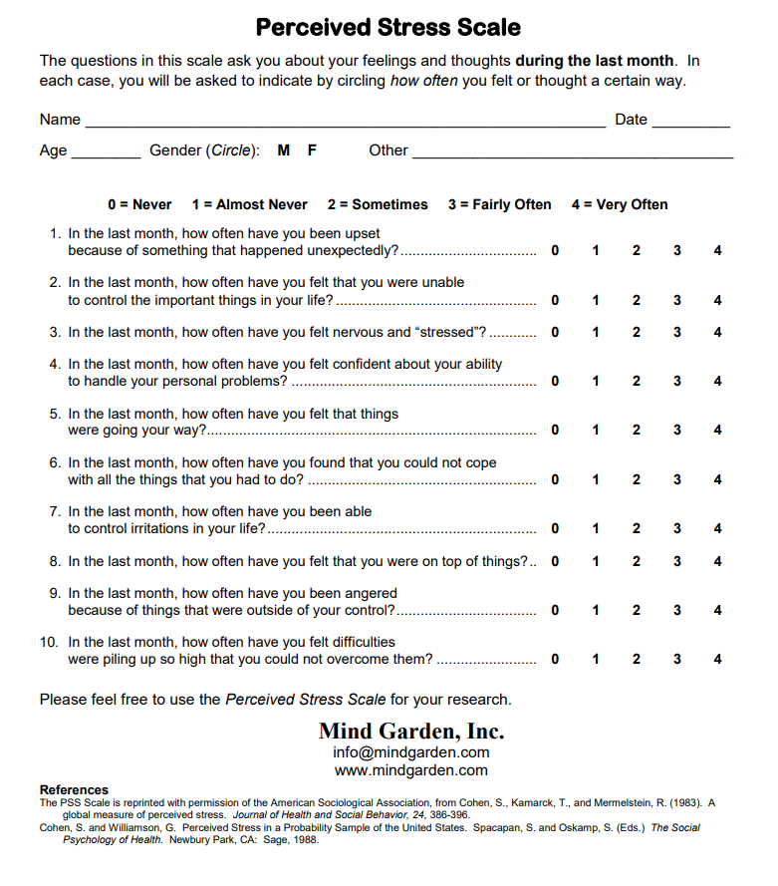

Appendix J

Interventional Flow Diagram

Appendix K

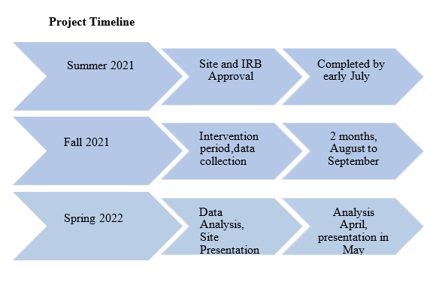

Appendix L Logic Model for DNP Project

Student: Tara Hommelson
Inquiry: In pediatric nurses, does mindfulness meditation decrease stress within 8 weeks of implementation at a pediatric hospital?

Inputs |  | Intervention(s) Outputs |  |  | Outcomes -- Impact
Inputs |  | Activities | Participation |  | Short | Medium | Long
Evidence, sub-topics  1. Stress in Nurses  2. Stress in Pediatric Nurses  3. Mindfulness Meditation and Mental Health  4. Mindfulness Meditation and Health Care Providers  5. Mindfulness Meditation and Registered Nurses  6. Mindfulness Meditation via a smartphone application  Major Facilitators or Contributors  1. Facility CNO  2. Hospital Staff RNs  3. DNP Preceptor  4. Inexpensive  Major Barriers or Challenges  1. Small hospital; small sample size  2. Mental health stigma  3. Buy in from staff  4. Time constraints due to staff workload  5.Comfort level with technology and mindfulness meditation smartphone application |  | EBP intervention  Mindfulness meditation via a smartphone application  Major steps of the intervention  1. Site approval letter (completed 2/2021) & UMKC IRB approval  2. Virtual orientation to project purpose, benefits, timeline, and mindfulness app use and enroll participants  2. Participants receive informational letter, orientation video, and pre-intervention PSS  3. Weekly check-in with participants to motivate, encourage participation, and address technology issues with app  4. Check-in with CNO via email biweekly to address questions, concerns, feedback  5. Participants complete post-intervention PSS  6. Analyze and present collected data  7. Disseminate findings | The participants (subjects)  Staff RNs  Site: Private Pediatric Bridge Hospital in St. Louis Missouri  Time Frame  8 weeks  Participants will receive an informational letter and orientation video regarding the project  Other person(s) collecting data (yes,no) no  Others consenting (yes/no) no |  | Outcome(s) to be measured during project. Primary:  Secondary, if applies:  Perceived stress pre mindfulness meditation intervention and post mindfulness meditation intervention  Measurement tool(s)  1. Perceived Stress Scale  Statistical analysis to be used  1.Paired t-test to analyze results of PSS pre-intervention and post-intervention. | Outcomes to be measured beyond project time.  1.Stress reduction 6 months post project end date |  | Outcomes to be measured in distant future.  1.Stress reduction 1 year post project end date.

Appendix M
Faculty DNP Approval

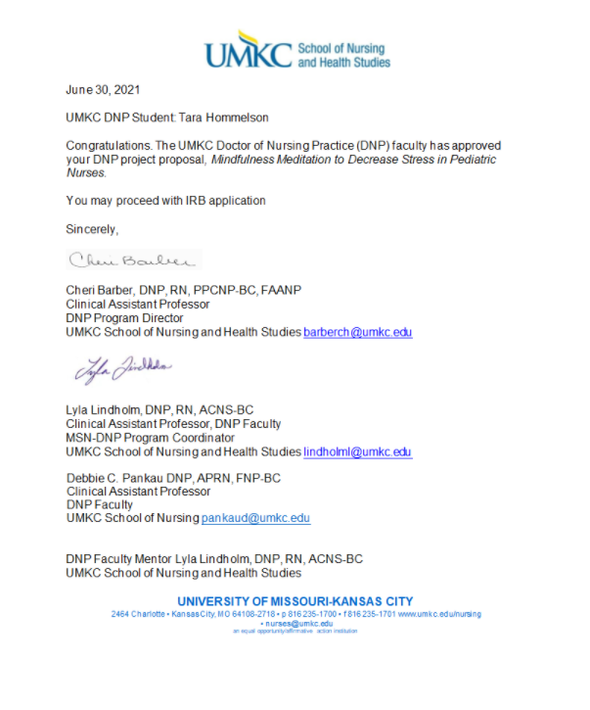

Appendix N

IRB Approval
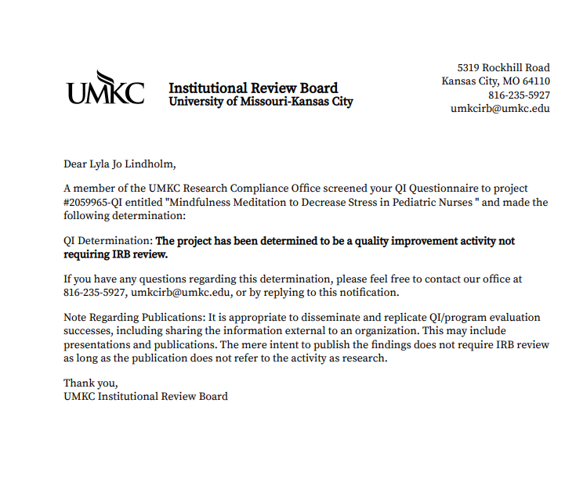

Appendix O

Data Collection Template

Participants | Age | Pre PSS  Score | PSS Stress Level – Low (0 -13), Medium (14 – 26) or High (27 – 40) | Post PSS Score | PSS Stress Level – Low (0 -13), Medium (14 – 26) or High (27 – 40)
1
2
3
4
5
6
7
8
9
10
Continue

Appendix P

Outcome to Analysis

 | Outcome or Demographics | Measurement | Tool validity and reliability | Permission Need | Statistical Analysis Test
Primary Outcome | Successful implementation of a mindfulness meditation smartphone application to decrease stress | PSS-10 | Valid and Reliable | No | Paired t-test. Descriptive due to small sample size.
Demographics | One group with pre-intervention and post-intervention measurements | Not applicable | Not applicable | Not Applicable | Descriptive data includes age

Appendix Q

Descriptive Statistics, Pre-Post PSS Questions

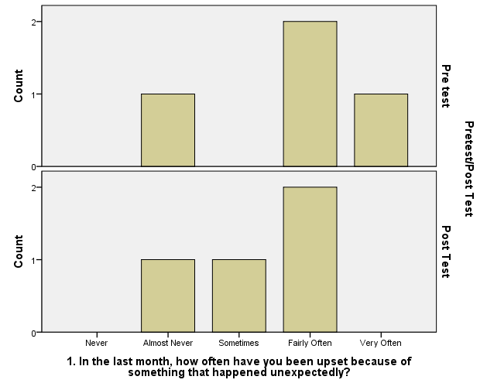
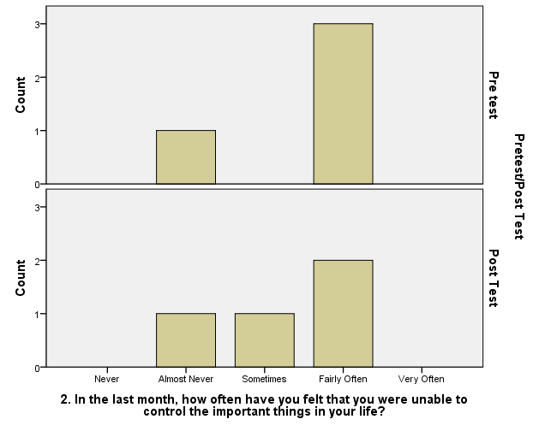
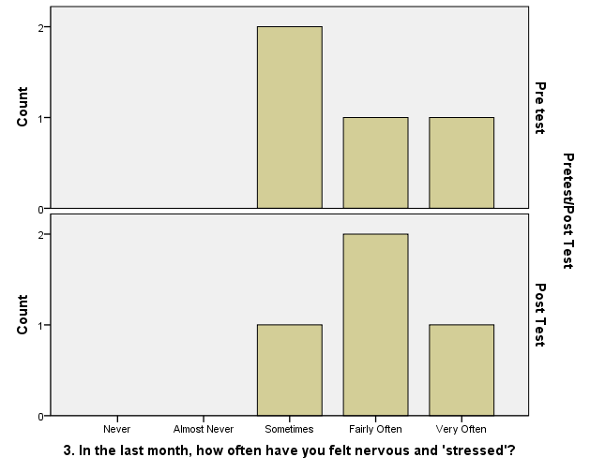
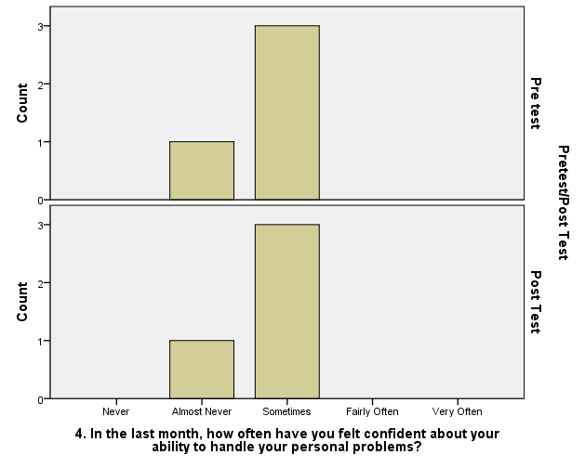
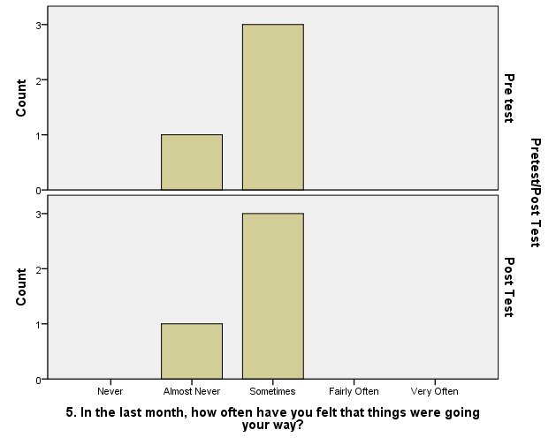
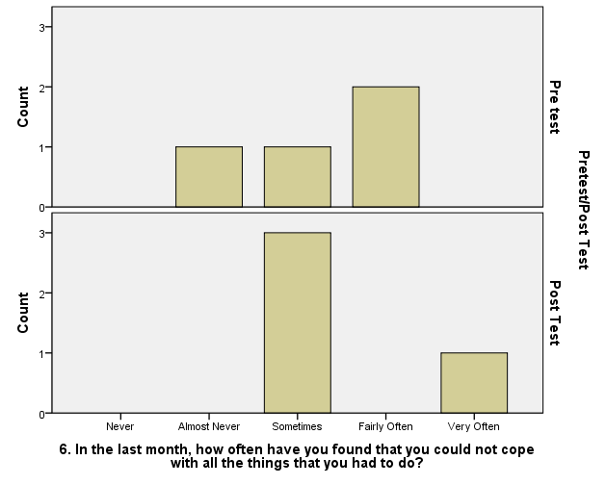
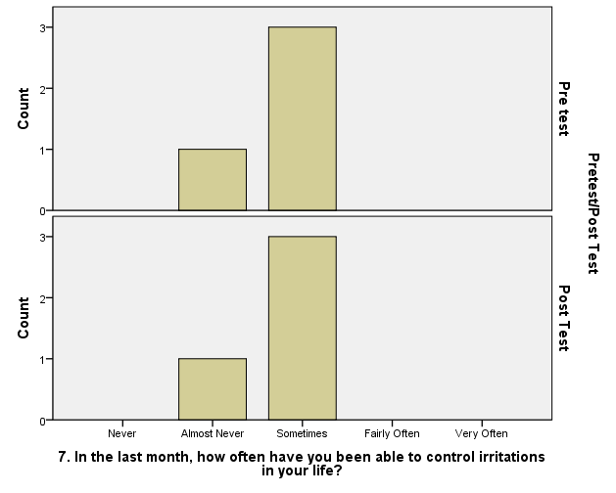
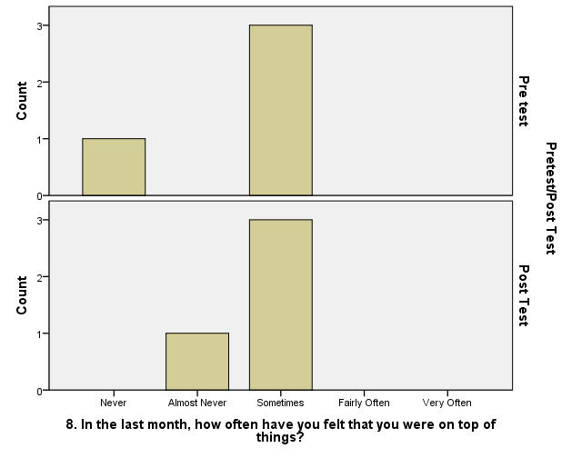
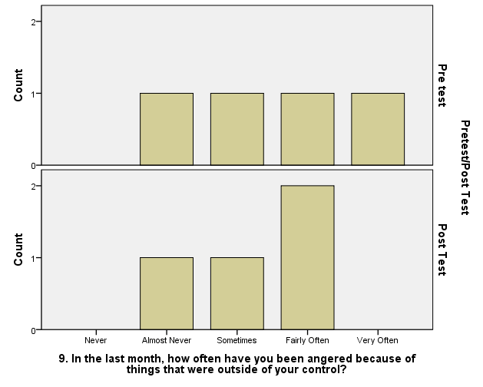
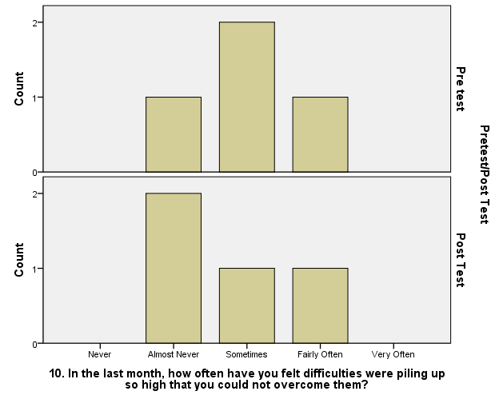

 |  | Pretest (n=24)
1. In the last month, how often have you been upset because of something that happened unexpectedly?
 |  | Frequency | Percent | Valid Percent | Cumulative Percent
Valid | Almost Never | 5 | 20.8 | 20.8 | 20.8
Valid | Somaetimes | 13 | 54.2 | 54.2 | 75.0
Valid | Fairly Often | 4 | 16.7 | 16.7 | 91.7
Valid | Very Often | 2 | 8.3 | 8.3 | 100.0
Valid | Total | 24 | 100.0 | 100.0
2. In the last month, how often have you felt that you were unable to control the important things in your life?
 |  | Frequency | Percent | Valid Percent | Cumulative Percent
Valid | Almost Never | 6 | 25.0 | 25.0 | 25.0
Valid | Sometimes | 10 | 41.7 | 41.7 | 66.7
Valid | Fairly Often | 8 | 33.3 | 33.3 | 100.0
Valid | Total | 24 | 100.0 | 100.0
3. In the last month, how often have you felt nervous and 'stressed'?
 |  | Frequency | Percent | Valid Percent | Cumulative Percent
Valid | Sometimes | 9 | 37.5 | 37.5 | 37.5
Valid | Fairly Often | 9 | 37.5 | 37.5 | 75.0
Valid | Very Often | 6 | 25.0 | 25.0 | 100.0
Valid | Total | 24 | 100.0 | 100.0
4. In the last month, how often have you felt confident about your ability to handle your personal problems?
 |  | Frequency | Percent | Valid Percent | Cumulative Percent
Valid | Almost Never | 11 | 45.8 | 45.8 | 45.8
Valid | Sometimes | 12 | 50.0 | 50.0 | 95.8
Valid | Fairly Often | 1 | 4.2 | 4.2 | 100.0
Valid | Total | 24 | 100.0 | 100.0
5. In the last month, how often have you felt that things were going your way?
 |  | Frequency | Percent | Valid Percent | Cumulative Percent
Valid | Never | 1 | 4.2 | 4.2 | 4.2
Valid | Almost Never | 8 | 33.3 | 33.3 | 37.5
Valid | Sometimes | 11 | 45.8 | 45.8 | 83.3
Valid | Fairly Often | 4 | 16.7 | 16.7 | 100.0
Valid | Total | 24 | 100.0 | 100.0
6. In the last month, how often have you found that you could not cope with all the things that you had to do?
 |  | Frequency | Percent | Valid Percent | Cumulative Percent
Valid | Never | 1 | 4.2 | 4.2 | 4.2
Valid | Almost Never | 9 | 37.5 | 37.5 | 41.7
Valid | Sometimes | 11 | 45.8 | 45.8 | 87.5
Valid | Fairly Often | 3 | 12.5 | 12.5 | 100.0
Valid | Total | 24 | 100.0 | 100.0
7. In the last month, how often have you been able to control irritations in your life?
 |  | Frequency | Percent | Valid Percent | Cumulative Percent
Valid | Never | 1 | 4.2 | 4.2 | 4.2
Valid | Almost Never | 6 | 25.0 | 25.0 | 29.2
Valid | Sometimes | 16 | 66.7 | 66.7 | 95.8
Valid | Fairly Often | 1 | 4.2 | 4.2 | 100.0
Valid | Total | 24 | 100.0 | 100.0
8. In the last month, how often have you felt that you were on top of things?
 |  | Frequency | Percent | Valid Percent | Cumulative Percent
Valid | Never | 1 | 4.2 | 4.2 | 4.2
Valid | Almost Never | 5 | 20.8 | 20.8 | 25.0
Valid | Sometimes | 14 | 58.3 | 58.3 | 83.3
Valid | Fairly Often | 4 | 16.7 | 16.7 | 100.0
Valid | Total | 24 | 100.0 | 100.0
9. In the last month, how often have you been angered because of things that were outside of your control?
 |  | Frequency | Percent | Valid Percent | Cumulative Percent
Valid | Almost Never | 6 | 25.0 | 25.0 | 25.0
Valid | Sometimes | 10 | 41.7 | 41.7 | 66.7
Valid | Fairly Often | 7 | 29.2 | 29.2 | 95.8
Valid | Very Often | 1 | 4.2 | 4.2 | 100.0
Valid | Total | 24 | 100.0 | 100.0
10. In the last month, how often have you felt difficulties were piling up so high that you could not overcome them?
 |  | Frequency | Percent | Valid Percent | Cumulative Percent
Valid | Never | 2 | 8.3 | 8.3 | 8.3
Valid | Almost Never | 9 | 37.5 | 37.5 | 45.8
Valid | Sometimes | 8 | 33.3 | 33.3 | 79.2
Valid | Fairly Often | 5 | 20.8 | 20.8 | 100.0
Valid | Total | 24 | 100.0 | 100.0

 |  | PRE TEST (n=4) |  |  |  |  |  |  | POST TEST
 |  |  |  |  |  |  |  |  | (n=4)
Age |  |  |  |  |  |  | Age
 |  | Frequency | Percent | Valid Percent | Cumulative Percent |  |  |  | Frequency | Percent | Valid Percent | Cumulative Percent
Valid | 24 | 1 | 25 | 25 | 25 |  | Valid | 24 | 1 | 25 | 25 | 25
Valid | 25 | 2 | 50 | 50 | 75 |  | Valid | 25 | 1 | 25 | 25 | 50
Valid | 48 | 1 | 25 | 25 | 100 |  | Valid | 26 | 1 | 25 | 25 | 75
Valid | Total | 4 | 100 | 100 |  |  | Valid | 48 | 1 | 25 | 25 | 100
 |  |  |  |  |  |  | Valid | Total | 4 | 100 | 100
1. In the last month, how often have you been upset because of something that happened unexpectedly? |  |  |  |  |  |  | 1. In the last month, how often have you been upset because of something that happened unexpectedly?
 |  | Pretest
 |  | Frequency | Percent | Valid Percent | Cumulative Percent |  |  |  | Frequency | Percent | Valid Percent | Cumulative Percent
Valid | Almost Never | 1 | 25 | 25 | 25 |  | Valid | Almost Never | 1 | 25 | 25 | 25
Valid | Fairly Often | 2 | 50 | 50 | 75 |  | Valid | Sometimes | 1 | 25 | 25 | 50
Valid | Very Often | 1 | 25 | 25 | 100 |  | Valid | Fairly Often | 2 | 50 | 50 | 100
Valid | Total | 4 | 100 | 100 |  |  | Valid | Total | 4 | 100 | 100
2. In the last month, how often have you felt that you were unable to control the important things in your life? |  |  |  |  |  |  | 2. In the last month, how often have you felt that you were unable to control the important things in your life?
 |  | Frequency | Percent | Valid Percent | Cumulative Percent |  |  |  | Frequency | Percent | Valid Percent | Cumulative Percent
Valid | Almost Never | 1 | 25 | 25 | 25 |  | Valid | Almost Never | 1 | 25 | 25 | 25
Valid | Fairly Often | 3 | 75 | 75 | 100 |  | Valid | Sometimes | 1 | 25 | 25 | 50
Valid | Total | 4 | 100 | 100 |  |  | Valid | Fairly Often | 2 | 50 | 50 | 100
 |  |  |  |  |  |  |  |  | Total | 4 | 100 | 100
3. In the last month, how often have you felt nervous and 'stressed'? |  |  |  |  |  |  | 3. In the last month, how often have you felt nervous and 'stressed'?
 |  | Frequency | Percent | Valid Percent | Cumulative Percent |  |  |  | Frequency | Percent | Valid Percent | Cumulative Percent
Valid | Sometimes | 2 | 50 | 50 | 50 |  | Valid | Sometimes | 1 | 25 | 25 | 25
Valid | Fairly Often | 1 | 25 | 25 | 75 |  | Valid | Fairly Often | 2 | 50 | 50 | 75
Valid | Very Often | 1 | 25 | 25 | 100 |  | Valid | Very Often | 1 | 25 | 25 | 100
Valid | Total | 4 | 100 | 100 |  |  |  |  | Total | 4 | 100 | 100
4. In the last month, how often have you felt confident about your ability to handle your personal problems? |  |  |  |  |  |  | 4. In the last month, how often have you felt confident about your ability to handle your personal problems?
 |  | Frequency | Percent | Valid Percent | Cumulative Percent |  |  |  | Frequency | Percent | Valid Percent | Cumulative Percent
Valid | Almost Never | 1 | 25 | 25 | 25 |  | Valid | Almost Never | 1 | 25 | 25 | 25
Valid | Sometimes | 3 | 75 | 75 | 100 |  | Valid | Sometimes | 3 | 75 | 75 | 100
Valid | Total | 4 | 100 | 100 |  |  |  |  | Total | 4 | 100 | 100
5. In the last month, how often have you felt that things were going your way? |  |  |  |  |  |  | 5. In the last month, how often have you felt that things were going your way?
 |  | Frequency | Percent | Valid Percent | Cumulative Percent |  |  |  | Frequency | Percent | Valid Percent | Cumulative Percent
Valid | Almost Never | 1 | 25 | 25 | 25 |  | Valid | Almost Never | 1 | 25 | 25 | 25
Valid | Sometimes | 3 | 75 | 75 | 100 |  | Valid | Sometimes | 3 | 75 | 75 | 100
Valid | Total | 4 | 100 | 100 |  |  |  |  | Total | 4 | 100 | 100
6. In the last month, how often have you found that you could not cope with all the things that you had to do? |  |  |  |  |  |  | 6. In the last month, how often have you found that you could not cope with all the things that you had to do?
 |  | Frequency | Percent | Valid Percent | Cumulative Percent |  |  |  | Frequency | Percent | Valid Percent | Cumulative Percent
Valid | Almost Never | 1 | 25 | 25 | 25 |  | Valid | Sometimes | 3 | 75 | 75 | 75
Valid | Sometimes | 1 | 25 | 25 | 50 |  | Valid | Very Often | 1 | 25 | 25 | 100
Valid | Fairly Often | 2 | 50 | 50 | 100 |  | Valid | Total | 4 | 100 | 100
Valid | Total | 4 | 100 | 100
7. In the last month, how often have you been able to control irritations in your life? |  |  |  |  |  |  | 7. In the last month, how often have you been able to control irritations in your life?
 |  | Frequency | Percent | Valid Percent | Cumulative Percent |  |  |  | Frequency | Percent | Valid Percent | Cumulative Percent
Valid | Almost Never | 1 | 25 | 25 | 25 |  | Valid | Almost Never | 1 | 25 | 25 | 25
Valid | Sometimes | 3 | 75 | 75 | 100 |  | Valid | Sometimes | 3 | 75 | 75 | 100
Valid | Total | 4 | 100 | 100 |  |  | Valid | Total | 4 | 100 | 100
8. In the last month, how often have you felt that you were on top of things? |  |  |  |  |  |  | 8. In the last month, how often have you felt that you were on top of things?
 |  | Frequency | Percent | Valid Percent | Cumulative Percent |  |  |  | Frequency | Percent | Valid Percent | Cumulative Percent
Valid | Never | 1 | 25 | 25 | 25 |  | Valid | Almost Never | 1 | 25 | 25 | 25
Valid | Sometimes | 3 | 75 | 75 | 100 |  | Valid | Sometimes | 3 | 75 | 75 | 100
Valid | Total | 4 | 100 | 100 |  |  | Valid | Total | 4 | 100 | 100
9. In the last month, how often have you been angered because of things that were outside of your control? |  |  |  |  |  |  | 9. In the last month, how often have you been angered because of things that were outside of your control?
 |  | Frequency | Percent | Valid Percent | Cumulative Percent |  |  |  | Frequency | Percent | Valid Percent | Cumulative Percent
Valid | Almost Never | 1 | 25 | 25 | 25 |  | Valid | Almost Never | 1 | 25 | 25 | 25
Valid | Sometimes | 1 | 25 | 25 | 50 |  | Valid | Sometimes | 1 | 25 | 25 | 50
Valid | Fairly Often | 1 | 25 | 25 | 75 |  | Valid | Fairly Often | 2 | 50 | 50 | 100
Valid | Very Often | 1 | 25 | 25 | 100 |  | Valid | Total | 4 | 100 | 100
Valid | Total | 4 | 100 | 100
10. In the last month, how often have you felt difficulties were piling up so high that you could not overcome them? |  |  |  |  |  |  | 10. In the last month, how often have you felt difficulties were piling up so high that you could not overcome them?
 |  | Frequency | Percent | Valid Percent | Cumulative Percent |  |  |  | Frequency | Percent | Valid Percent | Cumulative Percent
Valid | Almost Never | 1 | 25 | 25 | 25 |  | Valid | Almost Never | 2 | 50 | 50 | 50
Valid | Sometimes | 2 | 50 | 50 | 75 |  | Valid | Sometimes | 1 | 25 | 25 | 75
Valid | Fairly Often | 1 | 25 | 25 | 100 |  | Valid | Fairly Often | 1 | 25 | 25 | 100
Valid | Total | 4 | 100 | 100 |  |  | Valid | Total | 4 | 100 | 100

Appendix R
Executive Summary
Nurses are at high risk for experiencing stress during their careers; pediatric nurses may experience even higher levels of stress because they care for the patient and the family. Promoting the health and wellbeing of frontline pediatric nurses by reducing stress is paramount.
Purpose
The purpose of this evidence-based quality improvement project was to determine if a mindfulness meditation smartphone application decreased stress in pediatric nurses.
Methods
The pediatric nurses who chose to participate in the project completed a pretest Perceived Stress Scale (PSS). Participants were then encouraged to utilize the Healthy Minds app for Mindfulness meditation was delivered through use of the free Healthy Minds smartphone app and was Participants were instructed to access the Healthy Minds app intervention three times per week for eight weeks. Baseline data and post-intervention data were measured using the Perceived Stress Scale. Participants were asked to complete the posttest immediately after completing the eight-week intervention. All data was collected online. The data was analyzed using descriptive statistics due to the low number of participants who completed the post-test Perceived Stress Scale.
Findings
Utilizing the Perceived Stress Scale, participants were asked ten questions regarding stress over the past month. According to the PSS, if a participant scores 0-13 stress is considered low, if a participant scores 14-26, stress is considered moderate, and if a participant scores 27-40 they would be considered as having high perceived stress. The pretest data analysis showed that 23 participants had moderate stress. One participant had high perceived stress. And zero participants had low stress. Of the 4 participants who completed both the pretest and posttest, the pretest data revealed three participants had moderate stress and one participant had high perceived stress.
Recommendations
The literature review reveals a need for change to assist nurses in cultivating healthier coping mechanisms to manage stress. Interventions, such as meditation, are needed to support nurses in developing healthy strategies to decrease the prevalence of stress. The regular practice of meditation has been shown to aid in managing anxiety disorders (Dundas et al., 2016). Moreover, meditation has been shown to reduce cortisol levels, anxiety, stress, and depression (Van der Riet et al., 2018). The Healthy Minds Program mindfulness meditation application was utilized as the intervention in this project and may be an asset to pediatric nurses because it is free and easily accessible from a smartphone. The project sought to support the mental health of nurses through evidence-based quality improvement by reducing stress. Stress is inevitable but learning healthy coping mechanisms, such as meditation, may assist in combating stress. Addressing stress via a mobile mindfulness meditation smartphone application may play a role in decreasing stress, but the implementation of mindfulness meditation on health care and nurse’s mental health may be even more profound.

