Utilization of Telehealth in Primary Care to Improve Patient Outcomes

Sabrina M. Slifer
School of Nursing and Health Studies, University of Missouri-Kansas City
Dr. Linda Lindholm, Dr. Cheri Barber and Dr. Deb Pankau
May 5, 2023
Table of Contents
Abstract………………………………………………………………………………..………….5
Significance…………………………………………………………………………………….…7
Site Description……………………………………………………………………………………8
Problem, Purpose………………………………………………………………………………….9
Aim, Timeline…………………………………………………..…………………………………9
Inquiry………………………………………………………………………………………….10
Review of Evidence
Search……………………………………………………………………………………10
Themes…………………………………………………………………………………..11
Theory……………………………………………………………………………………………15
Methods
IRB……………………………………………………………………………………….16
Ethical Concerns…….…………………………………………………………………...16
Privacy and Confidentiality……………………………………………………………...16
EBP Intervention…………………………………………………………………………17
Change Process…………………………………………………………………………..18
Project Design……………………………………………………………………………18
Validity…………………………………………………………………………………..19
Outcomes………………………………………………………………………………...19
Measurement Tools………………………………………………………………………19
Quality of Data……..……….……….…………………………………………………..19
Analysis………………………………………….………………………………………20
Results
Setting and Participants……………………………………………………………….21
Intervention Course……………………………………………………………………21
Outcome Data………………………………………………………………………….21
Discussion
Successes, Most Important……………………………………………………………22
Study Strengths……………………………………………………………………….22
Limitations
Internal Validity Effects……………………………………………………………..23
External Validity Effects…………………………………………………………….23
Sustainability of Effects and Plans to Maintain Effects…………………………….23
Efforts to Minimize the Study Limitations………………………………………….23
Interpretation
Expected and Actual Outcomes…………………………………………………….24
Intervention Effectiveness and Revision……………………………………..…….25 Expected and Actual Impact to Health System, Costs, and Policy…………………25
Conclusions………………………………………………………………………………………26
References………………………………………………………………………………………..27
Appendices
PRISMA Diagram………………………………………………………………………..32
Review of Evidence Table……………………………………………………………….33
Evidence Themes……………………………………………………………….………..44
Theory of Self Efficacy…………………………………………………………………52
Cognitive Learning Theory………………………………………………………………53
Timeline and Interventional Flow Diagram.…………………………………………….54
Data Collection Template………………………………………………………………..56
Logic Model……………………………………………………………………………...58
Secondary Survey..………………………………………………………………………60
Statistical Analysis Results.…………………………………………….………………..61
Institutional Review Board Approval……………………………………..………..……63
Consent…………………………………………………………………….………….…65
Initial Survey……………………………………………………………….……………69

Abstract
Purpose: one-cohort posttest only expedited research project is to decrease emergency department utilization and improve patient outcomes by increasing access to primary care services using telehealth. Background: recent data has demonstrated a concerning trend that many patients who miss appointments also have a previous mental health diagnosis leading to discontinuity of care and increased use of tertiary care. Not only are missed appointments expensive for the health system, but they also represent a significant risk to patients’ well-being with a greater than 8-fold increase in all-cause mortality compared to patients who did not miss any appointments. Theoretical framework: the Theory of Self-Efficacy hypothesizes that increasing a person’s perceived self-efficacy leads to increased effort when faced with challenges. Telehealth can increase patient self-efficacy with disease management and empower patients to take control of their health. Method: All patients seen at a private, primary care clinic were offered participation to schedule a telehealth appointment every 2-4 weeks. Data collection used self-report surveys administered during appointment check-in and at subsequent follow-ups. Results: low participation led to diminished survey returns, however no participants reported emergency department usage during the intervention period. Conclusions: low participation yielded inconclusive data. This project highlights the need for future research to support the expansion of telehealth to provide better access to high-quality healthcare.
Keywords: failure-to-attend, telehealth, primary care, mental health, COVID-19
NOTES: this research project and poster are solely the work of the student investigator.

Utilization of Telehealth in Primary Care to Improve Patient Outcomes
Previous research yielded compelling data showing that adverse childhood events (ACEs), or exposure to trauma in childhood is a powerful predictor of lifetime morbidity and mortality. Research has shown that Cognitive Behavioral Therapy (CBT) is an effective treatment for patients who have experienced childhood trauma; however, further research has revealed that this intervention might be outside the realm of possibility for the average, busy primary care clinic. Recent clinical experiences in a small family practice clinic in rural Missouri have uncovered a trend demonstrating that many patients who miss appointments also have a previous mental health diagnosis leading to discontinuity of care and increased use of tertiary care.
Data from the National Health Services in 1999 estimated that missed appointments cost £360 million per year (Mitchell & Selmes, 2007). Not only are missed appointments expensive for the health system, but they represent a significant risk to patient health. Patients with more chronic health diagnoses are at an increased risk of missing primary care appointments, which is especially true for those with chronic mental health diagnoses (McQueenie et al., 2019). “Patients with long-term mental health conditions who missed more than two appointments per year had a greater than 8-fold increase in the risk of all-cause mortality compared with those who missed no appointments” (McQueenie et al., 2019, p. 1). Researchers in Denver, CO implemented a prediction model that accurately identified patients at high risk of missing appointments and designed an interactive voice response and text message intervention system that reduced missed appointments (Steiner et al., 2016).

Site Description
Risk factors for missing appointments include being female, young, black, or Hispanic and most importantly, living in a deprived area(Kaplan-Lewis & Percac-Lima, 2013; Neal et al., 2001). The anticipated project site is UpCare Clinics in Olathe, Kansas. This clinic is a privately owned clinic that is not affiliated with any health system. UpCare Clinic provides both dental and medical services to many clients in the area including an underserved population of Hispanic immigrants. Due to prior ownership by a different dental practice, the clinic already has many established dental patients but is currently working to expand its medical practice.
Problem
Research has shown that access to telehealth can reduce ED visits (Pulcini et al., 2021), increase psychotherapy encounters (Jacobs et al., 2019), and improve quality of life (Pratt et al., 2015). Researchers have found conflicting results: one study found that there was no significant decrease in ED or urgent care usage (Jacobs et al., 2019), while another found a 75% decrease in ED visits and an 82% decrease in hospital admissions (Pratt et al., 2015). Crucial research from 2019 shows an 8-fold increase in all-cause mortality in patients who missed more than two appointments per year vs those who missed no appointments (McQueenie et al., 2019) which demonstrates a significant risk to patients and requires attention from healthcare providers.
The year 2020 will stand out in the history books for the radical impact of the novel coronavirus pandemic which has upended the economy, US politics, culture, and race relations (DeVoe & Bazemore, 2021). A shining star in the pandemic has been the flexibility and resilience of primary care and family medicine, two areas of the healthcare system that have swiftly implemented new policies and systems to continue to meet patient needs while maintaining public and staff safety. One academic health system in northern California was able to scale a new video visit program to cover more than 80% of clinic visits in two weeks in February 2020 (Artandi et al., 2020). Many see these adjustments as long-overdue opportunities for growth and change in our healthcare system. Still, the novel coronavirus pandemic has offered a glimpse of a bright future ahead in healthcare and highlighted the need for future research.
Purpose Statement
Telehealth interventions have been shown to improve patient outcomes and improve overall health, but the broader expansion of these services has been beleaguered by regulatory, compliance, and privacy issues. The coronavirus disease 2019 (COVID-19) pandemic has drastically changed the landscape of healthcare delivery and may encourage the growth needed to realize the potential of telehealth (Shachar et al., 2020). ). The purpose of this one-cohort posttest only expedited research project is to decrease emergency department utilization and improve patient outcomes by increasing access to primary care services using telehealth.
Aim and Timeline
To reduce tertiary care use for mental health disorders by increasing primary care encounters over 12-weeks. The goal is to obtain data from 35 patients who volunteer to participate in the telehealth intervention.
Keywords searched include but are not limited to failure-to-attend, primary care, emergency department, telehealth, mental health, and COVID-19.
Inquiry
In patients with mental health diagnoses (P), can encouraging telehealth visits every 2-4 weeks (I) compared to no telehealth (C), reduce the number of emergency department visits (O) over a 90-day period (T) in a primary care clinic (S)?
Literature Search
Google Scholar search engine as well as the UMKC Libraries, have been accessed for this research. Multiple articles have been sourced from ScienceDirect, BioMedCentral, and SAGE online databases. To be included in this research, studies should be published between January 1, 2001, and present-day, ideally within the last two years (see Appendix A). Studies should also have a sample size greater than 30 participants. Exclusion criteria: published before 2001, sample size restricted to a specific age group with no generalizability or small sample size.
Synthesis of Evidence
Researchers have long wanted to understand which patients miss appointments and why (see Appendix B). General practitioners from the United Kingdom found that 40% of patients who missed an appointment stated it was due to forgetfulness while others said they tried to cancel the appointment or family commitments prevented their attendance (Neal et al., 2001). They also found that patients who lived in a deprived area, who were young and female were more likely to miss appointments (Neal et al., 2001). Dantas et al. confirmed this in a 2018 systematic review of 105 studies of missed appointments showing evidence that younger age, lower socioeconomic status, longer distance to a clinic, and lack of private insurance are all risk factors that increase the likelihood that adult patients would fail to attend (Dantas et al., 2018). Failure to attend presents a significant cost to both the patient and the healthcare system. Patients not missing any appointments were at an 8-fold decreased risk of mortality (McQueenie et al., 2019). Estimates suggest that as many as 50% of patients who miss appointments eventually withdraw from regularly scheduled care (Mitchell & Selmes, 2007). Missed appointments also represent a significant financial burden on the healthcare systems internationally (Mitchell & Selmes, 2007). Estimates from 2017 suggest that the total cost of missed appointments in the United States is $150 billion (Gier, 2017) and hampers effectiveness and efficiency (Mehra et al., 2018). Further investigation is necessary to determine what impact the COVID-19 pandemic has had on overall public health, the rate of missed appointments, and potential telehealth solutions to support public safety.
Mental Health
Many researchers have found a specific subset of the population, patients with moderate to severe mental illness, to prove especially challenging. McQueenie et al., note that patients with chronic medical conditions demonstrated an increased risk of missing appointments, especially among patients with mental health diagnoses (2019). These patients with chronic mental health diagnoses were subject to a markedly increased risk of mortality when missing appointments and frequently these patients died prematurely of non-natural external factors like suicide (McQueenie et al., 2019). Mental health services can be difficult to access, particularly in rural areas and telehealth is a safe, effective treatment option that helps increase access for many patients (Jacobs et al., 2019; Patel et al., 2020; Pratt et al., 2013, 2015). One researcher even noted that missed appointments in young adults are strongly associated with the onset of a new mental health problem that warrants further evaluation and management (Moscrop et al., 2012).
Interventions to Reduce Missed Appointments
A wide variety of interventions to reduce the frequency of missed appointments in outpatient care with varied success. One of the most common options studied is a reminder notification via telephone call or automated text message before the appointment. A randomized controlled trial in 2018 found that two automated reminders were more effective at reducing missed appointment rates than a single reminder, especially in patients who were identified as high risk of missing appointments (Steiner et al., 2018). Another study found that patients who received a live call from a staff member as an appointment reminder were more likely to attend than the patients that received an automated reminder (Vang et al., 2020). A randomized clinical trial in 2013 found that text messages were equally effective at reducing missed appointments and more cost-effective than live phone calls (Junod Perron et al., 2013).
Telehealth is an alternative method studied for its potential to reduce the frequency of missed appointments and improve continuity of care; however, conflicting data have been found regarding efficacy. Research in the United States has shown that access to telehealth can reduce emergency department visits (Pulcini et al., 2021), increase psychotherapy encounters (Jacobs et al., 2019), and improve quality of life (Pratt et al., 2015). Researchers in Australia found no statistically significant reduction in non-attendance among a retrospective cohort of telehealth appointments compared to in-person appointments (Greenup et al., 2019). A smaller, separate study in the United States found that telehealth offerings can reduce non-attendance rates concluding that telehealth should be further investigated and offered when possible (Snoswell & Comans, 2020). Multiple studies note that telehealth appointments are still subject to forgetfulness, the most common reason patients cite for missing appointments (Greenup et al., 2019; Snoswell & Comans, 2020).
Researchers also tested interventions after hospital discharge to prevent readmission. Telephone follow-up calls have been shown to increase telehealth use and decreased the frequency of missed appointments. For example, a systematic review from Woods et al. found that telephone follow-up improved patient outcomes but did not present a significant reduction in patient readmission or mortality (2019). It is also important to note that this systematic review included 10 studies; however, only 2 of them were methodologically strong enough to draw practice conclusions (Woods et al., 2019). Similarly, researchers in 2014 were able to demonstrate a significant increase in follow-up appointment attendance with telephone follow-up after hospital discharge; however, there was not a significant difference in readmission rate (Tang et al., 2014).
While very promising, telehealth does present many new challenges to safe, effective healthcare services. Prior to the COVID-19 pandemic, researchers theorized that some clinics may struggle to implement new telehealth technologies due to staff's lack of knowledge and confidence. Researchers demonstrated an increase in telehealth utilization after nurses attended a training program designed to improve knowledge and self-efficacy (van Houwelingen et al., 2020).
Limitations
To date, telehealth research has been limited by access, cost, few participants, and confounding variables such as forgetfulness. Getting patients access to high-speed internet and the devices needed to use telehealth has long been an obstacle. As technology improves and becomes more affordable, more patients will be able to access telehealth services. Other researchers have already found that there will always be patients who simply forget the appointment regardless of how many interventions are used to help get them into the clinic. Telehealth technology deserves more research as it continues to grow and evolve at an exponential rate and carries great potential to improve patient outcomes and quality of life.
Evidence Summary
Multiple themes have been identified including telehealth, mental health, failure to attend, and emergency department utilization (see Appendix C). When looking at telehealth and mental health, research has demonstrated the incidence of missed appointments is correlated with emergency department utilization. Staff training to increase self-efficacy and telephone follow-up calls have also been shown to increase telehealth use and a decreased frequency of missed appointments with encouraging results.
Many researchers have found a specific subset of the population, patients with moderate to severe mental illness, to prove especially challenging. Patients with mental health problems who missed primary care appointments had an 8-fold increased risk in all-cause mortality (McQueenie et al., 2019). The highest frequency of missed appointments is among young adult patients, those with multiple comorbidities, those of lower socioeconomic status, minorities such as Hispanic and black Americans, and those who had previously missed appointments. One researcher even noted that missed appointments in young adults are strongly associated with the onset of a new mental health problem that warrants further evaluation and management (Moscrop et al., 2012).
Many modes of health care delivery have been studied in this population of mental health patients including reminder notifications, telephone follow-up, and programmed electronic messaging device (Kaplan-Lewis & Percac-Lima, 2013; Koziatek et al., 2020; Moscrop et al., 2012; Pratt et al., 2013; Woods et al., 2019) and researchers in 2015 showed improvements in self-reported psychiatric symptoms and decrease in hospital admissions and emergency room visits via these telehealth modes (B. B. Jacobs, 2013; Pratt et al., 2015).
Evidence Discussion
The most frequent reasons patients cite for the cause of missed in-person appointments are forgetfulness and scheduling conflicts, both of which also affect telehealth appointments (Greenup et al., 2019; Neal et al., 2001). Although there is compelling evidence to suggest that offering telehealth appointments helps reduce the rate of missed appointments, most of these studies were small, retrospective case-control studies. This indicates that the research is weak, and more research is needed to confirm these findings, especially in other subsets of the population.
Theory
The theory of Self-Efficacy is appropriate for this project in multiple domains. Training nurses in telehealth activities increase their self-efficacy, which then increases the number of telehealth appointments (van Houwelingen et al., 2020). Telehealth can also increase patient self-efficacy with disease management and empower patients to take control of their health (Suter et al., 2011). Previous research has shown that Self-Efficacy Theory has the potential to impact multidisciplinary practice across the lifespan (see Appendix D). The most effective way to increase a person’s self-efficacy is through mastery experience (Smith & Liehr, 2014). Mastery experiences, also known as enactive attainment or repeated success experiences, are a powerful source of self-efficacy information that is commonly used in adult populations to strengthen efficacy expectations (Estabrooks et al., 2005) (see Appendix E). Using telehealth is a powerful tool to increase the frequency of mastery experiences for patients and healthcare providers alike.

Methods
IRB and Site Approval
The primary IRB used for this project is the UMKC IRB because the site, UpCare Clinics, does not have its own IRB (see Appendix F). The UMKC IRB determined that this project is human subjects research and expedited approval was obtained on January 25, 2022.
Ethical Concerns
Participant autonomy and confidentiality will be respected by presenting each potential participant with the unsigned consent with ample time to assess, ask questions and make an informed decision. The risk of student-investigator research conflicts are low due to the retrospective nature of the data collection via patient self-report surveys.
A significant ethical concern is the population studied due to their vulnerability as patients with mental illness. The study aim was to gather 35 participants during the recruitment study time frame; however, this proved to be difficult and 31 ultimately participated. All patients scheduled at the clinic are potential study participants, which could lead to another significant ethical consideration due to the potential for lack of diversity and corruption of internal validity. Many factors can influence what patients present such as clinic location, and patient self-selection. As a new clinic that is looking to build a patient panel, UpCare Clinic employs multiple marketing strategies to attract new patients to join the practice. One of the primary methods they use is social media and search engine optimization, which tends to be seen by younger aged people. Demographic data such as age and gender will be included in the study results to help identify confounding variables.
Privacy and Confidentiality
All research using telehealth must also take privacy and confidentiality into account. Historically, the Health Insurance Portability and Accountability Act of 1996 (HIPAA) is an important regulation to protect patient privacy, however it is also sometimes considered a barrier to telehealth due to the strict requirements for patient communication. With recent events such as the COVID-19 pandemic, new considerations have been made to increase access for patients during the pandemic by allowing providers to use non-HIPAA-compliant platforms, although many acknowledge that continuing telehealth expansion after the pandemic will likely require a more nuanced approach to privacy (Shachar et al., 2020). In this study, the program used for videoconferencing was the program embedded within the electronic health record, therefore protected by dual encryption. The project lead also protected participant privacy by using surveys that contained no patient identifiers and which were kept in a locked box accessed only by the project lead.
Sampling Method
This project involved a new Standard of Care by encouraging staff to offer telehealth services; therefore, the new intervention (telehealth) was offered to every patient at the clinic. Upon arrival to the clinic visit, all adult patients at UpCare Clinic were given a consent form. The patients were allowed to review this in private and ask the student investigator any questions. All patients choosing to participate after reading the consent answered the initial survey. Patients were then scheduled for follow-up at routine intervals.
EBP Intervention
The project lead found that staff were enthusiastic about the telehealth intervention at initiation, but were not familiar with the telehealth platform which lead to difficulty with implementation. Education was provided for staff to use the telehealth programs available in their system and improve their competence. The recruitment phase began with pretest surveys given to all patients willing to participate. Patients with mental health diagnoses will be offered telehealth appointments every two weeks (see Appendix H).
The primary purpose of this interventional evidence-based research study, one cohort posttest-only design, is to decrease emergency department and urgent care utilization by increasing access to primary care services using telehealth. The current standard of care at the clinic is to deliver care through both in-person clinic and telehealth visits over various time intervals. In-person clinic visits represent the vast majority of appointments. All adult patients seen during recruitment will be offered at least every two-week telehealth visits, with an expected 35 patients choosing to participate. Emergency department and urgent care encounters that occur between scheduled visits will be gathered from patient self-report. The primary outcome measure will be emergency department and urgent care use in patients with mental health diagnoses. The secondary outcome measure is emergency department and urgent care use in all patients. Demographic data (age and gender) will be collected from self-report to describe the population for generalization of the findings and because the research indicates that they are confounding factors for emergency and urgent care access.
Change Process
The Plan-Do-Check-Act cycle is a change process that enables continuous improvement (PDCA Cycle - What Is the Plan-Do-Check-Act Cycle? | ASQ, n.d.) and is appropriate for this project due to the use of technology. This project used telehealth to increase patient contact in primary care settings to potentially decrease emergency department encounters with the primary goal to improve patient outcomes. Technology and telehealth are rapidly evolving fields that require constant evaluation and adjustments to achieve continuous improvement.
Study Design
The project is a one cohort posttest only design to is to decrease emergency department and urgent care utilization by increasing access to primary care services using telehealth.
Validity
Internal validity was subject to the quality and accuracy of self-report surveys which were largely unmeasurable by the investigator. Similarly, other potential threats to internal validity such as historical events like the COVID-19 pandemic and changes to insurance reimbursement regulations fall beyond the scope of measurement for this project. Due to the convenience sampling method, external validity was limited by participants self-selection but the new standard of care needed to be offered to all patients at the clinic. Decreased patient participation led to a high attrition rate which subsequently led to decreased internal validity.
Outcomes
The primary outcome was to study whether an increased frequency of telehealth encounters with a primary care provider can decrease emergency department usage in patients with mental health diagnoses. The potential impact of this project is to expand telehealth services and increase patient contact without increasing provider time or expense, however, the results of the study did not show a significant correlation. This may have been due to many factors including waning participant interest and skepticism around the cost-effectiveness of telehealth. Telehealth and telemedicine are two underutilized tools that are growing rapidly, and our healthcare delivery needs to adapt to employ them based on research.
Measurement Instruments and Budget
This project used the data from patient self-report surveys recording in-office primary care visits, telehealth visits, and emergency room visits, to support the use of telehealth. The self-reported survey is a single-use survey tailored to this project and will not use a measurement tool, which kept costs low. The primary cost incurred was the time required for the project lead to recruit participants, collect data and analyze the results (see Appendix I).
Quality of Data
For an optimal power of 0.8, the minimum sample size was calculated as 35. According to national data from 2016: 8.3% of emergency department visits in the United States were for psychiatric or substance use-related diagnoses (Theriault et al., 2020). More recent data from North Carolina published in 2022 showed similar results with 9.4% of emergency department visits were mental health diagnosis related (Brathwaite et al., 2022). The independent variable of this study is a continuous variable because it is the number of primary care visits in a 90-day period. The dependent variables of this study are dichotomous because they are yes or no questions. (See Secondary Survey; Appendix I)
Analysis
Only the frequency of visits intra-intervention and self-reported use of emergency departments were planned for use in statistical analysis (See Appendix J). However, the results of the project yielded low participation in the intervention making statistical analysis futile. Demographics studied but not used for analysis would include patient age and gender.
Results
Setting and Participants
UMKC IRB approval was granted on January 25, 2022 (Appendix K). Participant recruitment took place from March 30, 2022, through September 19, 2022, at UpCare Clinic in Olathe Kansas. All patients presenting to the clinic for a primary care visit were presented with the informational letter (see Appendix L) and were asked to answer the initial survey if they chose to participate (Appendix M). Participants ranged in age from 18 years old to 89 years old, with a total of n=31. The age group most frequently participating in the study was 25-35 years old (n=11) followed by patients aged 35-45 (n=7) and patients aged 45-56 (n=6). More participants self-identified as female (n=21) than males (n=10). Of the 31 participants, 18 self-reported a history of mental health diagnosis while 13 declined a history of mental health diagnosis. Anxiety was reported by 14 participants, depression was identified by 12 participants, post-traumatic stress disorder three times, attention deficit hyperactivity disorder two times, eating disorder two times, bipolar disorder two times, and panic disorder once. All data collection was conducted through self-report surveys on a rolling schedule for 90 days beginning immediately after each participant’s recruitment date. Data collection continued through December 14, 2022, which was 85 days after the final participant was recruited. The data collection was terminated early because the final participant had not scheduled another appointment and was lost to follow-up. Mutual decision-making with the student investigator and faculty concluded that participant recruitment would not continue after September 19, 2022, to facilitate conference presentation.
Intervention Course, Actual
All data were collected via self-report surveys on paper for 90 days following their initial survey at recruitment. Each follow-up appointment during that 90-day time frame would begin with the standard check-in process with the clinic nurse and would conclude with the participant answering the secondary survey on paper. For appointments that took place via telehealth in which the participant could not fill out the paper survey, the clinic nurse would ask the questions verbally and record the participant's responses. 90 days after their initial survey, the data collection time frame would close, and the participant would no longer be asked to answer a secondary survey during any subsequent appointments. In April 2022 7 participants enrolled and in May there were 10 participants enrolled but recruitment frequency suffered in the months of June and July as the clinic saw low patient visits overall. Participant recruitment continued at a steady rate through August, before experiencing a decrease in September due to a decrease in patient volume. Mutual decision-making with the student investigator and faculty concluded that participant recruitment would not continue after September 19, 2022, to facilitate conference presentation.
Outcome Data by Sub-topic
Participants ranged in age from 18 years old to 89 years old, with a total of n=31. The age group most frequently participating in the study was 25-35 years old (n=11) followed by patients aged 35-45 (n=7) and patients aged 45-56 (n=6). More participants self-identified as female (n=21) than males (n=10). Of the 31 participants, 18 self-reported a history of mental health diagnosis while 13 declined a history of mental health diagnosis. Anxiety was reported by 14 participants, depression was identified by 12 participants, post-traumatic stress disorder three times, attention deficit hyperactivity disorder two times, eating disorder two times, bipolar disorder two times, and panic disorder once. For secondary surveys, a total of 11 surveys were collected from 8 unique participants. Of the eight participants who presented for a follow-up appointment, only two participants completed visits at 2-week intervals as stated in the intervention. Of the two participants who completed visits at the 2-week intervals, only one was comfortable enough with technology to utilize telehealth. The other patient reported that she wasn’t sure how to use telehealth and did not feel comfortable using it. Although only eight participants actually presented for a follow-up appointment, they all responded “No” to both emergency department visits and urgent care visits.
Discussion
Successes, Most Important
The primary outcome of this study was to reduce emergency department visits.
Of the 11 secondary surveys that were returned during the intervention time frame, there were zero reported emergency department visits and zero reported urgent care visits.
Study Strengths
The patients who decided to participate were very excited about the concept of telehealth as prevention. Clinic leadership was enthusiastic and supportive of the study and the staff was very welcoming to the student investigator. The electronic medical record used by the clinic has a robust and effective telehealth function that worked well when used during the study.
Limitations
Internal Validity-Effects
Data collection relied upon self-report surveys which are notably prone to participant bias, therefore, yielding less powerful results. Participants who had fears of bias for mental health diagnoses may have also chosen to report their diagnoses or their emergency department usage inaccurately. Participants also voiced concerns over the cost of frequent appointments and insurance coverage which might have caused them to cancel appointments on the intervention schedule. During recruitment, the primary investigator was told by one patient who chose not to participate: “Thanks for offering this to me but I have a lot of anxiety that makes me too scared to sign up.” Other patients may have declined to participate in the study for similar reasons.
External Validity Effects
External validity was influenced by multiple factors in this study including setting and patient volume. UpCare Clinic is a very new clinic that just opened in January 2021 and has experienced low patient volume since opening. This made the study conditions less than ideal for patient recruitment as there were very few new patients to offer study participation. UpCare is also located in a suburban area of metropolitan Kansas City with many other primary care or mental health resources for patients to choose from.
Sustainability of Effects and Plans to Maintain Effects
This study is not sustainable due to lack of participant engagement. A meta-analysis in 2018 noted that attrition rates were lower at the earlier stages of intervention and increased with time (Nair et al., 2018). Especially for smaller clinics, telehealth can be utilized to increase patient contact and reduce employee labor costs when used appropriately and efficiently.
Efforts to Minimize the Study Limitations
The study encountered several limitations due to clinic location in a suburban area, convenience sampling, staff support, a high attrition rate, and low patient volume. The project lead successfully got the support of ancillary staff at the clinic, however, struggled to maintain the support of the lead provider, who verbalized cost and benefit concerns. The provider at the clinic was hesitant to schedule participants at the specified 2-week intervention interval out of concern for potential increased cost to participants and low concern for severe mental disease necessitating the intervention. The overall low patient volume through the clinic also precipitated a protracted recruitment period spanning almost 6 months and support for the project from staff decreased during this time. The clinic also experienced high staff turnover which subsequently caused low awareness of the project and increased stress on the remaining employees.
Interpretation
Expected and Actual Outcomes
Overall, the intervention was expected to reduce emergency department visits, however low participation was unable to support this outcome. Participant recruitment was expected to take 60 days for 35 participants, while actual recruitment took 174 days and achieved only 31 participants. With a sample size of 35 participants returning every 2 weeks over a 12-week period, the study was projected to obtain as many as 210 secondary surveys, however, observed a return of only 8 secondary surveys. Possible reasons for this discrepancy include but are not limited to: cost concerns, high staff turnover, decreased staff support, suburban demographic, and low concern for severe mental illness. As the COVID-19 pandemic continued, regulations on insurance reimbursement fluctuated and many patients verbalized concerns that their commercial insurance provider would not cover frequent telehealth appointments. These cost concerns observed by the project lead could have been a causative factor leading to decreased follow-up and multiple appointment cancellations. The lead provider at the clinic also reported uneasiness with telehealth technology and this likely contributed to hesitation in recommending this appointment modality.
Intervention Effectiveness and Revision
This study is more likely to be effective in an established clinic with a known patient empanelment that is located in a rural area or area with fewer resources. Providers who are more comfortable with telehealth technology might also be more willing to use this modality more frequently and those more accustomed to treating patients with mental health diagnoses. This study would also probably experience high data return in a dedicated psychiatric clinic. The project lead estimated that approximately 26% of participants returned for follow-up and completed a secondary survey, leading to a 74% attrition rate. Similar research in telehealth showed significantly higher participation rates, which may be correlated to multiple factors. Data from 2016 that treated rural pediatric obesity through telemedicine yielded a very low attrition rate of 10% in spite of prior research on similar interventions in similar demographics showing much higher attrition rates (Davis et al., 2016). Research conducted in a dedicated mental health clinic located in rural Vermont demonstrated positive effects on quality measures and good participation (McDougal Ronconi et al., 2022). Large sample sizes can also be seen in research using telehealth in management of other chronic diseases such as congestive heart failure, COPD and stroke with one systematic review finding sample sizes ranging from 160 participants to 17,025 participants (Bashshur et al., 2014). Another study also noted that a potential facilitator of the telemedicine intervention was the project lead conducting the study was also the sole practitioner of the clinic (McDougal Ronconi et al., 2022). Another study on weight loss program found the telephone intervention group to have very similar attrition rate to the video-conference intervention group (Davis et al., 2016). Any of these factors could make future research more sustainable, powerful and generalizable.
Expected and Actual Impact on Health System, Costs, and Policy
Due to study limitations, this EBP intervention had very little impact on the clinic where it was conducted, however, there was also no cost. The net effect on the clinic was difficult to measure, although the time spent by the student investigator was a positive gain for the clinic in healthcare experience, systems integration, and general patient recruitment. No funding was used for this study and the student investigator was the sole facilitator.

Conclusion
Missed outpatient appointments pose a significant risk to public health, especially for patients with chronic health conditions and those with mental health diagnoses. Many causes for non-attendance have been evaluated, and a wide variety of prevention strategies have been analyzed with varied success. In the past, telehealth was viewed by many as a promising way to reduce costs and improve patient access to care but was frequently underutilized. The year 2020, on the other hand, brought sweeping international changes and upheaval in the form of the COVID-19 pandemic. The purpose of this one-cohort posttest-only, evidence-based research project was to reduce emergency department utilization by using telehealth more frequently in primary care settings. Although this study experienced multiple limitations due to many factors and the results were uncompelling, this research has the potential to be transferable to other settings and populations expanding telehealth services and increasing patient contact to improve outcomes. The COVID-19 pandemic has caused a dramatic upheaval of societal norms, and further research is necessary to fully realize the potential of telehealth in our changing world.

References
Artandi, M., Thoma, S., Shah, N., & Srinivasan, M. (2020). Rapid System Transformation to More Than 75% Primary Care Video Visits within Three Weeks at Stanford: Response to Public Safety Crisis during a Pandemic. NEJM Catalyst Innovations in Care Delivery. https://catalyst.nejm.org/doi/full/10.1056/CAT.20.0100
Bashshur, R. L., Shannon, G. W., Smith, B. R., Alverson, D. C., Antoniotti, N., Barsan, W. G., Bashshur, N., Brown, E. M., Coye, M. J., Doarn, C. R., Ferguson, S., Grigsby, J., Krupinski, E. A., Kvedar, J. C., Linkous, J., Merrell, R. C., Nesbitt, T., Poropatich, R., Rheuban, K. S., … Yellowlees, P. (2014). The Empirical Foundations of Telemedicine Interventions for Chronic Disease Management. Telemedicine Journal and E-Health, 20(9), 769–800. https://doi.org/10.1089/tmj.2014.9981
Brathwaite, D., Waller, A. E., Gaynes, B. N., Stemerman, R., Deselm, T. M., Bischof, J. J., Tintinalli, J., Brice, J. H., & Bush, M. (2022). A 7 Year Summary of Emergency Department Visits by Patients With Mental Health Disorders. Frontiers in Psychiatry, 13, 831843. https://doi.org/10.3389/fpsyt.2022.831843
Dantas, L. F., Fleck, J. L., Cyrino Oliveira, F. L., & Hamacher, S. (2018). No-shows in appointment scheduling – a systematic literature review. Health Policy, 122(4), 412–421. https://doi.org/10.1016/j.healthpol.2018.02.002
Davis, A. M., Sampilo, M., Gallagher, K. S., Dean, K., Saroja, M. B., Yu, Q., He, J., & Sporn, N. (2016). Treating rural paediatric obesity through telemedicine vs. telephone: Outcomes from a cluster randomized controlled trial. Journal of Telemedicine and Telecare, 22(2), 86–95. https://doi.org/10.1177/1357633X15586642
DeVoe, J. E., & Bazemore, A. (2021). Primary Care in the COVID-19 Pandemic: Essential, and Inspiring. The Journal of the American Board of Family Medicine, 34(Supplement), S1–S6. https://doi.org/10.3122/jabfm.2021.S1.200631
Estabrooks, P. A., Fox, E. H., Doerksen, S. E., Bradshaw, M. H., & King, A. C. (2005). Participatory Research to Promote Physical Activity at Congregate-Meal Sites. Journal of Aging and Physical Activity, 13(2), 121–144. https://doi.org/10.1123/japa.13.2.121
Gier, J. (2017, April 26). Missed appointments cost the U.S. healthcare system $150B each year. Healthcare Innovation. https://www.hcinnovationgroup.com/clinical-it/article/13008175/missed-appointments-cost-the-us-healthcare-system-150b-each-year
Greenup, E. P., Best, D., Page, M., & Potts, B. (2019). No observed reduction of non-attendance rate in telehealth models of care. Australian Health Review, 44(5), 657–660. https://doi.org/10.1071/AH19127
Jacobs, B. B. (2013). An Innovative Professional Practice Model: Adaptation of Carperʼs Patterns of Knowing, Patterns of Research, and Aristotleʼs Intellectual Virtues. Advances in Nursing Science, 36(4), 271–288. https://doi.org/10.1097/ANS.0000000000000002
Jacobs, J. C., Blonigen, D. M., Kimerling, R., Slightam, C., Gregory, A. J., Gurmessa, T., & Zulman, D. M. (2019). Increasing Mental Health Care Access, Continuity, and Efficiency for Veterans Through Telehealth With Video Tablets. Psychiatric Services, 70(11), 976–982. https://doi.org/10.1176/appi.ps.201900104
Junod Perron, N., Dao, M. D., Righini, N. C., Humair, J.-P., Broers, B., Narring, F., Haller, D. M., & Gaspoz, J.-M. (2013). Text-messaging versus telephone reminders to reduce missed appointments in an academic primary care clinic: A randomized controlled trial. BMC Health Services Research, 13(1), 125. https://doi.org/10.1186/1472-6963-13-125
Kaplan-Lewis, E., & Percac-Lima, S. (2013). No-Show to Primary Care Appointments: Why Patients Do Not Come. Journal of Primary Care & Community Health, 4(4), 251–255. https://doi.org/10.1177/2150131913498513
Koziatek, C., Klein, N., Mohan, S., Lakdawala, V., Swartz, J., Femia, R., Press, R., & Caspers, C. (2020). Use of a telehealth follow-up system to facilitate treatment and discharge of emergency department patients with severe cellulitis. The American Journal of Emergency Medicine. https://doi.org/10.1016/j.ajem.2020.01.061
McDougal Ronconi, J., Kim, S., Hackel, J., Kelly, L., & Zhang, L. (2022). Implementing Telemental Health to Improve Access to Mental Health Care in Rural Vermont. The Journal for Nurse Practitioners, 18(2), 226–231. https://doi.org/10.1016/j.nurpra.2021.10.007
McQueenie, R., Ellis, D. A., McConnachie, A., Wilson, P., & Williamson, A. E. (2019). Morbidity, mortality and missed appointments in healthcare: A national retrospective data linkage study. BMC Medicine, 17(1), 2. https://doi.org/10.1186/s12916-018-1234-0
Mehra, A., Hoogendoorn, C. J., Haggerty, G., Engelthaler, J., Gooden, S., Joseph, M., Carroll, S., & Guiney, P. A. (2018). Reducing Patient No-Shows: An Initiative at an Integrated Care Teaching Health Center. The Journal of the American Osteopathic Association, 118(2), 77–84. https://doi.org/10.7556/jaoa.2018.022
Melnyk, B. M., & Fineout-Overholt, E. (2015). Evidence-based practice in nursing and healthcare: A guide to best practice (Third edition). Wolters Kluwer Health.
Mitchell, A. J., & Selmes, T. (2007). Why don’t patients attend their appointments? Maintaining engagement with psychiatric services. Advances in Psychiatric Treatment, 13(6), 423–434. https://doi.org/10.1192/apt.bp.106.003202
Moscrop, A., Siskind, D., & Stevens, R. (2012). Mental health of young adult patients who do not attend appointments in primary care: A retrospective cohort study. Family Practice, 29(1), 24–29. https://doi.org/10.1093/fampra/cmr053
Nair, U., Armfield, N. R., Chatfield, M. D., & Edirippulige, S. (2018). The effectiveness of telemedicine interventions to address maternal depression: A systematic review and meta-analysis. Journal of Telemedicine and Telecare, 24(10), 639–650. https://doi.org/10.1177/1357633X18794332
Neal, R. D., Lawlor, D. A., Allgar, V., Colledge, M., Ali, S., Hassey, A., Portz, C., & Wilson, A. (2001). Missed appointments in general practice: Retrospective data analysis from four practices. British Journal of General Practice, 51(471), 830–832.
Parab, S., & Bhalerao, S. (2010). Choosing statistical test. International Journal of Ayurveda Research, 1(3), 187–191. https://doi.org/10.4103/0974-7788.72494
Patel, S. Y., Huskamp, H. A., Busch, A. B., & Mehrotra, A. (2020). Telemental Health and US Rural–Urban Differences in Specialty Mental Health Use, 2010–2017. American Journal of Public Health, 110(9), 1308–1314. https://doi.org/10.2105/AJPH.2020.305657
PDCA Cycle—What is the Plan-Do-Check-Act Cycle? | ASQ. (n.d.). Retrieved May 2, 2021, from https://asq.org/quality-resources/pdca-cycle
Pratt, S. I., Bartels, S. J., Mueser, K. T., Naslund, J. A., Wolfe, R., Pixley, H. S., & Josephson, L. (2013). Feasibility and effectiveness of an automated telehealth intervention to improve illness self-management in people with serious psychiatric and medical disorders. Psychiatric Rehabilitation Journal, 36(4), 297–305. https://doi.org/10.1037/prj0000022
Pratt, S. I., Naslund, J. A., Wolfe, R. S., Santos, M., & Bartels, S. J. (2015). Automated telehealth for managing psychiatric instability in people with serious mental illness. Journal of Mental Health, 24(5), 261–265. https://doi.org/10.3109/09638237.2014.928403
Pulcini, C. D., Coller, R. J., Houtrow, A. J., Belardo, Z., & Zorc, J. J. (2021). Preventing Emergency Department Visits for Children with Medical Complexity through Ambulatory Care: A Systematic Review. Academic Pediatrics. https://doi.org/10.1016/j.acap.2021.01.006
Shachar, C., Engel, J., & Elwyn, G. (2020). Implications for Telehealth in a Postpandemic Future: Regulatory and Privacy Issues. JAMA, 323(23), 2375–2376. https://doi.org/10.1001/jama.2020.7943
Smith, M. J., & Liehr, P. R. (Eds.). (2014). Middle range theory for nursing (3rd ed). Springer.
Snoswell, C. L., & Comans, T. A. (2020). Does the Choice Between a Telehealth and an In-Person Appointment Change Patient Attendance? Telemedicine and E-Health. https://doi.org/10.1089/tmj.2020.0176
Steiner, J. F., Shainline, M. R., Bishop, M. C., & Xu, S. (2016). Reducing Missed Primary Care Appointments in a Learning Health System. Medical Care, 54(7), 689–696. https://doi.org/10.1097/MLR.0000000000000543
Steiner, J. F., Shainline, M. R., Dahlgren, J. Z., Kroll, A., & Xu, S. (2018). Optimizing Number and Timing of Appointment Reminders: A Randomized Trial. The American Journal of Managed Care, 24(8), 8.
Suter, P., Suter, W. N., & Johnston, D. (2011). Theory-Based Telehealth and Patient Empowerment. Population Health Management, 14(2), 87–92. https://doi.org/10.1089/pop.2010.0013
Tang, N., Fujimoto, J., & Karliner, L. (2014). Evaluation of a Primary Care-Based Post-Discharge Phone Call Program: Keeping the Primary Care Practice at the Center of Post-hospitalization Care Transition. Journal of General Internal Medicine, 29(11), 1513–1518. https://doi.org/10.1007/s11606-014-2942-6
Theriault, K. M., Rosenheck, R. A., & Rhee, T. G. (2020). Increasing Emergency Department Visits for Mental Health Conditions in the United States. The Journal of Clinical Psychiatry, 81(5), 20m13241. https://doi.org/10.4088/JCP.20m13241
van Houwelingen, C. T. M., Ettema, R. G. A., Bleijenberg, N., van Os-Medendorp, H., Kort, H. S. M., & Cate, O. ten. (2020). Educational intervention to increase nurses’ knowledge, self-efficacy and usage of telehealth: A multi-setting pretest-posttest study. Nurse Education in Practice, 102924. https://doi.org/10.1016/j.nepr.2020.102924
Vang, M., Linzer, M., Freese, R., Vickery, K., Shippee, N. D., & Coffey, E. (2020). Facilitating Visit Attendance with Staff Reminder Calls in a Safety-Net Clinic. Journal of General Internal Medicine, 35(4), 1317–1319. https://doi.org/10.1007/s11606-020-05655-y
Woods, C. E., Jones, R., O’Shea, E., Grist, E., Wiggers, J., & Usher, K. (2019). Nurse-led postdischarge telephone follow-up calls: A mixed study systematic review. Journal of Clinical Nursing, 28(19–20), 3386–3399. https://doi.org/10.1111/jocn.14951

Appendix A

PRISMA 2009 Flow Diagram
Screening
Included

Eligibility

Identification

Records after duplicates removed
(n = 16,925 )

Records excluded
(n = 64 )

Records identified through database searching
(n = 39,705 )
Additional records identified through other sources
(n = 3,740,00 )

Records screened
(n = 138 )

Full-text articles assessed for eligibility
(n = 74 )

Full-text articles excluded, with reasons
(n = 44 )

Studies included in qualitative synthesis
(n = 30 )

Studies included in quantitative synthesis (meta-analysis)
(n = 30 )

Appendix B
Review of Evidence Table

First author, Year, Title, Journal | Purpose | Research Design¹, Evidence Level² & Variables | Sample & Sampling, Setting | Measures & Reliability (if reported) | Results & Analysis Used | Limitations & Usefulness
Topic: Failure-to-attend
Snoswell & Comans (2020). Does the Choice Between a Telehealth and an In-Person Appointment Change Patient Attendance? | Determine if telehealth offerings reduce the rate of missed appointments | Case-control study, Level IV  Telehealth offering, patient-specific factors such as previous missed appointment behavior and race | 6,131 appointments over 2.5 years | Multivariate logistic regression analysis | The greatest predictor of missed appointments was the mode of service; patients missed significantly fewer telehealth appointments than in-person appointments
Greenup et al. (2019). No observed reduction of non-attendance rate in telehealth models of care | Determine if telehealth offerings reduce the rate of missed appointments | Case-control study, Level IV  Mode of service delivery and whether the patient attended | 2,921,702 outpatient appointments over 12 months |  | No evidence that telehealth is effective at reducing missed appointments in an outpatient setting. Missed appointments were the result of forgetfulness or confusion and telehealth appointments are also subject to these factors. | Timely appointment reminders and a simplified process for rescheduling or canceling appointments is more effective at reducing missed appointments
Dantas et al. (2018). No-shows in appointment scheduling—a systematic literature review. | Determine which patient factors have the greatest impact on the rate of missed appointments | Systematic review, Level I  Age, socioeconomic status, distance from clinic, private insurance, previously missed appointments | 105 studies of missed appointments | Very large systematic review with no specific methods identified. | High lead time, prior missed appointments were the most frequently associated factors; young adults and lower socioeconomic status were most likely to miss their appointments | Limitations are the inability to establish relationships between factors
Steiner et al. (2018). Optimizing Number and Timing of Appointment Reminders: A Randomized Trial | Compared rates of missed appointments for patients receiving a single appointment reminder vs 2 | Randomized controlled trial, Level I  Number of appointment reminders, rate of attendance | 54,066 randomized patients | Very large RCT with strong conclusions | Patients who received two reminders were significantly less likely to miss than one reminder.
Samuels et al. (2015). Missed Appointments: Factors Contributing to High No-Show Rates in an Urban Pediatrics Primary Care Clinic | Study factors associated with missed appointments for pediatric patients | Retrospective qualitative study, Level VI  Type of appointment, rate of attendance, reason for missing appointment | 1,537 patients who missed appointments | Chi-squared test, Fisher’s exact test, multivariate logistic regression test | The patients most likely to miss appointments were African Americans, older patients, and those being seen for well-child visits | Efforts to decrease missed appointments should focus on older pediatric patients and well-child visits
Kaplan-Lewis & Percac-Lima (2013). No-Show to Primary Care Appointments: Why Patients Do Not Come | Determine which patients were more likely to miss appointments and why | Retrospective cohort study, Level IV.  Rate of appointment attendance and reason for missing appointment | 5,604 appointments had 927 missed appointments | Two-sided t-test used to com pare demographic characteristics | The 2 most common reasons for missing the appointment were patient forgot and miscommunication. | When compared with patients who did attend their appointments, patients who missed appointments were significantly younger
Nguyen et al. (2011). Missed Appointments in Resident Continuity Clinic: Patient Characteristics and Health Care Outcomes | Determine which patients were more likely to miss appointments and why | Retrospective observational study, Level VI  Rate of appointment attendance, demographics and resident vs. faculty patient status | 325 patients seen by resident physicians and 325 patients seen by faculty physicians | Cox regression analysis | The increased rate of missed appointments in the resident physician group can be attributed to patient factors and practice discontinuity. | No causality between patient factors can be implied and small sample size may diminish generalizability.  Patients who miss appointments demonstrate worse health outcomes.
Topic: Mental Illness
Patel et al. (2020). Telemental Health and US Rural-Urban Differences in Specialty Mental Health Use, 2010-2017 | To examine whether the increased use of telehealth services reduces the rural-urban gap in specialty mental health care in the US | Retrospective cohort study, Level IV  Age, sex, rural-urban status, Medicaid enrollment and cooccurring substance use disorder | 2,104,863 patients diagnosed with any mental illness |  | Telehealth has improved access to mental health care, especially in rural areas | Limited to Medicare population and may not be generalizable to the population
Jacobs et al. (2019). Increasing Mental Health Care Access, Continuity, and Efficiency for Veterans Through Telehealth with Video Tablets | Study the impact of video tablets on access to mental health care, missed opportunities of care and use of urgent care | Retrospective cohort study, Level IV  Mental health care continuity, missed or canceled appointments, number of ED or urgent care visits | 728 patients with mental health disorders were matched to a comparison group of 1,020 |  | Tablet recipients had increased psychotherapy encounters, an increase in medication management visits, and an 18.54% increase in receiving mental health care.  No significant decrease in ED or urgent care use. | Sample not randomized, and the patient experience was unobserved. Any treatment outside of the VHA could not be examined.
McQueenie et al. (2019) Morbidity, mortality and missed appointments in healthcare: a national retrospective data linkage study | Effect of missed primary healthcare appointments on all-cause mortality for patients with long-term mental and physical health conditions | Retrospective cohort study Level IV  Appointment history, number of long-term conditions, and death records | 824,374 patients |  | Patients with long-term mental health conditions were at significantly greater risk of all-cause mortality and showed a dose-response relationship with failure to attend appointments.  Negative binomial and Cox’s proportional hazards modelling | Unable to determine the cause of each missed appointment directly and patients who left the study area are unaccounted for.
Pratt et al. (2015) Feasibility and Effectiveness of an Automated Telehealth Intervention to Improve Illness Self-Management in People with Serious Psychiatric and Medical Disorders. | Feasibility and effectiveness of an automated telehealth system | Randomized control trial, Level II  Automated telehealth device that has 4 programmed buttons | 72 participants | Single-arm pilot study managed by a nurse care manager over 6 months | Automated telehealth devices can be used across diverse mental health populations | Small sample size, cost of device, device malfunction
Pratt et al. (2013). Automated telehealth for managing psychiatric instability in people with serious mental illness | Determine the effectiveness of automated telehealth interventions on patients with mental illness | Non-randomized control trial, Level III.  Automated telehealth intervention | 38 patients | Psychiatric symptoms, illness self-management, and self-reported ER visits collected at baseline, 3- and 6- months | Self-reported illness self-management skills improved and psychiatric symptoms decreased as well as ER visits and hospital admissions | No comparison group and small sample size
Moscrop et al. (2012) Mental health of young adult patients who do not attend appointments in primary care: a retrospective cohort study | Examine the relationship between young adult mental health and attendance at primary care | Case-control study, Level IV  Nonattendance and mental health problems | 209 patients |  | Patients who missed an appointment were more likely to have presented with mental health problems in the past and to present with mental health problems in the next 12 months compared to those who did not miss appointments | Sample size limited by age range to only young adults. Study also relied on self-report for identification of mental health problems; some data could have been missed.
Mitchell & Selmes (2007) Why don’t patients attend their appointments? Maintaining engagement with psychiatric services | Study the predictors of non-attendance using patient feedback and experiences | Systematic review of descriptive studies, Level V  Markers of engagement including patient stated trust, satisfaction and perceived participation in treatment decisions |  | Systematic review of qualitative studies with no specific measure stated | Barriers to care and administrative errors are frequently cited reasons for non-attendance and can often be improved with systematic changes and reducing anxiety for patients can help them alleviate this anxiety, so they do not miss their appointments | Patient experience is difficult to quantify, but researchers identify simple measures to reduce non-attendance
Topic: Telehealth
Pulcini et al. (2021). Preventing Emergency Department Visits for Children with Medical Complexity through Ambulatory Care: A Systematic Review | What elements of ambulatory care are most effective at reducing ED visits in medically complex pediatrics | Systematic review of qualitative studies, Level IV  Outpatient interventions, rate of ED visits | 16 articles published 2004 or later were included. Sample sizes ranged from 4-346 patients and the most common design was pre-post with no comparison group |  | Expedited or next-day appointments and 24/7 access to knowledgeable providers via telehealth were the most consistently successful at reducing ED visits | Risk of bias, small studies with observational data reduce the generalizability
Van Houwelingen et al. (2020). Educational intervention to increase nurses’ knowledge, self-efficacy and usage of telehealth: A multi-setting pretest-posttest study. | Better understanding of barriers to telehealth use. | Case-control study, Level IV  Number of remote consultations using telehealth | 37 participants across primary care, homecare and hospital nurses | Two-day tailored training program in nursing telehealth activities | Training nurses in telehealth increase self-efficacy and knowledge, which increases telehealth utilization | Small sample size and multiple comparisons were used, leading to an increased risk of type I error.
Koziatek et al. (2020). Use of a telehealth follow-up system to facilitate treatment and discharge of emergency department patients with severe cellulitis. | Study the impact of telehealth facilitated outpatient management on ED return rate and inpatient admissions | Prospective case-control study, Level IV  Rate of successful telehealth follow-up at 24- and 72-hour intervals post-discharge, ED return rate, and hospital admission rate. | 55 |  | 98.2% of patients participated in telehealth follow-up, 23.6% returned to the ED within 14 days and no patients required admission for worsening cellulitis. | Small sample size, no randomization
Subtopic: Telephone follow-up
Woods et al. (2019). Nurse-led postdischarge telephone follow-up calls: A mixed study systematic review | To explore the quantitative and qualitative literature on the impact of nurse-led postdischarge telephone follow-up (TFU) call interventions on patient outcomes | Systematic review of quantitative and qualitative studies, Level I  Postdischarge problems, premature contact with health systems, inability to self-manage conditions and hospital readmissions |  |  | Nurse-led telephone follow up can improve patient outcomes like patient satisfaction, self-management but do not reduce hospital readmission or mortality | Of the 10 studies reviewed, only 2 of them were methodologically strong enough to draw conclusions about practice
Tang et al. (2014). Evaluation of a Primary Care-Based Post-Discharge Phone Call Program: Keeping the Primary Care Practice at the Center of Post-Hospitalization Care Transition | Design a program based in primary care that can address problems arising after hospital discharge | Randomized controlled trial, Level II  Either “full-scripted” telephone encounters or “message-scripted” telephone encounters | 790 eligible discharges | Follow-up appointment attendance and 30-day readmission rates after | Discharges with telephone follow-up encounters were associated with an increased rate of follow-up appointment attendance | There was no reduction in 30-day readmission rates
Subtopic: Reminder Notification
Vang et al. (2020). Facilitating Visit Attendance with Staff Reminder Calls in a Safety-Net Clinic | Determine if staff reminder calls in a safety-net clinic could reduce missed attendance | Quantitative, Level III, nonrandomized control trial  Call outcomes were either “confirmed”, “left voicemail”, or “unavailable”. | 7,857 reminders for 3,368 patients across three different firms of the clinic | Difference in difference analysis adjusting for age, race and gender | Reminder calls resulted in a 2.9% absolute decrease in missed attendance with a 95% confidence interval and using Pearson’s chi-square | Weaknesses: Unmeasured confounders such as socioeconomic status, medical complexity, and technology access. Strengths: very large sample size and multiple firms of clinic evaluated

Appendix C
Evidence Themes
 | Theme | Theme | Theme | Theme | Theme | Theme
Article (last name of first author, date) | Telehealth | Failure to Attend | Mental Health | ED utilization | Telephone Follow Up | Self-Efficacy
Article
Snoswell & Comans (2020). Does the Choice Between a Telehealth and an In-Person Appointment Change Patient Attendance? | X | X
Greenup et al. (2019). No observed reduction of non-attendance rate in telehealth models of care |  | X
Dantas et al. (2018). No-shows in appointment scheduling—a systematic literature review |  | X
Steiner et al. (2018). Optimizing Number and Timing of Appointment Reminders: A Randomized Trial |  | X
Samuels et al. (2015). Missed Appointments: Factors Contributing to High No-Show Rates in an Urban Pediatrics Primary Care Clinic |  | X
Kaplan-Lewis & Percac-Lima (2013). No-Show to Primary Care Appointments: Why Patients Do Not Come |  | X
Nguyen et al. (2011). Missed Appointments in Resident Continuity Clinic: Patient Characteristics and Health Care Outcomes |  | X
Patel et al. (2020). Telemental Health and US Rural-Urban Differences in Specialty Mental Health Use, 2010-2017 | X |  | X
Jacobs et al. (2019). Increasing Mental Health Care Access, Continuity, and Efficiency for Veterans Through Telehealth with Video Tablets | X |  | X
McQueenie et al. (2019) Morbidity, mortality and missed appointments in healthcare: a national retrospective data linkage study |  | X | X | X
Pratt et al. (2015) Feasibility and Effectiveness of an Automated Telehealth Intervention to Improve Illness Self-Management in People with Serious Psychiatric and Medical Disorders. | X |  | X |  |  | X
Pratt et al. (2013). Automated telehealth for managing psychiatric instability in people with serious mental illness | X |  | X
Moscrop et al. (2012) Mental health of young adult patients who do no attend appointments in primary care: a retrospective cohort study |  | X | X | X
Mitchell & Selmes (2007) Why don’t patients attend their appointments? Maintaining engagement with psychiatric services | X | X | X
Pulcini et al. (2021). Preventing Emergency Department Visits for Children with Medical Complexity through Ambulatory Care: A Systematic Review |  |  |  | X
Van Houwelingen et al. (2020). Educational intervention to increase nurses’ knowledge, self-efficacy and usage of telehealth: A multi-setting pretest-posttest study. | X |  |  |  |  | X
Koziatek at al. (2020). Use of a telehealth follow-up system to facilitate treatment and discharge of emergency department patients with severe cellulitis. | X |  |  |  | X
Woods et al. (2019). Nurse-led postdischarge telephone follow-up calls: A mixed study systematic review | X |  |  | X | X
Tang et al. (2014). Evaluation of a Primary Care-Based Post-Discharge Phone Call Program: Keeping the Primary Care Practice at the Center of Post-Hospitalization Care Transition |  |  |  | X | X | X
Vang et al. (2020). Facilitating Visit Attendance with Staff Reminder Calls in a Safety-Net Clinic | X | X |  |  | X

Appendix D
Theory of Self Efficacy

Abuse

Humiliation or recurrent threats

Physical beatings

Sexual abuse

Theory of Self Efficacy

Neglect

Emotional needs unmet

Physical needs unmet

Psychological needs unmet

Resilience

Adaptive ability to cope

Appendix E
Cognitive Learning Theory

Cognitive Learning Theory

Personal/Cognitive

Self-Efficacy

Mastery Experiences

Social modeling

Social or Verbal Persuasion

Behavior

Environment

Appendix F
Timeline and Interventional Flow Diagram

Summer 2021

Site and IRB Approval
Completed by September 1, 2021

Fall 2021

Intervention period (pretest survey, implement telehealth, emergency department data collection)
Completed by December 31, 2021

Spring 2022

Data analysis (posttest surveys) and site presentation
Completed by May 15, 2022

Footnotes

IRB Approval

Enable "Telehealth Appointment" selection on UpCare Clinics website

Add Emergency Department Use Screening Questions to Patient Check In¹

Educate Staff on Screening Questions

Begin Patient Recruitment

Introduce Informed Consent and Outside Records Request

Offer Preintervention Survey to All Patients

Encourage Patients with Mental Health Diagnoses to Follow-up via Telehealth

Track Encounters for Patients Choosing Telehealth

Track Encounters for Patients Choosing No Telehealth

Data Collection (minimum 90 days)

Offer Postintervention Survey to All Patients

Data Analysis and Dissemination
¹ For example: “Have you visited the ED since your last visit here?”
Appendix G
Data Collection Template
Age | Gender | Number of total visits | Have you visited an emergency department since your last visit here?  Yes or No | Have you visited an urgent care since your last visit here?  Yes or No | History of mental health diagnosis? Yes or No
24 | M | 1 |  |  | N
50 | M | 3 | N | N | N
33 | F | 1 |  |  | Y
89 | F | 1 |  |  | Y
27 | M | 1 |  |  | N
40 | M | 1 |  |  | N
33 | M | 1 |  |  | Y
24 | F | 3 | N | N | Y
29 | F | 1 |  |  | Y
26 | M | 1 |  |  | N
53 | F | 4 | N | N | Y
34 | F | 1 |  |  | N
28 | F | 1 |  |  | N
53 | F | 4 | N | N | N
21 | F | 1 |  |  | Y
21 | F | 1 |  |  | Y
38 | F | 2 | N | N | N
36 | F | 1 |  |  | Y
47 | F | 1 |  |  | Y
44 | M | 3 | N | N | N
63 | M | 1 |  |  | N
38 | M | 1 |  |  | N
37 | F | 3 | N | N | Y
30 | F | 1 |  |  | Y
31 | F | 2 | N | N | Y
30 | F | 1 |  |  | N
44 | F | 2 | N | N | Y
48 | F | 1 |  |  | Y
32 | F | 3 | N | N | Y
18 | M | 1 |  |  | Y
53 | F | 2 | N | N | Y

Appendix H

Logic Model for DNP Project

Student: Sabrina Slifer

Inquiry: In patients with mental health diagnoses (P), can telehealth offerings (I) compared to no telehealth (C), reduce the number of ER visits (O) over a six-month period (T) in a primary care clinic (S)?

Inputs |  | Intervention(s) Outputs |  |  | Outcomes -- Impact
Inputs |  | Activities | Participation |  | Short | Medium | Long
Evidence, sub-topics  1. Telehealth  2. Mental Health  3. Failure-to-attend  4. ED utilization  5. Self-efficacy  Major Facilitators or Contributors  1. Popularity of telehealth  2. Popularity of smartphones  3.  4.  Major Barriers or Challenges  1. Identifying relevant ER visits  2. Staff education  3. Cost  4. Time required to obtain convenience sample |  | EBP intervention (brief phrase)  Implement scheduling telehealth appointments for patients with serious mental illness every 2 weeks.  Major steps of the intervention (brief phrases)  1. Administer pretest surveys  2. Schedule appointments every 2 weeks via telehealth  3. Monitor for worsening symptoms  4. Assess for emergency department usage  5. Administer posttest surveys  6.  Continue if need | The participants (subjects)  50 patients  Site  Unknown; potentially primary care clinic with <15% telehealth usage  Time Frame  3-6 months  Consent or assent Needed  Yes, patient consent is needed prior to data collection  Other person(s) collecting data (yes,no)  Others consenting (yes/no) |  | Outcome(s) to be measured during project. Primary: reduce ER visits  Secondary, if applies: improve mental health treatment plan adherence, self-reported overall health and patient satisfaction.  Measurement tool(s)  1. Self-reported surveys  2. Data from encounters (ER, telehealth, primary care physical visit, etc.)  Continue if need  Statistical analysis to be used  1.  2.  Continue if need | Improve patient quality of life. |  | Reduce mortality

Appendix I
Secondary Survey
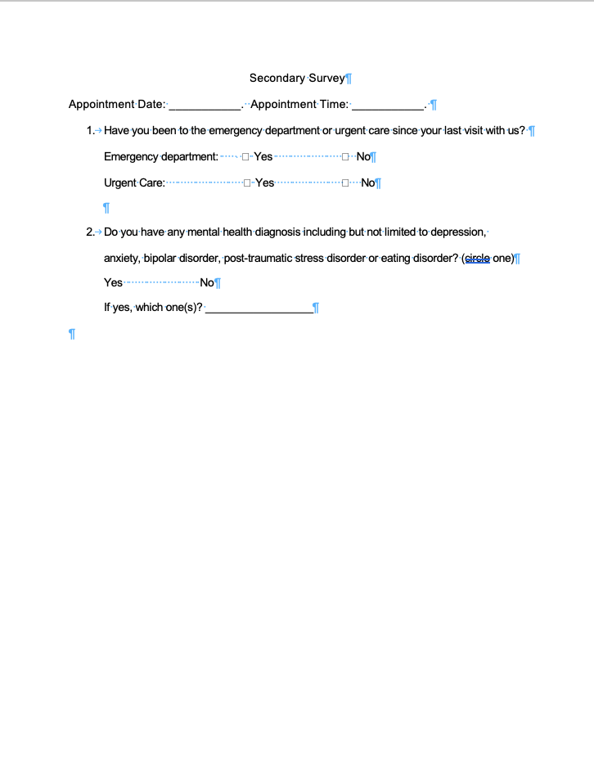

Appendix J
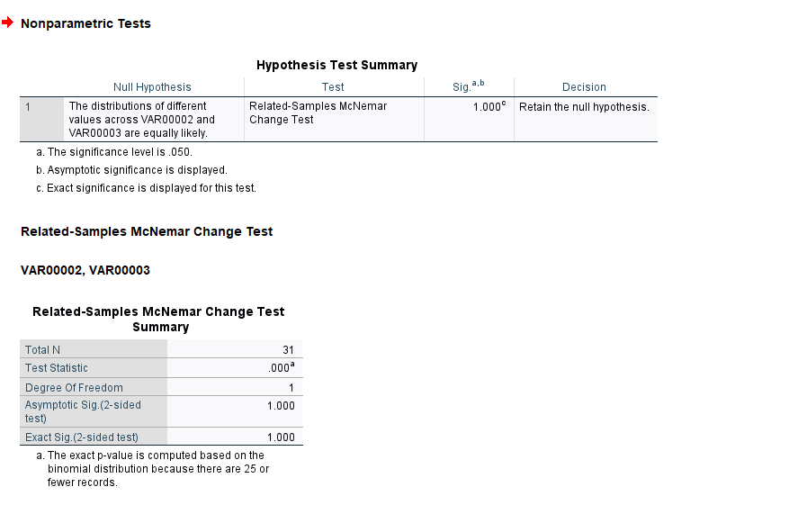
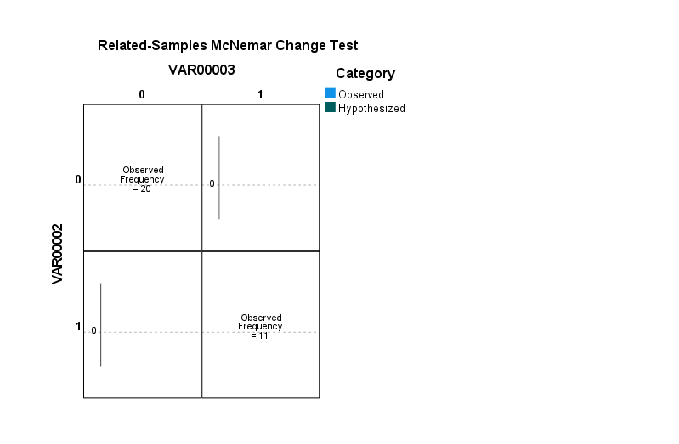
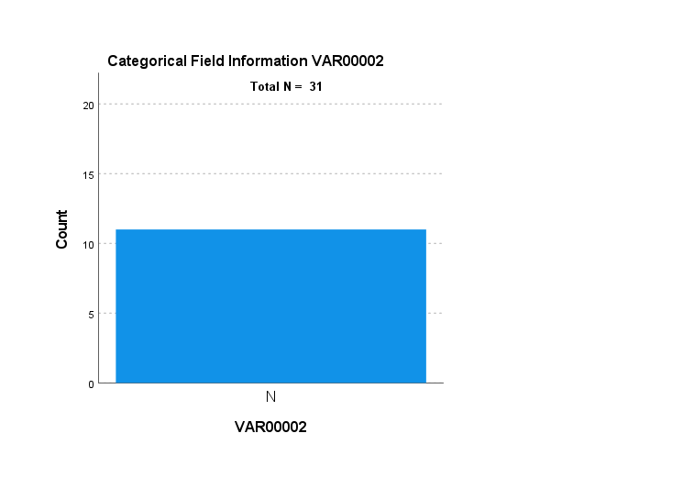
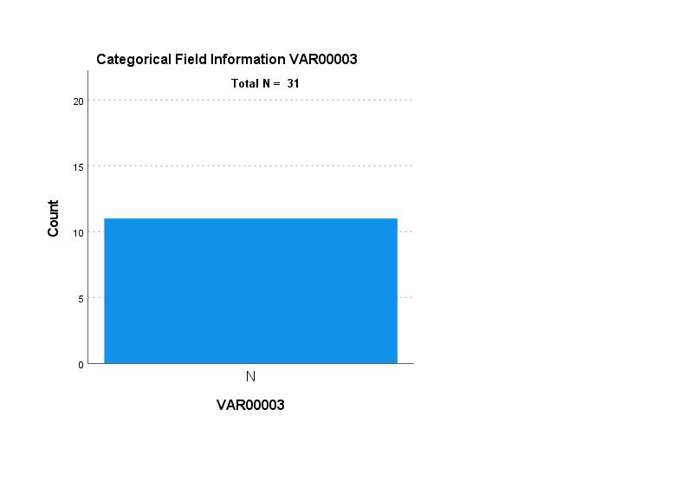

Appendix K
Institutional Review Board Approval
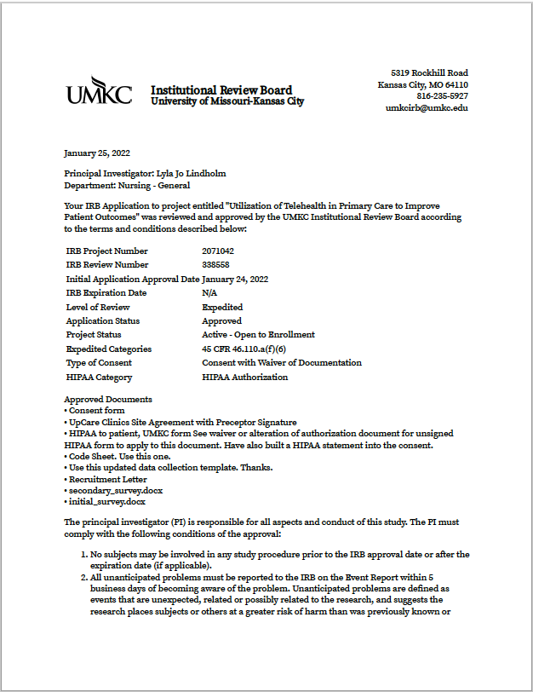
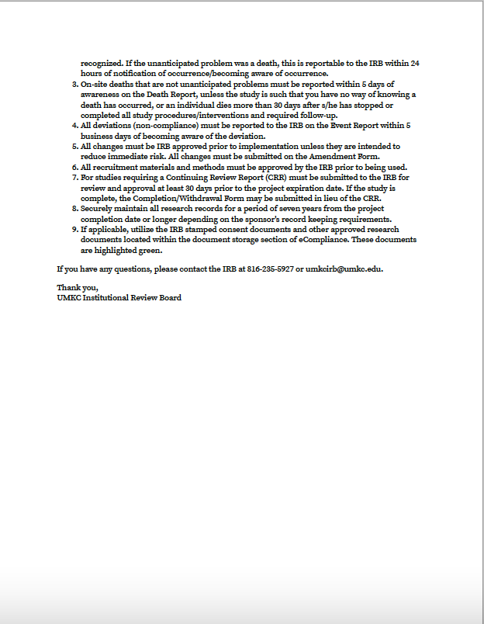

Appendix L
Consent
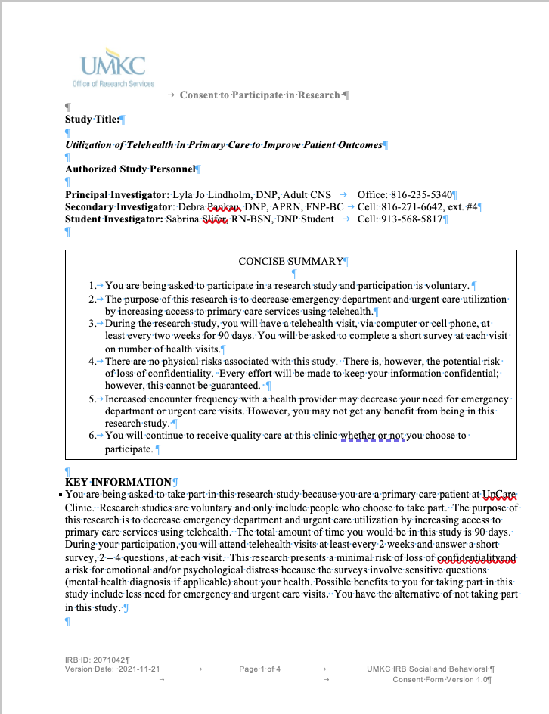
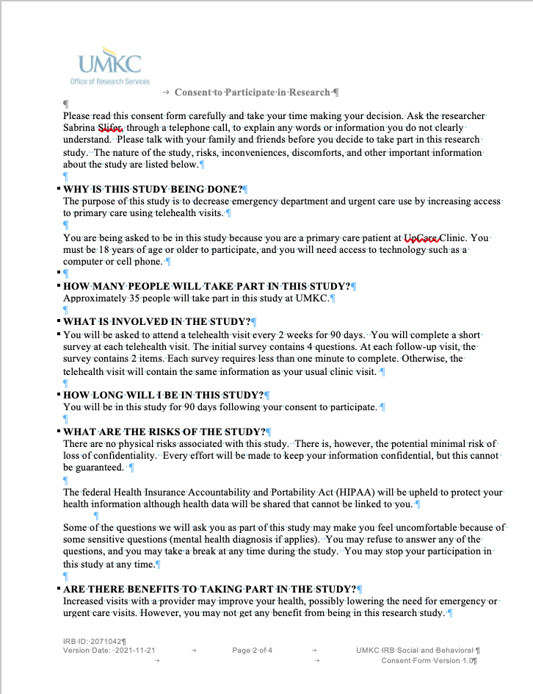

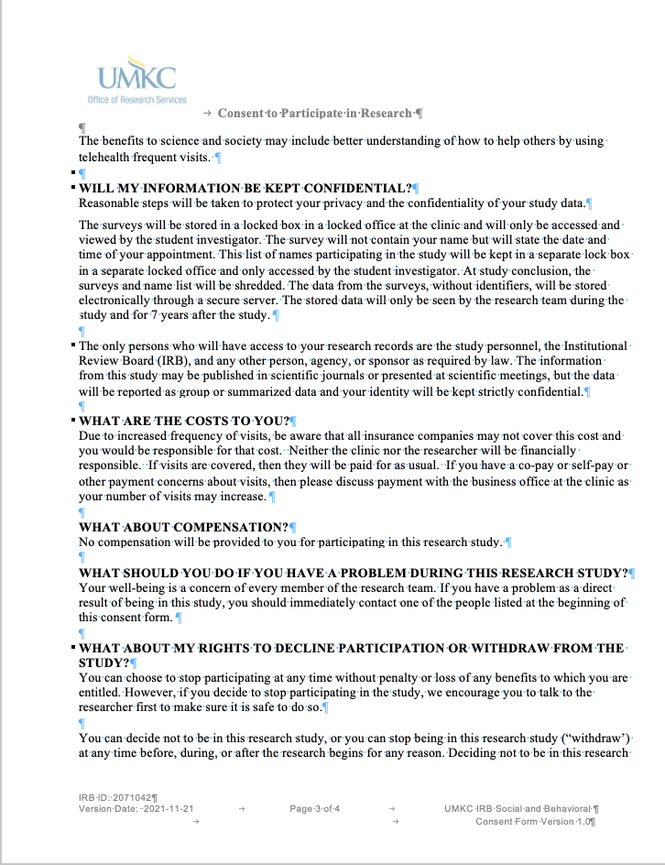

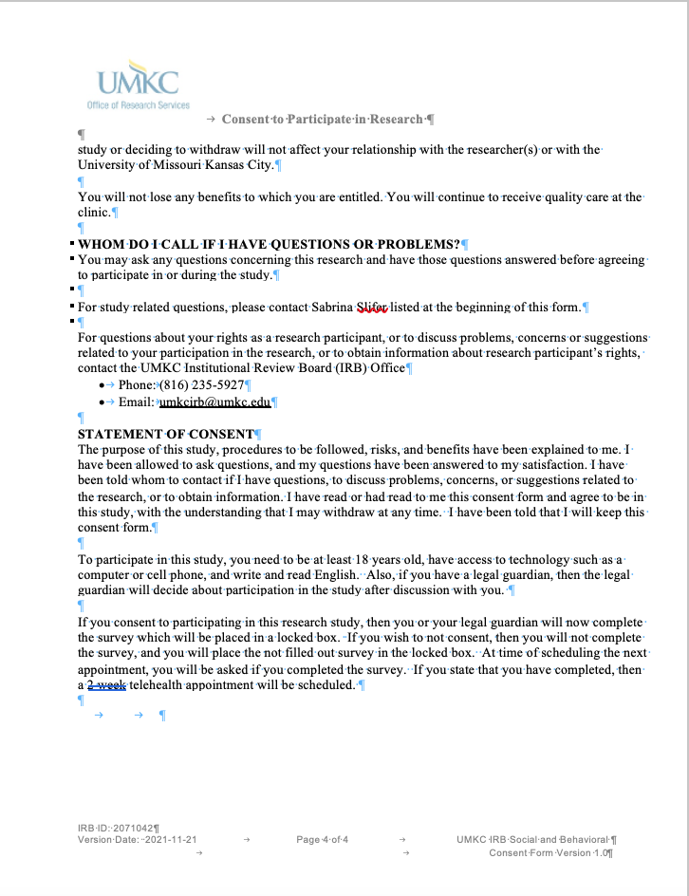

Appendix M
Initial Survey