The State of Maternal and Child Health in Kansas City: A Report

Emma Gilham
University of Missouri- Kansas City
Public Health Capstone 496
November 1, 2022

Acknowledgments
This research would not have been possible without the admirable work of Dr. Mariah Chrans and her dedication to providing accurate maternal, infant, and child health data to the Kansas City region through the works of Cradle KC.
Dr. Joseph Lightner is also to thank for his much-needed insights into carrying out a process of this magnitude. His advice was crucial to finishing this study, and his teaching inspired me to continue pursuing public health when I first arrived at UMKC.
Additionally, Renee Semarge is to thank for showing me how to be enthusiastic about public health. Her teaching has sparked a lifelong love for epidemiology within me.
I want to thank my friends for encouraging, listening, and empathizing with me. Adulthood can be isolating, but I know I have some of the most compassionate and generous friends cheering me on.
Finally, I want to thank my family for helping me through my higher education endeavors: financially, emotionally, physically, and socially. From preparing meals for me to endlessly listening to me talk about my projects, they have been supportive through it all. I absolutely could not have completed my time in undergraduate without the encouragement and love from others.

Contents
Abstract 5
Background: 5
Methods 5
Results 5
Conclusion: 6
Background: 7
Purpose Statement: 12
Methods: 13
Design 13
Data Sources 13
U.S. Census Bureau 14
March of Dimes 14
Annie E. Casey Kids Count Data Center 14
Missouri Public Health Information Management Systems 15
Missouri Department of Health and Senior Services 15
Missouri Department of Social Services 16
Kansas Information for Communities 16
Kansas Department of Health and Environment 16
Kansas Maternal Mortality Review Committee 17
Kansas Health Matters 17
Analysis 17
Results: 18
Demographic Data 18
Poverty 20
Disparities: 20
Maternal Mortality 20
Infant Mortality 21
Low-Birth Weight 25
Teen Births 26
Measurable Assets 27
Prenatal Care 27
Smoking Cessation 28
Family Planning 29
Insurance 30
Breastfeeding 33
Immunizations 33
Education 34
Discussion: 35
Assets 35
Disparities 37
Strengths 37
Limitations 38
Public Health Implications 39
Conclusion: 39

Abstract
Background: Maternal and child health (MCH) is an important aspect of a community’s health. Understanding how to improve MCH depends on knowing the needs of the community and the interventions that improve it. Cradle KC supported the creation of a MCH report for the eight counties surrounding Kansas City that they serve.
Methods: Data were gathered from public sources to formulate a report on MCH for the Kansas City region. Data for the MCH report were collected from: the Census Bureau, March of Dimes, the Annie E. Casey Kids Count Data Center, Missouri Public Health Information Systems, Missouri Department of Social Services, Kansas Information for Communities, Kansas Department of Health and Environment, Kansas Maternal Mortality Review Committee, and Kansas Health Matters. After being compared, analyzed, and formatted, the data were added into the report draft guided by an Asset Model approach.
Results: Between 2017 and 2019, Black women were three times more likely to die from pregnancy related causes in Missouri, and in Kansas, between 2016 and 2018, non-White minorities were nearly two times more likely to die a year after pregnancy than non-Hispanic White women. The average infant mortality rate for the region is 6.8 for every 1,000 live births. The average infant mortality rate for Black infants was over 4 times higher than White infants. The average percentage of births that were low-birth weight in the region was 7.5%. Teen birth counts in the region decreased between 2005 and 2020. Prenatal care initiation in the first trimester was at an average of 77.5%. Smoking during pregnancy between 2005 and 2020 had an average decrease of 7.7%. On average the percentage of births that were less than 18 months apart was 9.7%. The average rate of uninsured children in the region was 5.4%, and the average rate of breastfeeding initiation in the region is 88.7%. The average high school graduation rate was 89.8%.
Conclusion: Reducing racial disparities and continual work to prevent maternal and infant deaths are major priorities for the Kansas City region. Areas of improvement for the region include improving breastfeeding retention, and immunization rates. Additionally, access to health insurance and access to quality prenatal care must be intentionally improved in Jackson and Wyandotte counties to help reduce disparities. Data collection must be standardized to collect information on the same key indicators and social determinants of health across the region. Streamlining data dissemination should be a priority for all health organizations in the region that focus on maternal and child health in order to be more effective, informed, and timely with interventions.

Background:
In the United States, the average mortality rate from 2017 to 2019 for infants was 5.6 deaths for every 1,000 live births. Infant mortality rate measures the risk an infant is at of dying from the time of birth to up to a year after birth, and it is a key indicator of a community’s health (A.March of Dimes, 2020). There are numerous causes of infant mortality. The top causes for infant mortality in the U.S. are listed in order from highest to lowest incidence.
Top Causes of Infant Mortality in the U.S.
      - Birth defects (115 per 100,000)
      - Preterm birth (before 37 weeks completed gestation) and low-birth weight (LBW) (92.2 per 100,000)
      - Sudden infant death syndrome (SIDS) (33.3 per 100,000)
3. Maternal pregnancy complications (33.3 per 100,000)
      - Respiratory distress syndrome (11.5 per 100,000)
- March of Dimes, 2020)
In 2018, Black infants were born preterm at a rate of 14.1%. This was higher than the national average of 10% and the average rate for White infants and Hispanic infants at 9.1% and 9.7%, respectively (Beck et al., 2020). Black infants are at a higher risk of being born preterm and at a LBW, which can result in death.
Maternal mortality and morbidity reflect the shortcomings of public and clinical health. In the United States, the average maternal mortality rate between 2018 and 2020 was 20.4 for every 100,000 live births (B. March of Dimes, 2020). The U.S. has the highest maternal mortality when compared to other wealthy countries (Declercq & Zephyrin, 2020). Overall, there are numerous conditions that contribute to maternal mortality, related to different perinatal stages. In 2018, hemorrhages and cardiovascular conditions were the leading cause of death in pregnancy. During birth, infection caused the most deaths. The most imminent postpartum causes included mental health conditions and cardiomyopathy (Declercq & Zephyrin, 2020). The most imminent postpartum causes included mental health conditions and cardiomyopathy (Declercq & Zephyrin, 2020). Non-Hispanic Black women are at a three to four times higher risk of pregnancy related death than non-Hispanic White women (Collier & Molina, 2019). Understanding the scope and causes of maternal and infant mortality is vital to improving a population’s overall health.
Monitoring factors that influence infant and maternal mortality and morbidity can help stakeholders understand how to reduce the impact. Maternal morbidity and mortality are influenced by pre-existing conditions, age, lifestyle, multiple births, pregnancy complications, birth complications, race, ethnic, and socioeconomic background (A. NIH, 2020). Pregnancy complications include high blood pressure, gestational diabetes, infections, preeclampsia, preterm labor, mental health complications, fetal loss, and iron-deficiency (B. NIH, 2021). Pre-existing conditions that can make a pregnancy higher risk are cardiovascular disease, obesity, asthma, and compromised immune systems (A. NIH, 2020). Prevention efforts for maternal mortality and morbidity are often focused on mitigating these health factors. Infant mortality prevention efforts focus heavily on preventing preterm births, SIDS, and sleep-related deaths. Some non-clinical risk factors for preterm birth in the United States include being Black/African American, high stress levels, and using tobacco or narcotics (Zierden et al., 2021). Stress and substance use can be mitigated by public health prevention efforts. SIDS and other sleep related deaths are prevented by recommended safe sleeping procedures, skin-to-skin contact, and breastfeeding. Further, regular prenatal care, smoking cessation, and immunizations are also considered to decrease the likelihood of SIDs (Moon et al., 2016). Data on maternal and child health (MCH) must be gathered regularly and effectively to evaluate the state of these risk factors and prevention measures.
Cradle KC has the overarching goal to close the health equity gap for MCH in the Kansas City region. This region is comprised of eight counties in the metropolitan area: Leavenworth County, KS, Miami County, KS, Johnson County, KS, Wyandotte County, KS, Platte County, MO, Cass County, MO, Clay County, MO, and Jackson County, MO (map below). Cradle KC intends to accomplish their goal by cutting extreme preterm births, ending all preventable sleep related deaths, and reducing maternal smoking. Cradle KC also prioritizes developing best practices for data sharing in the region, creating integrated healthcare teams, and advocating for policies that work to close health equity gaps in maternal and infant care. Cradle KC’s initiatives are the Cradle KC Collective, a community action board, “My Life, My Plan” a family planning workbook, Every Baby to 1, and Plan Your Pause. To work towards achieving the best practice objective of improving data and data sharing in the KC metro, Cradle KC initiated the creation of a public report about the status of MCH in all eight counties.

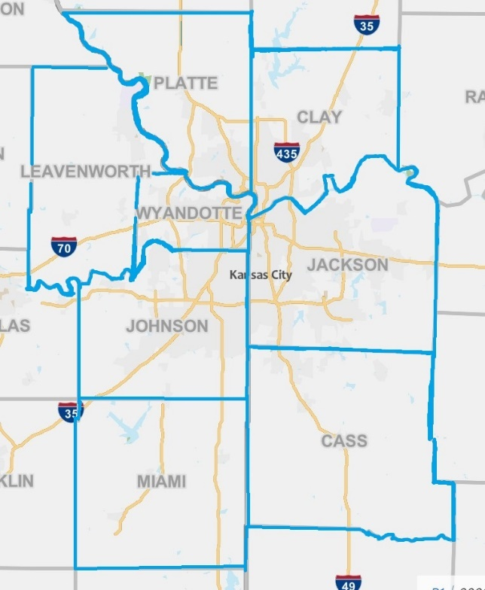
Figure 1: Region Map (U.S. Census Bureau)
Community trust is essential for Cradle KC’s work to be effective. Community trust in health organizations relies on many things. A review in 2021 found that forming trusted partnerships, investing in the community, and communicating and understanding the community were keys to securing community trust in medical institutions (Nandyal et al., 2021). These ideas of trust can also be applied to community health organizations. Forming strong partnerships with other organizations with the community’s trust helps with positive association. Cradle KC has done this through their Every Baby to 1 initiative to promote safe sleeping practices through partnerships with faith-based communities. Investing in the community demonstrates willingness to put policy into action. Transparent and open communication with the community is necessary to ensure programs and services are meeting needs. The MCH report is a form of communication with the public. Releasing data allows the community to evaluate the effectiveness of health systems. The creation of the maternal and child health report shows an invested interest in the community and gives the public an opportunity for reflection on the state of health in the community.
The Cradle KC MCH report was guided by the Health Asset Model (AM). The AM prioritizes health solutions and centering the voices of the community. This framework has three phases: assessment, action, and evaluation. The assessment phase is used to understand a community’s protective factors or assets (Morgan & Hernán, 2013). This project’s assessment phase identifies assets and burdens to the community. However, a traditional AM does not assess problems within the target population. It was necessary to identify both assets and burdens in order to use the data available to the public which generally shows health deficits. Another reason disease burden needed to be shown was to accurately display disparities in MCH for the entire region. The action phase of the AM puts into practice the protective factors that were identified in the assessment (Morgan & Hernán, 2013). For the MCH project, the action phase would be releasing information to the public and community health organizations to improve best practices. Finally, the evaluation phase is necessary to see how an intervention is received by the target audience (Morgan & Hernán, 2013). The evaluation for the MCH report would be Cradle KC assessing whether any structural, organizational, or policy changes are adopted due to the information in the report. Overall, the MCH report’s Health Asset Model was chosen as the framework to release data in a productive manner that leads the stakeholders to solutions.
Assets in the community were identified by the Program Director of Cradle KC. Measurable assets were breastfeeding programs/support, family planning methods, prenatal care initiation, WIC, Medicaid, home visiting, smoking cessation, education. Available data were collected on these topics. Other assets to the community are delivery centers, postpartum expansion, home visiting programs (Promise 1000), maternal mortality reviews, fetal/infant review committees in Kansas, Nurture KC, New Birth Company, Baobab Tree Midwives & Doulas, Uzazi Village, and doula groups.
Purpose Statement: This project’s purpose is to create an initial draft of Cradle KC’s MCH report in Kansas City by gathering publicly available data in key indicators of MCH. The intention of the report is to educate the community and health organizations on the status of MCH in the region, improvements that can be made, and future steps to take in improving MCH. Improving maternal, infant, and child health, reducing the associated disparities, and streamlining data dissemination should become all community-level goals after the release of this report.

Methods:
Design
This is a longitudinal secondary data study to describe maternal and child health indicators in the Kansas City metropolitan region. Initially, the timeliest data was prioritized (2018-2022), but several indicators required looking at trends over time (2005-2020). The most recent data available were used to inform each data point. The data varied from state to state and among different indicators. Because of this variability, comparability between the data and between counties was the focus of processing the data collected

Data Sources
Data for the MCH report were collected from: the Census Bureau, March of Dimes, the Annie E. Casey Kids Count Data Center, Missouri Public Health Information Systems, Missouri Department of Health and Senior Services, Missouri Department of Social Services, Kansas Information for Communities, Kansas Department of Health and Environment, Kansas Maternal Mortality Review Committee, and Kansas Health Matters. Cradle KC uses key indicators to measure success in MCH. For birthing people and children these indicators include measuring maternal/infant wellness, maternal education, maternal support (personal/ professional), breastfeeding, safe sleeping, substance use (including smoking), intimate partner and domestic violence, insurance, housing, and food access (Cradle KC). The MCH report was formulated to collect available data that pertains to these categories. All the data compiled in the report draft was released between the years of 2015 and 2022 and publicly accessible at the time of research. This project’s scope of information was for the eight-county region that Cradle KC serves. Data collection between states was a major challenge as Kansas and Missouri gather information with different indicators and measurements.

U.S. Census Bureau
The United States Census Bureau contains population and demographic information from both Kansas and Missouri. The Census Bureau surveys the national population for data collection. The MCH report used population, population under 5, population by race, children in poverty counts and rates from the Census Bureau to give an overview of the region. All data were from 2020. Data were aggregated from the American Community Survey and the 2020 Census.

March of Dimes
March of Dimes Perinatal Data Center contains national, state, and county data on maternal and infant health. The goal of March of Dimes information is to improve maternal and infant health outcomes. The MCH report used March of Dimes information to describe the causes of infant death in the Kansas and Missouri in 2019. The data are aggregated from nine government agencies and health organizations: Centers for Disease Control and Prevention (CDC), National Center for Health Statistics (NCHS), National Center for Chronic Disease Prevention and Health Promotion, National Center for HIV, STD and TB Prevention, Centers for Medicare and Medicaid Services (CMS), Health Resources Services Administration (HRSA), Substance Abuse and Mental Health Services Administration (SAMHSA), National Birth Defects Prevention Network (NBDPN), and the Robert Wood Johnson Foundation (RWJF)

Annie E. Casey Kids Count Data Center
The Annie E. Casey Kids Count Data Center contains information on both Kansas and Missouri maternal and infant health by county. The data were compiled to focus on women, children, and families. Several data points were broken down by race and ethnicity. Dates of data varied in this source. The MCH report used 2019 high school graduation rates, 2020 child population under 18 in KS, 2019 child population under 18 by race (KS) and minority populations (MO), 2019 uninsured children under 19, 2021 children under 19 in Kansas on CHIP and Medicaid, 2015-2020 LBW infants in Missouri by county, 2019 Kansas infant mortality rate, 2015-2019 infant mortality rate in Missouri, 2019 Kansas infant mortality rate by race, 2019 Kansas breastfeeding initiation rates, 2018 Kansas child immunizations, and 2020 Kansas early head start and head start rates from Kids Count to give a picture of MCH indicators in the region. This data were aggregated from public sources such as: U.S. Census Bureau, Kansas Department of Health and Environment, Kansas State Department of Education, Missouri Department of Health and Senior Services, Missouri Department of Elementary and Secondary Education, Missouri Department of Social Services.

Missouri Public Health Information Management Systems
The Missouri Public Health Information Management Systems (MOPHIMS) contain public health data for Missouri by county. Data profiles and Missouri Information for Community Assessments (MICAs) were both used to collect maternal, infant, and child health information from the database. The MCH report used the 2020 WIC infant immunizations not up to date, 2020 child population under 18, 2020 gendered population percentages, 2005-2020 teen birth counts, 2005-2020 smoking statuses of pregnant women percentages, 2020 first trimester prenatal care initiation percentages, 2020 inadequacy of prenatal care, 2019 breastfeeding initiation percentages, 2020 birth spacing of less than 18 months, and 2015-2019 infant mortality rates by race (“White” and “Black”) from MOPHIMS to give a picture of the factors that influence Missouri’s maternal and infant health. The data were aggregated from the Missouri Department of Health and Senior Services (MODHSS).

Missouri Department of Health and Senior Services
Missouri Department of Health and Senior Services with the Pregnancy Associated Mortality Review (PAMR) was a source of information on maternal health in Missouri. This information focused on maternal mortality and severe morbidity. The MCH report used the number of maternal deaths in 2018 and the percentage of preventable deaths in 2017-2019. Data for the MCH report were collected from “A Multi-Year Look at Maternal Mortality in Missouri, 2017- 2019 Pregnancy- Associated Mortality Review: Annual Report” (2022).

Missouri Department of Social Services
The Missouri Department of Social Services contains information on child health and insurance statuses, some of which is released by county. The MCH report used the 2015 child eligibility for CHIP enrollment. This was the only insurance information found for Missouri counties. The data were aggregated from the department’s data collection and released on their website.

Kansas Information for Communities
Kansas Information for Communities (KIC) contains vital and health statistics information for Kansas by county. Birthing people and infants were the population the data set focused on. The MCH report used 2020 gendered population percentages, 2020 number of deliveries with different insurance coverages, 2005-2020 teen birth counts, 2005-2020 smoking during pregnancy percentages, 2020 first trimester prenatal care initiation percentages, 2020 adequacy of prenatal care, and 2020 percentages of birth spacing of less than 18 months from KIC queries to give a picture of the factors that impact maternal and infant health in Kansas. Data were aggregated from the Bureau of Epidemiology and Public Health Informatics within the Kansas Department for Health and Environment (KDHE).

Kansas Department of Health and Environment
KDHE collects data on the overall health of Kansas residents per county. The KDHE Annual Summary of Vital Statistics Report 2020 was used to collect the number of infant deaths per county for 2016-2018. Data were collected from local health sources that report to the state health department.

Kansas Maternal Mortality Review Committee
The Kansas Maternal Mortality Review Committee alongside KDHE was a data source for maternal health. The information focused on was maternal mortality and severe maternal morbidity. The MCH report used the number of maternal deaths in 2018 and preventable maternal death percentages for 2016 and 2018. Data for the MCH report were collected from the Kansas Maternal Mortality Report 2016-2018.

Kansas Health Matters
Kansas Health Matters contains statistical data on indicators of health in Kansas by county. The MCH report collected data for 2018-2020 LBW infant percentages, 2020 percent of WIC participants that breastfed for 6 months, and the 2017-2018 percent of infants fully immunized by 24 months old in Kansas. This information was used to supplement Kansas data for infant health. Kansas Health Matters has a large database of public sources.

Analysis
Data were compiled and organized into a table. Each column was a county in which the correlating data were entered underneath. Calculations were made to get digestible percentages and rates, if needed. Rates were compared by dividing the larger rate by the smaller rate. Charts and graphs were created using Canva, Google Sheets, and Microsoft PowerPoint (through Excel). These programs allowed for various styles and color schemes to be explored.

Results:

Demographic Data
Table 1
2020 Population by Race per 100
County | Total population | White | Black | American  Indigenous | 2+  Races | AAPI | Other
Leavenworth | 81,881 | 78.9 | 8.4 | 0.9 | 8.7 | 1.5 | 1.6
Wyandotte | 169,245 | 43.6 | 20.4 | 1.1 | 14.9 | 4.8 | 15.2
Miami | 34,191 | 90.4 | 1.3 | 0.5 | 6.4 | 0.5 | 0.9
Johnson | 609,863 | 77.6 | 4.7 | 0.4 | 8.7 | 5.5 | 3.1
Jackson | 717, 204 | 60.8 | 22.1 | 0.6 | 9.1 | 2.4 | 5
Platte | 106,718 | 78.3 | 7.8 | 0.5 | 9.1 | 3.3 | 2
Clay | 253,335 | 78.4 | 7.2 | 0.6 | 8.2 | 2.8 | 2.3
Cass | 107,824 | 84.5 | 4.7 | 0.5 | 7.7 | 0.9 | 1.8

Jackson County has the highest population overall, but Johnson County has the highest population in the Kansas region and the second highest overall. The smallest overall population count was found in Miami County with the next smallest county being Leavenworth at over 2 times Miami’s population. The most racially diverse county is Wyandotte.
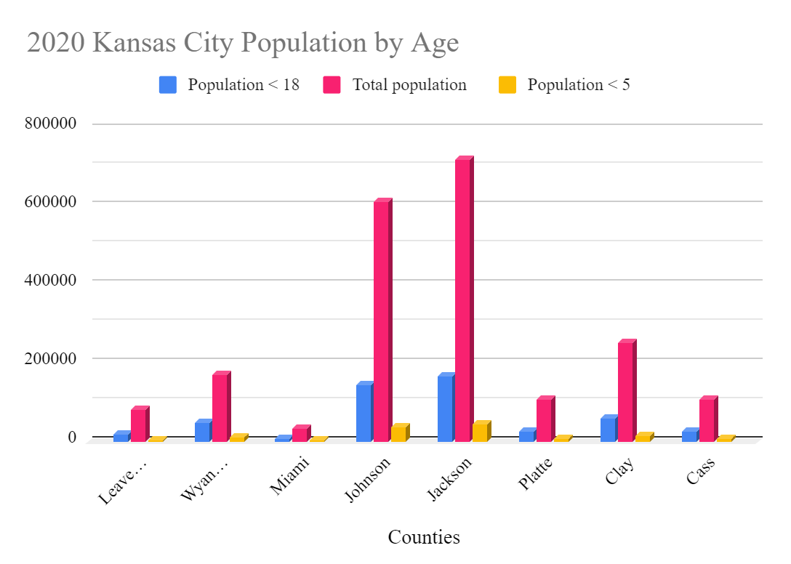
Figure 2: 2020 Kansas City Region Population by Age
The majority of the region’s children under 18 and under 5 come from Johnson and Jackson Counties.

Poverty

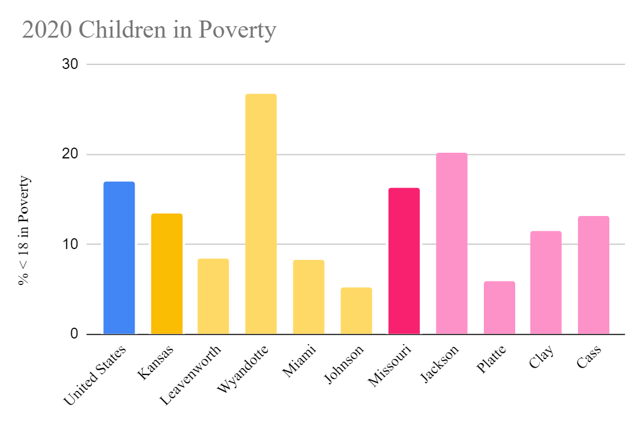
Figure 3: Children in Poverty
Data were collected to understand how the region compares to their states and nationally when it comes to children under 18 at or below the Federal Poverty Line. Jackson County (20.2%) has the highest percentage of children in poverty in the Missouri counties. Wyandotte County at 26.7% has the highest child poverty rate in the region, and Johnson County at 5.2% has the lowest child poverty rate overall. In Wyandotte County over a fourth of their children live in poverty, and the child poverty rate is nearly two times higher than Kansas overall.

Disparities:

Maternal Mortality
In 2018, there were 17 maternal deaths in Kansas and 68 maternal deaths in Missouri. These deaths occurred up to a year after pregnancy, and they have either related, associated, or had unknown connectedness to pregnancy. Maternal mortality is categorized into pregnancy-associated and pregnancy-related deaths. Pregnancy associated deaths happen within 1 year postpartum. Pregnancy-related deaths are considered deaths directly attributed to pregnancy. Pregnancy associated deaths can be considered related or not. 75% of pregnancy-related deaths in Missouri were considered preventable between 2017 and 2019. 92.3% of pregnancy related deaths in Kansas were considered preventable between 2016 and 2018. Between 2017 and 2019, Black women were three times more likely to die from pregnancy related causes in Missouri. In Kansas, between 2016 and 2018, non-White minorities were nearly two times more likely to die a year after pregnancy than non-Hispanic White women.

Infant Mortality
Table 2: Infant Mortality by County
Kansas 2019 | Infant mortality rate per 1,000
Leavenworth | 7.9
Wyandotte | 7.7
Miami | 6.2
Johnson | 4.5
Missouri 2015-2019 | Infant mortality rate per 1,000
Jackson | 7.9
Platte | 6.8
Clay | 6.6
Cass | 7.1

Jackson and Leavenworth counties had the highest infant mortality rates at 7.9, and Johnson County had the lowest overall infant mortality rate at 4.5. The average infant mortality rate for the region is 6.8 for every 1,000 live births.
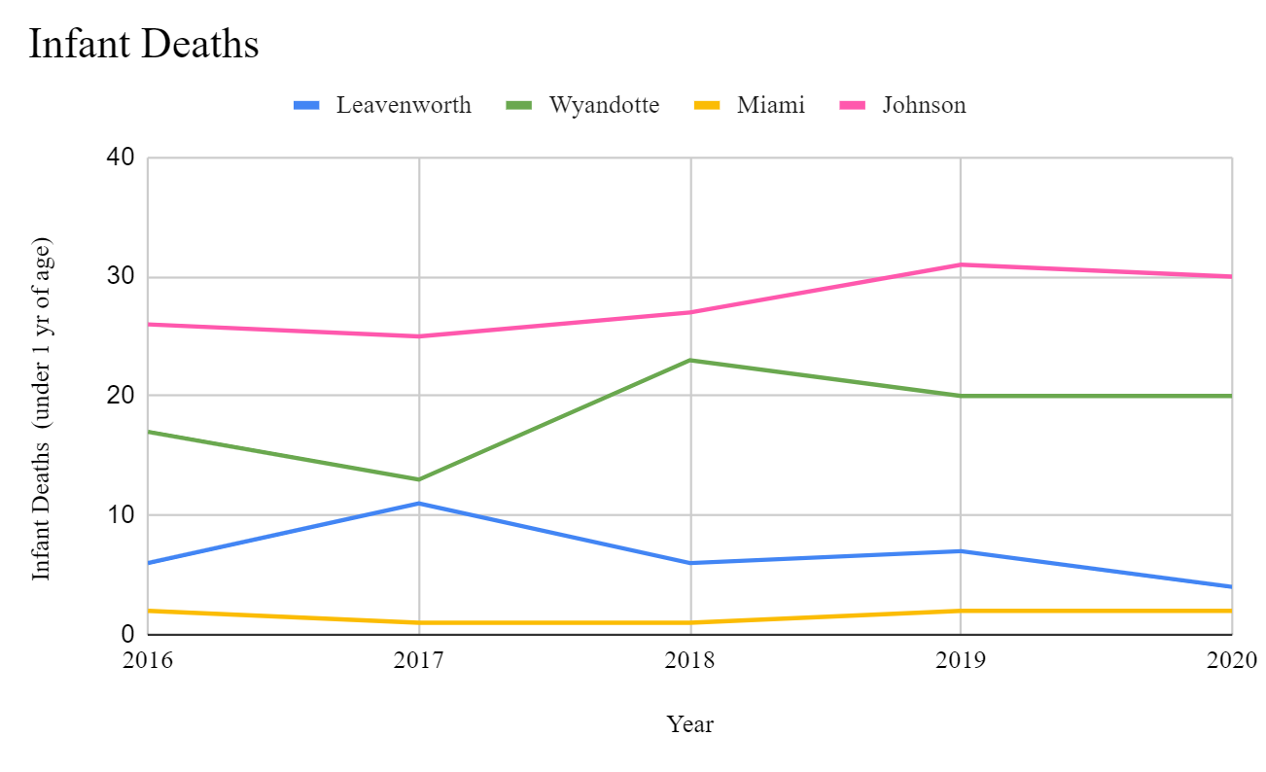
Figure 4: Infant Deaths
The number of infant deaths was only publicly available for Kansas counties. The counts increased in Johnson and Wyandotte but decreased in Leavenworth.

Kansas Infant Mortality by Race
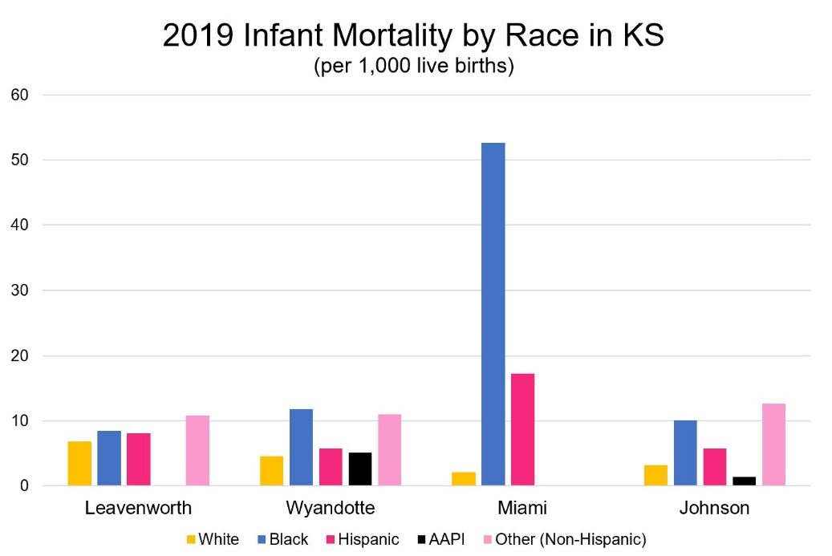
Figure 5: Kansas Infant Mortality Rates by Race
Racial disparities are evident in the infant mortality data when dispersed by race. All counties in Kansas displayed disproportionate mortality in Black and Hispanic populations when compared to White mortality. In Miami County, Black infants, with an infant mortality rate of 52.6 per 1,000, are approximately 25 times more likely to die than White infants, with an infant mortality rate of 2.1. Hispanic infants were 8.2 times as likely to experience mortality when compared to White infants. In Wyandotte County, 20.4% of the population is Black, but Black infants are still 2.6 times more likely to die when compared to White infants. Leavenworth and Johnson counties’ highest infant mortality rates were in the “Other (Non-Hispanic)” category. In Johnson County, infants in the “Other (Non-Hispanic)” category are nearly 4 times as likely to experience mortality as White infants. In Leavenworth County, infants in the “Other (Non-Hispanic)” category were 1.6 times as likely to experience mortality as White infants.

Missouri Infant Mortality by Race
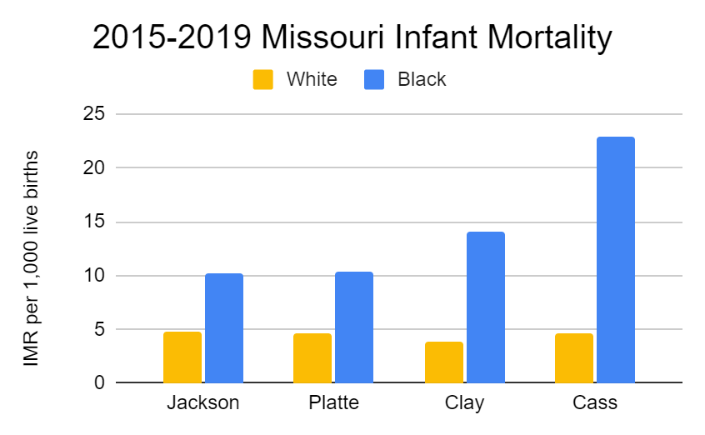
Figure 6: Missouri Infant Mortality Rates by Race

Data for race and infant mortality rates in Missouri counties were only found for White and Black infant deaths. In every county, Black infants were more than 2 times more likely to experience mortality than their White counterparts. The largest gaps between Black and White infants were found in Clay and Cass counties.
The average infant mortality rate for Black infants in the entire 8 county region was 17.6 and the White infant mortality rate was 4.3. Black infants are on average over 4 times more likely to die than White infants in their first year of life. The median infant mortality rates by race were 4.6 for White infants and 11.1 for Black infants.

Low-Birth Weight
Table 3: Percent of Low-Birth Weight Infants by County
Kansas Counties | LBW 2018- 2020
Leavenworth | 7.1%
Wyandotte | 9.7%
Miami | 7%
Johnson | 6.6%
Missouri Counties | LBW 2015-2019
Jackson | 9.2%
Platte | 6.5%
Clay | 6.8%
Cass | 7.3%

The highest percent of low-birth weight infants were in Wyandotte County at 9.7%, and the lowest percent was in Platte County at 6.5%. The average percentage of births that were low-birth weight in the region was 7.5%.

Teen Births
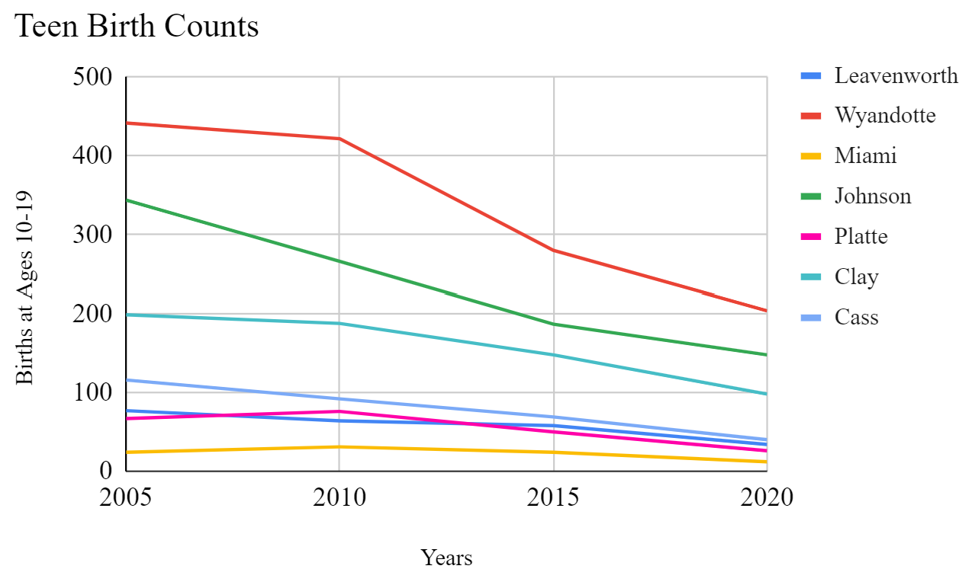
Figure 7: Teen Births Over Time

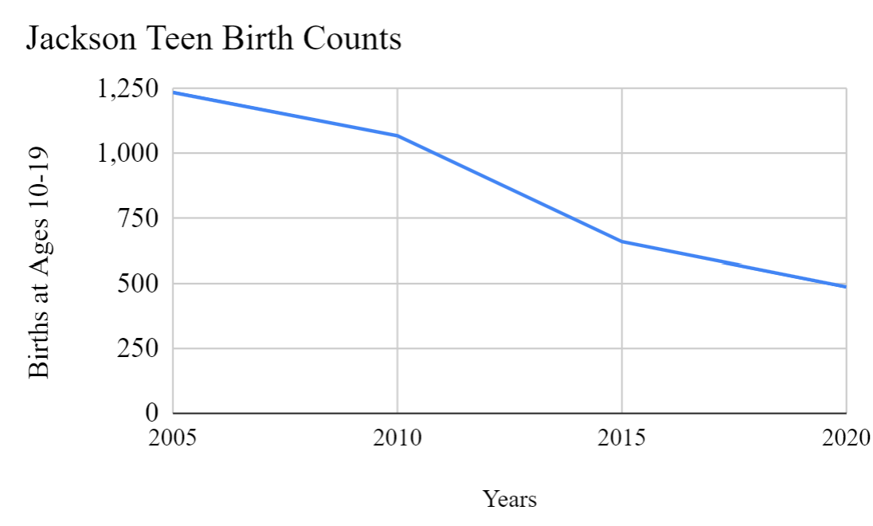
Figure 8: Teen Births Over Time (Jackson County)
Counts in all counties decreased overall. Jackson County was separated from the region to allow for more visibility in the graph. Note the difference in the graph’s axis than that of the combined counties’ graph. Teen births in Jackson County were higher in 2020 than the starting point for every other county in 2005.

Measurable Assets

Prenatal Care

Figure 9: Prenatal Care Initiation and Quality

Prenatal care initiation in the first trimester was overall higher in Kansas at an average of 82.3%, and for Missouri counties, the average was 72.7%. The overall average for the region is 77.5% prenatal care initiated in the first trimester. The lowest rates of initiation were in Jackson County (66.1%) and Wyandotte County (66.7%). Kansas counties measure the quality of prenatal care by adequacy, but Missouri counties measure quality of prenatal care by inadequacy. Both states measure quality using the Kotelchuck index, but there are no data on the percentage of adequacy in Missouri or the inadequacy in Kansas. Jackson County and Wyandotte County have the highest rate of inadequacy and the lowest rate of adequacy at 22.3% and 41.4%, respectively.

Smoking Cessation

Figure 10: Smoking During Pregnancy Over Time
Over fifteen years, all counties in the region reduced smoking during pregnancy. The largest decrease can be seen in Leavenworth County with a decrease of 12.6% in smoking during pregnancy. The smallest decrease of 4.9% was in Johnson County. Johnson also had the lowest rate overall between 2005 and 2020. In 2020, Cass County had the highest rate, and average rate of smoking during pregnancy for all counties was 6.6%. The regional average decrease was 7.7%.

Family Planning
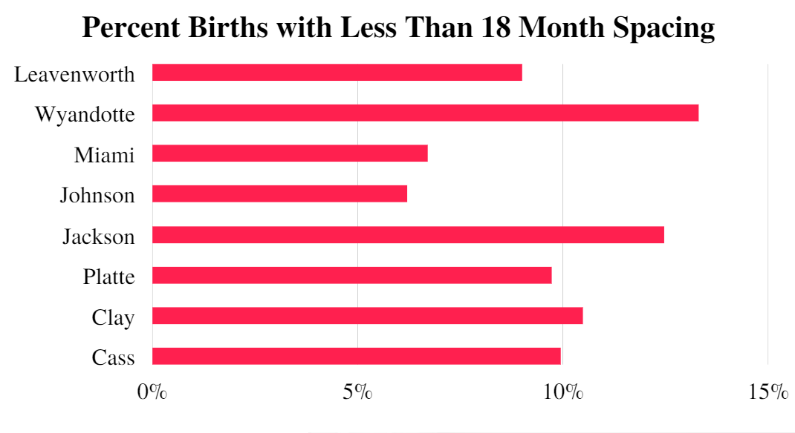
Figure 11: Family Planning (2018-2020 (KS) and 2015-2020 (MO))
On average the percentage of births that were less than 18 months apart was 9.7%. The county with the lowest percentage of births less than 18 months apart was Johnson (6.2%). The county with the highest percentage of births less than 18 months apart was Wyandotte (13.3%).

Insurance
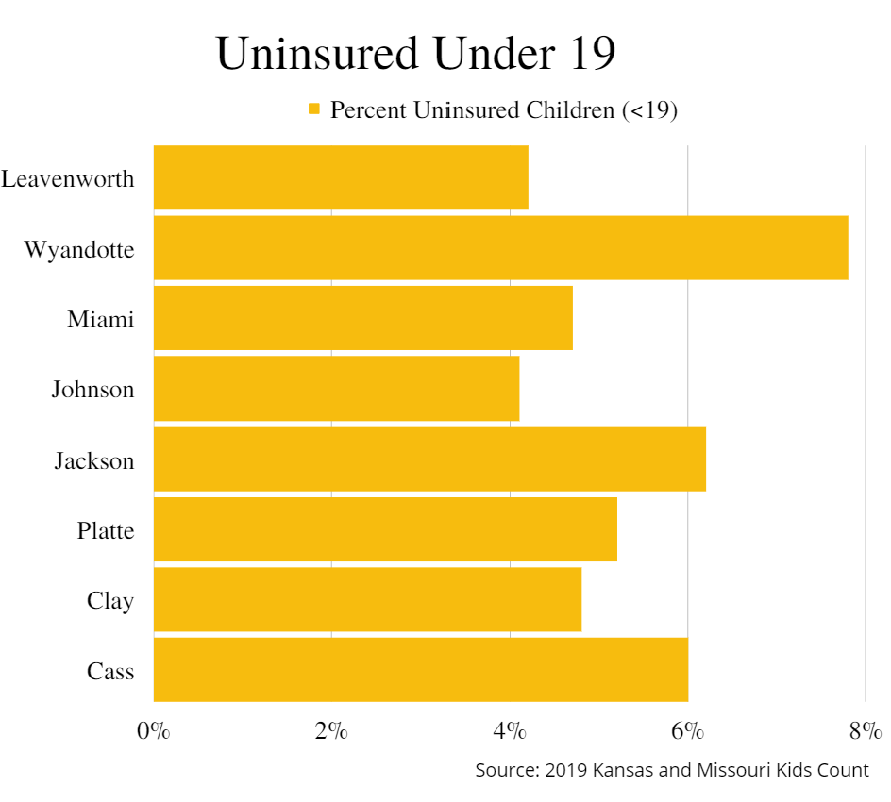
Figure 12: Percentage of Uninsured Children
The highest rates of uninsured children are in Wyandotte County at 7.8%, and the lowest rates of uninsured children are in Johnson County at 4.1%. The average rate of uninsured children in the region was 5.4%.
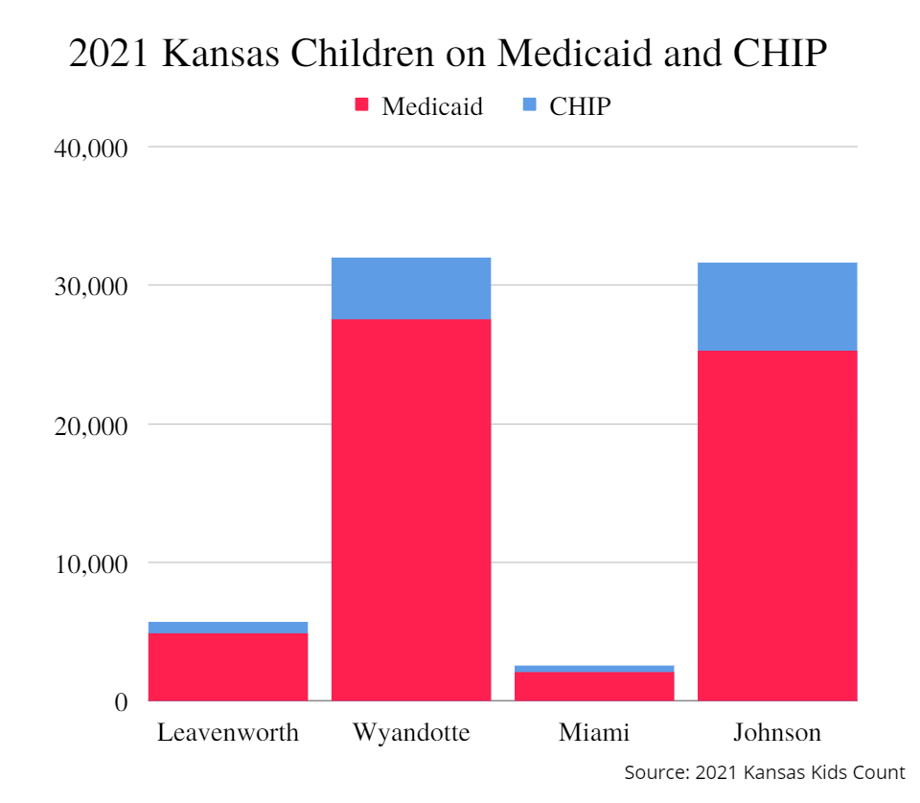
Figure 13: Kansas Medicaid and CHIP Recipients (<19)
In 2021, there were many children under 19 on Medicaid and Child Health Insurance Plans (CHIP). The highest numbers were in Wyandotte and Johnson counties with 31,942 and 31,576 children, respectively. The lowest number of children, 2,518, was in Miami County (KS Kids Count 2021).
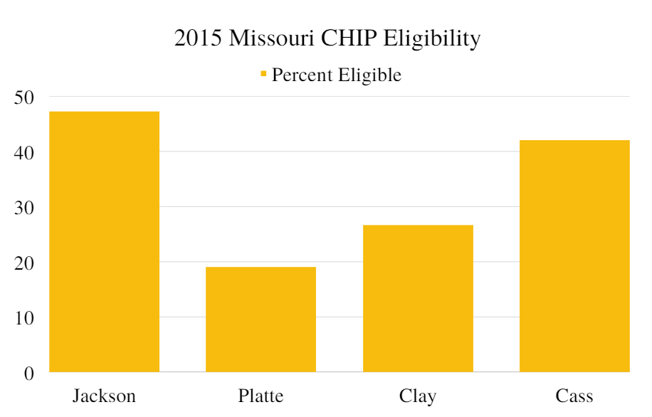
Figure 14: CHIP Eligibility in Missouri
The data available for insurance in Missouri were the percentages of children under 18 in each county eligible to enroll in the Children's Health Insurance Program (CHIP) in 2015. These were 47.2% in Jackson, 42% in Cass, 26.6% in Clay, and 19% in Platte. Because of the age of this data, the status has likely changed.
Table 4: Payment Types for Deliveries in Kansas
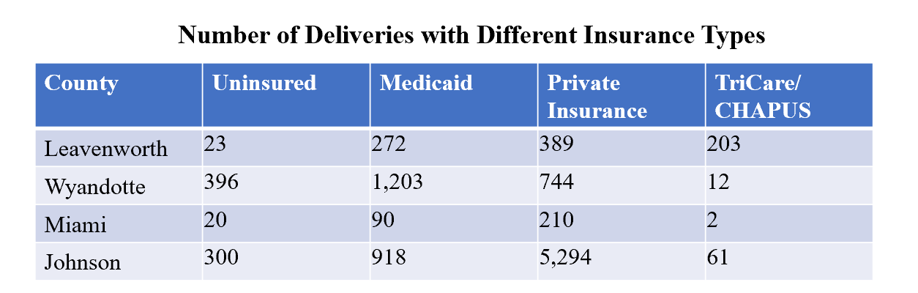
In 2020, Wyandotte County had the highest number of uninsured and Medicaid insured deliveries. The number of those giving birth on Medicaid was higher than those with private insurance and TriCare/CHAPUS combined. Miami County had the lowest number of uninsured and Medicaid insured deliveries. Johnson County had the highest number of deliveries with private insurance.

Breastfeeding
Breastfeeding initiation happens in the hospital after delivery. The highest rate of breastfeeding initiation in the region was in Johnson County at 95%. The lowest rate of breastfeeding initiation was in Jackson County at 78.5%. The average rate of initiation in the region was 88.7%.
The percentage of women in the WIC program that were breastfeeding at 6 months was publicly available for the Kansas counties. The average rate of only breastfeeding for WIC mothers was 13.8%. The highest rate was 16.6% in Leavenworth County and the lowest rate was in Wyandotte County at 8.9%.

Immunizations
Table 5: Immunization Data
Kansas Counties | Children Fully Immunized, 2018 | Infants Fully Immunized by 24 Months, 2017-2018
Leavenworth | 63% | 66%
Wyandotte | 63% | 66%
Miami | 43% | 42%
Johnson | 81% | 77%
Child immunization data were publicly available only for Kansas counties. The highest immunizations rates in Kansas were in Johnson County. The lowest immunization rates in Kansas were in Miami County.
Table 6: WIC Infant Immunizations Not Up To Date
Missouri Counties | % WIC Infant Immunizations Not Up To Date, 2020
Jackson | 29%
Platte | 50%
Clay | 31%
Cass | 12%
In Missouri, the highest percent of WIC infants not up to date on their vaccines was found in Platte County, but the lowest percent was in Cass County.

Education
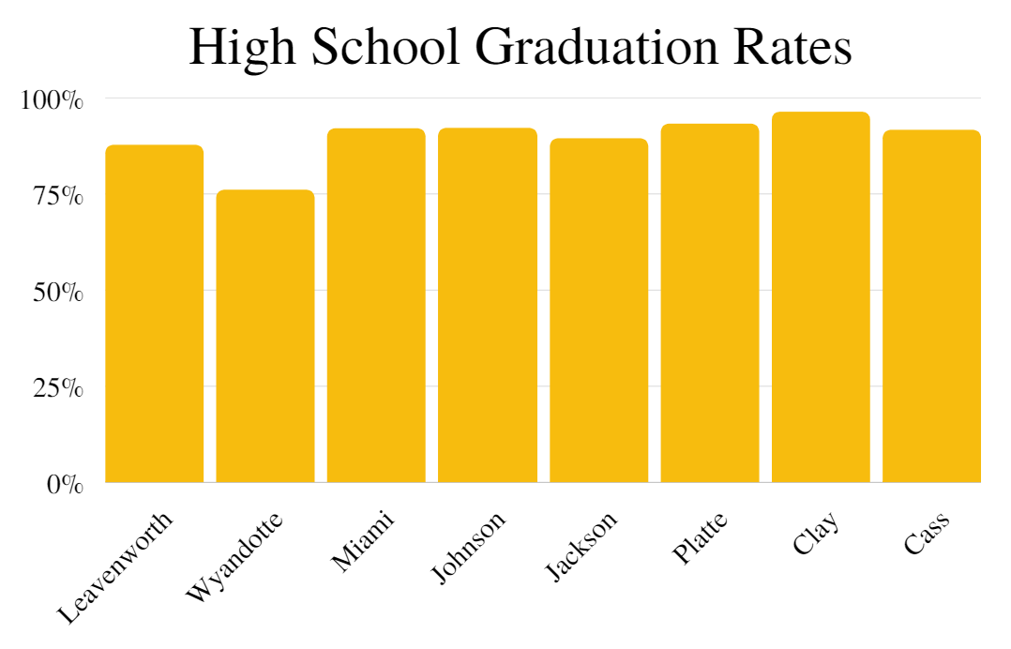
Figure 15: High School Graduation Rates
In 2019, the average high school graduation rate was 89.8%. The highest rate was 96.3% in Clay County, and the lowest rate was 76% in Wyandotte County.
Table 7: Early Childhood Education in Kansas
Kansas Counties | Early Head Start | Head Start
Leavenworth | 6.5% | 17.7%
Wyandotte | 11.1% | 42.5%
Miami | 8.0% | 50.0%
Johnson | 9.9% | 34.2%
Early Head Start and Head Start percentages were only available for Kansas counties and from the year 2020. The average attendance for Early Head Start was 8.9% of children aged 3 to 4. The average percent of children eligible to attend Head Start that attended was 36.1%.

Discussion:
The purpose of this study was to evaluate MCH in the Kansas City region to improve maternal, infant, and child health, reduce the associated disparities, and promote streamlining data dissemination. The research results showed disparities in maternal and infant mortality and low-birth weights. Assets to MCH were prenatal care initiation and quality, smoking cessation, family planning, insurance, immunizations, and education.

Assets
Many maternal and infant health morbidities and deaths are preventable. In fact, the majority of pregnancy-related deaths in Kansas (2019) and Missouri (2016- 2018) were considered preventable (KDHE & MODHSS). Assets to MCH like prevention methods can help reduce negative health outcomes for people that give birth and infants. Preconception prevention involves family planning and delaying the age at first pregnancy (Bhutta et al., 2014). Over time, teen births have decreased in the metropolitan area. This drop may be connected to the availability of pregnancy prevention services. One service is Teen Primary Care at Children’s Mercy hospital that helps teens explore birth control options (Children’s Mercy, n.d.). Nationally, among 15 to 19-year-olds, the use of highly effective contraceptive methods and emergency contraception has increased (Livingston & Thomas, 2019). Another method of effective prevention, specifically for reducing preterm and low-birth weight infants, is reducing or quitting smoking before or during pregnancy (Bhutta et al., 2014). In the Kansas City region, smoking during pregnancy was another indicator that decreased over time. Reducing teen births and smoking during pregnancy has been an improvement in Kansas City.
Access to healthcare is understood through insurance coverage. Measuring rates of uninsured children can give an idea of child healthcare access in the region. Medicaid is an asset to people in the community, but extended coverage postpartum would be helpful in addressing maternal health concerns that arise after the infant is born (Declercq & Zephyrin, 2020). Currently, Medicaid has been expanded in Missouri, but not in Kansas. The number of deliveries by various insurance sources can show how much Medicaid is utilized by families. Data was only available for Kansas, but Wyandotte County had the highest Medicaid utilization for deliveries (KIC, 2020).
Child health is dependent on innumerable factors. Early education serves an important purpose in sustaining cognitive, social, and emotional development. They can also screen children early for health and learning concerns, which may lead to earlier interventions (Schiariti et al., 2021). Immunizations are another asset to a child’s health. Receiving immunizations is an effective way to decrease incidence of disease and vaccine-preventable disease outbreaks. However, vaccination rates have fallen in recent years (Dinleyici et al., 2021). The Kansas City metropolitan area has improvements to make with child immunizations. Miami County had less than half of children fully immunized, and Platte County had half of their WIC infants not up to date on their immunizations. Not utilizing vaccinations poses a health risk to the entire region.

Disparities
Disparities between demographics place disproportionate burdens on communities that have been historically disinvested in. Racial disparities in maternal and infant health are a major issue in the United States, and those disparities remain on the local level. In Kansas City metropolitan area, structural racism has continually shaped maternal and child health. This can be displayed by Jackson and Wyandotte counties. They had the highest poverty rates and highest populations of minority communities. Both counties had the two highest percentages of infants born at low-birth weights, uninsured children, and births not spaced 18 months. Prenatal care adequacy was lowest in Wyandotte County, and prenatal care inadequacy was highest in Jackson County. Access to prenatal quality prenatal care and structured data collection on the social determinants of health were identified as interventions to reduce racial disparities regarding preterm birth (Beck et al., 2020). Further, community health assets must be culturally specific and intentionally programmed to effectively reduce racial disparities that have been persistent for decades. Evidence of racial disparities is shown in disproportionate infant mortality rates, maternal mortality rates, preterm births, and LBW in Black populations.

Strengths
The Cradle KC MCH Report will be the first of its kind to document the scope of this region. Kansas City spans more than one county and state; therefore, it is important to analyze all areas involved. Additionally, the MCH report can be used by health organizations that serve people from these counties to gain a better understanding of the health in that location. This report will enable future reports with more input from other orgs and setting regional goals for MCH.
Not only is the MCH report an informational tool for organizations, but it is also a tool for the public. The report will disseminate vital information about this diverse region. One strength of this is that it may empower individuals to advocate for themselves and their families when it comes to their care plans. It has been found that people that are self-advocates have a higher quality of life. In addition, those that collaborate and provide input on their care, are more satisfied with the results (Schmidt et al., 2020). The report will be available as an educational source for the community to understand factors that influence their health.

Limitations
Limitations of the MCH report focus on data collection challenges. Across state jurisdictions there are differences in data collection methods. Kansas and Missouri track different indicators of health. This led to incompatible and missing information in the report. For example, prenatal care adequacy was an indicator included in the MCH report. Kansas collected the number and percent of people that received adequate prenatal care as determined by the Kotelchuck index (KIC, 2020). Missouri collected the number and percent of people that received inadequate prenatal care as determined by the same index (MOPHIMS, 2020). Not only was the information between states collected differently, but it was also released at different times. The years for many of the data points were inconsistent between states. In general, Kansas disseminated more data and more detailed data than Missouri when it came to maternal, birth, and child health outcomes.
Data sharing agreements can benefit local organizations and agencies. Sharing data can encourage diverse opinions, promote research, cut down costs associated with duplicate collections, and improve methods (NACCHO, 2014). In addition, data sharing can help organizations create strong partnerships with shared values. Cradle KC uses a data sharing agreement for partners that establishes data management, life cycle, and the mission of the agreement. These partnerships should be utilized between all health departments, non-profits, hospitals, clinics, and other organizations that collect data in the area.

Public Health Implications
The research gathered by this study has public health implications on maternal and child education, health programming, surveillance methods, healthcare systems, and governmental policies and regulations. Broadly, the data collected suggests that while disparities persist, risks can be mitigated to reduce their impact.

Conclusion:
Overall, maternal child health is a multifaceted issue with numerous opportunities to intervene on risk factors. The most glaring issues in MCH for the Kansas City region must be addressed by broad systemic change. Reducing with the goal to end disproportionate infant mortality in Black infants and preventable maternal mortality in non-White minorities are central issues to the conversation of providing effective care to this diverse region. Access to health insurance and access to quality prenatal care must be intentionally improved in Jackson and Wyandotte counties to help reduce disparities. Immunization rates, and breastfeeding utilization must be improved across all counties in order to support healthy children.
Data collection and dissemination has a huge impact on informing interventions. Data sharing agreements must be a priority for regional health departments and local health organizations. Governing bodies should build compatibility in regions with urban areas spanning states. This means collecting data on the same indicators of health, especially the social determinants of health, and investing in universally structured tools. This will streamline the release of data, allowing for more accurate, more timely information. The necessity for quality data and evaluations cannot be overstated. Public health data that has been properly de-identified should be easily accessible and available to the community.

References
American Community Survey. United States Census Bureau. 2020. Found at https://data.census.gov/cedsci/map?layer=VT_2020_020_00_PY_D1&mode=selection&loc=38.8398,-94.3989,z7.4262
Beck, A. F., Edwards, E. M., Horbar, J. D., Howell, E. A., McCormick, M. C., & Pursley, D. M. (2020). The color of health: how racism, segregation, and inequality affect the health and well-being of preterm infants and their families. Pediatric research, 87(2), 227–234. https://doi.org/10.1038/s41390-019-0513-6
Bhutta, Z. A., Das, J. K., Bahl, R., Lawn, J. E., Salam, R. A., Paul, V. K., Sankar, M. J., Blencowe, H., Rizvi, A., Chou, V. B., Walker, N., Lancet Newborn Interventions Review Group, & Lancet Every Newborn Study Group (2014). Can available interventions end preventable deaths in mothers, newborn babies, and stillbirths, and at what cost?. Lancet (London, England), 384(9940), 347–370. https://doi.org/10.1016/S0140-6736(14)60792-3
Children’s Mercy. (n.d.). Teen Primary Care. Children’s Mercy. Retrieved from https://www.childrensmercy.org/departments-and-clinics/general-pediatrics/teen-primary-care/
Collier, A. Y., & Molina, R. L. (2019). Maternal Mortality in the United States: Updates on Trends, Causes, and Solutions. NeoReviews, 20(10), e561–e574. https://doi.org/10.1542/neo.20-10-e561
Cradle KC.(n.d.). About Cradle KC. Cradle KC. Retrieved from https://www.cradlekc.com/about-cradle-kc/
Declercq E., Zephyrin L., (2020). Maternal Mortality in the United States: A Primer. Commonwealth Fund. https://doi.org/10.26099/ta1q-mw24
Dinleyici, E. C., Borrow, R., Safadi, M., van Damme, P., & Munoz, F. M. (2021). Vaccines and routine immunization strategies during the COVID-19 pandemic. Human vaccines & immunotherapeutics, 17(2), 400–407. https://doi.org/10.1080/21645515.2020.1804776
Ezezika, O.C., (2016). Building Trust: A Critical Component of Global Health. Annals of Global Health, 81(5), pp.589–592. DOI: http://doi.org/10.1016/j.aogh.2015.12.007
Kansas Department of Health and Environment. Kansas Information for Communities. 2005, 2010, 2015, 2020. Found at https://www.kdhe.ks.gov/655/Local-State-Health-Data
Kansas Maternal Mortality Review Committee. Kansas Maternal Morbidity Mortality Report. 2016-2018. Found at https://kmmrc.org/wp-content/uploads/2022/07/KS-Maternal-Morbidity-Mortality-Report_Dec-2020_FINAL.pdf
Kansas Health Matters. Kansas Partnership for Improving Community Health. 2017-2020. Found at https://www.kansashealthmatters.org/indicators
Kids Count. Annie E. Casey Foundation. 2015-2021. Found at https://datacenter.kidscount.org/
Livingston, G., Thomas, D. (2019). Why is the teen birth rate falling?. Pew Research Center. Retrieved from https://www.pewresearch.org/fact-tank/2019/08/02/why-is-the-teen-birth-rate-falling/
A.March of Dimes. (2020). Infant Mortality and Morbidity. Peristats. Retrieved from https://www.marchofdimes.org/peristats/data?top=6&lev=1&stop=91&ftop=92&reg=99&sreg=99&obj=1&slev=4&creg
B.March of Dimes. (2020). Maternal Mortality and Morbidity. Peristats. Retrieved from https://www.marchofdimes.org/peristats/data?top=6&lev=1&stop=370&reg=99&sreg=99&obj=35&slev=4
Missouri Department of Health and Senior Services, Pregnancy Associated Mortality Review. Missouri Annual Maternal Mortality Review. 20https://health.mo.gov/data/pamr/pdf/2019-annual-report.pdf
Missouri Department of Health and Senior Services. Missouri Public Health Information Management System. 2005, 2010, 2015, 2020. https://healthapps.dhss.mo.gov/MoPhims/MOPHIMSHome
Morgan, A., & Hernán, M. (2013). Promoting health and wellbeing through the asset model. Revista espanola de sanidad penitenciaria, 15(3), 78–86. https://doi.org/10.4321/S1575-06202013000300001
Moon, R. Y., & TASK FORCE ON SUDDEN INFANT DEATH SYNDROME (2016). SIDS and Other Sleep-Related Infant Deaths: Evidence Base for 2016 Updated Recommendations for a Safe Infant Sleeping Environment. Pediatrics, 138(5), e20162940. https://doi.org/10.1542/peds.2016-2940
Nandyal, S., Strawhun, D., Stephen, H., Banks, A., & Skinner, D. (2021). Building trust in American hospital-community development projects: a scoping review. Journal of community hospital internal medicine perspectives, 11(4), 439–445. https://doi.org/10.1080/20009666.2021.1929048
National Association of County and City Health Officials (NACCHO). (2014). Connecting the Dots: A Data Sharing Framework for the Local Public Health System. National Association of County and City Health Officials. Issue brief. https://www.naccho.org/uploads/downloadable-resources/Issue-Brief-Data-Sharing-Framework-NA592.pdf
A. National Institutes of Health (NIH). (2020). What factors increase the risk of maternal morbidity and mortality?. U.S. Department of Health and Human Services. Retrieved from https://www.nichd.nih.gov/health/topics/maternal-morbidity-mortality/conditioninfo/factors#
B. National Institutes of Health (NIH). (2021). What are some common complications of pregnancy?. U.S. Department of Health and Human Services. Retrieved from https://www.nichd.nih.gov/health/topics/pregnancy/conditioninfo/complications
Schiariti, V., Simeonsson, R. J., & Hall, K. (2021). Promoting Developmental Potential in Early Childhood: A Global Framework for Health and Education. International journal of environmental research and public health, 18(4), 2007. https://doi.org/10.3390/ijerph18042007
Schmidt, E. K., Faieta, J., & Tanner, K. (2020). Scoping Review of Self-Advocacy Education Interventions to Improve Care. OTJR : occupation, participation and health, 40(1), 50–56. https://doi.org/10.1177/1539449219860583
Zierden, H. C., Shapiro, R. L., DeLong, K., Carter, D. M., & Ensign, L. M. (2021). Next generation strategies for preventing preterm birth. Advanced drug delivery reviews, 174, 190–209. https://doi.org/10.1016/j.addr.2021.04.021

