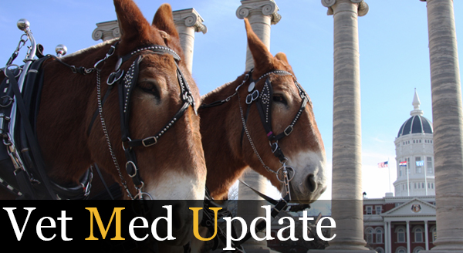
  St. Louis Couple Gives $2.5 Million to Fund CVM Scholarships
  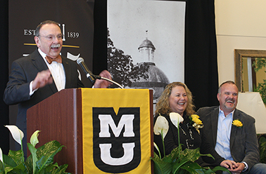
  Chancellor R. Bowen Loftin announces a $2.5 million estate gift given to the MU CVM by Barbara Stampfli-Savill and Gary Savill of St. Louis.
  Gary Savill and Barbara Stampfli-Savill, residents of St. Louis, have made an estate commitment of $2.5 million to the University of Missouri College of Veterinary Medicine. The gift will create an endowment to support scholarships for veterinary students and will encourage volunteer work among its recipients.
  “We are thrilled to be able to give this gift to the College of Veterinary Medicine with the intent that it will support the development of future veterinarians for years to come,” Gary Savill said. “Barbara and I are animal lovers, and we hope this gift will help care for animals around the nation and the world by educating future classes of veterinarians. We also wish to enable students who otherwise would not be able to afford the education and training required to enter this noble profession. Another important aspect of this scholarship is volunteer work; we hope that students who receive this scholarship will be inspired to continue such charitable work throughout their careers.”
  Read More
  Featured News
  Challenging Cornea Repair Means Owl Can Return to the Wild
  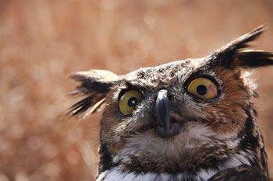
  MU Veterinarians Put Springfield Dog on the Road to Recovery After Overpass Fall
  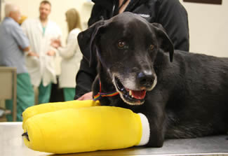
  Upcoming Events
  Gentle Doctor Benefit
  April 5, 2014 5 p.m.
  Holiday Inn Executive Center
  Find out more here
  Dental CE Seminar
  April 26-27, 2014
  Adams Conference Center and the Auditorium
  Learn more and register here
  Research Focus
  Faster Anthrax Detection Could Speed Bioterror Response and Save Millions in Decontamination Costs
  CVM’s Middleton Named National Mastitis Council President
  Surgical Resident Jessica Knapp Receives Research Award
  Giving
  Learn More About Ways to Support the CVM
  Through the Lens
  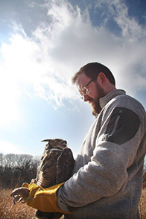
  Check out more photos on Facebook!


