Appendix A. Table of Fractional Factorial Designs

Runs | Factors
 | $γ_{1\overline{i}}$ | $$α_{1}$$ | $$β_{1}$$ | $$δ_{11}$$ | $$δ_{12}$$ | $$θ_{1\overline{i}}$$ | $$μ_{1}$$ | $$η_{1}$$ | $$λ_{11}$$ | $$λ_{12}$$
1 | 20 | 0 | 0 | 10 | 4 | 0 | 0.65 | 3360 | 9 | 10
2 | 20 | 0 | 0 | 0 | 0 | 0 | 0.65 | 3360 | 9 | 1
3 | 20 | 0 | 0 | 10 | 0 | 0 | 0.36 | 1920 | 1 | 10
4 | 20 | 60 | 0 | 0 | 0 | 0.5 | 0.36 | 3360 | 1 | 10
5 | 20 | 0 | 4 | 10 | 4 | 0.5 | 0.65 | 1920 | 1 | 10
6 | 20 | 60 | 4 | 0 | 0 | 0 | 0.65 | 3360 | 9 | 10
7 | 20 | 60 | 4 | 0 | 4 | 0.5 | 0.36 | 1920 | 1 | 1
8 | 0 | 60 | 0 | 10 | 0 | 0 | 0.36 | 1920 | 9 | 1
9 | 0 | 0 | 4 | 10 | 0 | 0 | 0.65 | 3360 | 9 | 10
10 | 20 | 60 | 0 | 10 | 4 | 0.5 | 0.36 | 3360 | 1 | 1
11 | 0 | 60 | 0 | 10 | 0 | 0 | 0.65 | 3360 | 9 | 1
12 | 20 | 60 | 0 | 10 | 4 | 0 | 0.36 | 3360 | 1 | 10
13 | 0 | 0 | 4 | 0 | 0 | 0.5 | 0.65 | 3360 | 1 | 10
14 | 0 | 0 | 0 | 0 | 4 | 0.5 | 0.36 | 3360 | 1 | 1
15 | 0 | 0 | 0 | 0 | 4 | 0 | 0.36 | 3360 | 1 | 10
16 | 0 | 60 | 0 | 0 | 0 | 0 | 0.36 | 1920 | 1 | 10
17 | 20 | 60 | 4 | 10 | 4 | 0 | 0.65 | 3360 | 9 | 1
18 | 0 | 60 | 0 | 0 | 4 | 0.5 | 0.36 | 1920 | 9 | 1
19 | 20 | 0 | 0 | 10 | 4 | 0 | 0.65 | 3360 | 9 | 10
20 | 20 | 0 | 0 | 0 | 0 | 0 | 0.65 | 3360 | 9 | 1
21 | 20 | 0 | 0 | 10 | 0 | 0 | 0.36 | 1920 | 1 | 10
22 | 20 | 60 | 0 | 0 | 0 | 0.5 | 0.36 | 3360 | 1 | 10
23 | 20 | 0 | 4 | 10 | 4 | 0.5 | 0.65 | 1920 | 1 | 10
24 | 20 | 60 | 4 | 0 | 0 | 0 | 0.65 | 3360 | 9 | 10
25 | 20 | 60 | 4 | 0 | 4 | 0.5 | 0.36 | 1920 | 1 | 1
26 | 0 | 60 | 0 | 10 | 0 | 0 | 0.36 | 1920 | 9 | 1
27 | 0 | 0 | 4 | 10 | 0 | 0 | 0.65 | 3360 | 9 | 10
28 | 20 | 60 | 0 | 10 | 4 | 0.5 | 0.36 | 3360 | 1 | 1
29 | 0 | 60 | 0 | 10 | 0 | 0 | 0.65 | 3360 | 9 | 1
30 | 20 | 60 | 0 | 10 | 4 | 0 | 0.36 | 3360 | 1 | 10
31 | 0 | 0 | 4 | 0 | 0 | 0.5 | 0.65 | 3360 | 1 | 10
32 | 0 | 0 | 0 | 0 | 4 | 0.5 | 0.36 | 3360 | 1 | 1
33 | 0 | 0 | 0 | 0 | 4 | 0 | 0.36 | 3360 | 1 | 10
34 | 0 | 60 | 0 | 0 | 0 | 0 | 0.36 | 1920 | 1 | 10
35 | 20 | 60 | 4 | 10 | 4 | 0 | 0.65 | 3360 | 9 | 1
36 | 0 | 60 | 0 | 0 | 4 | 0.5 | 0.36 | 1920 | 9 | 1
37 | 20 | 0 | 0 | 10 | 4 | 0 | 0.65 | 3360 | 9 | 10
38 | 20 | 0 | 0 | 0 | 0 | 0 | 0.65 | 3360 | 9 | 1
39 | 20 | 0 | 0 | 10 | 0 | 0 | 0.36 | 1920 | 1 | 10
40 | 20 | 60 | 0 | 0 | 0 | 0.5 | 0.36 | 3360 | 1 | 10
41 | 20 | 0 | 4 | 10 | 4 | 0.5 | 0.65 | 1920 | 1 | 10
42 | 20 | 60 | 4 | 0 | 0 | 0 | 0.65 | 3360 | 9 | 10
43 | 20 | 60 | 4 | 0 | 4 | 0.5 | 0.36 | 1920 | 1 | 1
44 | 0 | 60 | 0 | 10 | 0 | 0 | 0.36 | 1920 | 9 | 1
45 | 0 | 0 | 4 | 10 | 0 | 0 | 0.65 | 3360 | 9 | 10
46 | 20 | 60 | 0 | 10 | 4 | 0.5 | 0.36 | 3360 | 1 | 1
47 | 0 | 60 | 0 | 10 | 0 | 0 | 0.65 | 3360 | 9 | 1
48 | 20 | 60 | 0 | 10 | 4 | 0 | 0.36 | 3360 | 1 | 10
49 | 0 | 0 | 4 | 0 | 0 | 0.5 | 0.65 | 3360 | 1 | 10
50 | 0 | 0 | 0 | 0 | 4 | 0.5 | 0.36 | 3360 | 1 | 1
51 | 0 | 0 | 0 | 0 | 4 | 0 | 0.36 | 3360 | 1 | 10
52 | 0 | 60 | 0 | 0 | 0 | 0 | 0.36 | 1920 | 1 | 10
53 | 20 | 60 | 4 | 10 | 4 | 0 | 0.65 | 3360 | 9 | 1
54 | 0 | 60 | 0 | 0 | 4 | 0.5 | 0.36 | 1920 | 9 | 1
55 | 20 | 0 | 0 | 10 | 4 | 0 | 0.65 | 3360 | 9 | 10
56 | 20 | 0 | 0 | 0 | 0 | 0 | 0.65 | 3360 | 9 | 1
57 | 20 | 0 | 0 | 10 | 0 | 0 | 0.36 | 1920 | 1 | 10
58 | 20 | 60 | 0 | 0 | 0 | 0.5 | 0.36 | 3360 | 1 | 10
59 | 20 | 60 | 0 | 10 | 4 | 0.5 | 0.65 | 1920 | 1 | 1
60 | 20 | 0 | 4 | 10 | 0 | 0.5 | 0.36 | 3360 | 9 | 10
61 | 0 | 60 | 0 | 0 | 4 | 0 | 0.36 | 1920 | 9 | 10
62 | 20 | 60 | 4 | 0 | 0 | 0.5 | 0.65 | 3360 | 9 | 1
63 | 20 | 0 | 0 | 10 | 4 | 0.5 | 0.36 | 1920 | 9 | 1
64 | 0 | 60 | 0 | 0 | 4 | 0 | 0.65 | 3360 | 9 | 10
65 | 0 | 0 | 0 | 10 | 4 | 0.5 | 0.65 | 1920 | 9 | 10
66 | 20 | 0 | 0 | 0 | 4 | 0 | 0.36 | 1920 | 1 | 1
67 | 0 | 0 | 4 | 10 | 0 | 0.5 | 0.36 | 1920 | 9 | 1
68 | 0 | 60 | 4 | 0 | 4 | 0.5 | 0.65 | 1920 | 1 | 10
69 | 0 | 60 | 4 | 0 | 0 | 0 | 0.65 | 1920 | 9 | 1
70 | 0 | 0 | 0 | 10 | 0 | 0.5 | 0.36 | 3360 | 1 | 10
71 | 0 | 0 | 0 | 10 | 0 | 0.5 | 0.65 | 1920 | 1 | 10
72 | 0 | 0 | 4 | 10 | 4 | 0 | 0.36 | 1920 | 1 | 10
73 | 0 | 0 | 0 | 10 | 0 | 0 | 0.65 | 1920 | 1 | 1
74 | 20 | 0 | 4 | 0 | 0 | 0 | 0.65 | 1920 | 1 | 10
75 | 20 | 60 | 0 | 10 | 0 | 0 | 0.65 | 1920 | 9 | 10
76 | 0 | 0 | 0 | 0 | 4 | 0 | 0.65 | 1920 | 1 | 10
77 | 0 | 60 | 4 | 0 | 4 | 0 | 0.65 | 1920 | 1 | 1
78 | 20 | 0 | 4 | 0 | 4 | 0 | 0.65 | 1920 | 9 | 10
79 | 0 | 60 | 4 | 10 | 4 | 0 | 0.65 | 1920 | 9 | 10
80 | 0 | 0 | 4 | 0 | 4 | 0.5 | 0.36 | 1920 | 9 | 10
81 | 0 | 0 | 4 | 0 | 4 | 0 | 0.65 | 3360 | 9 | 1
82 | 20 | 0 | 4 | 0 | 0 | 0.5 | 0.65 | 1920 | 1 | 1
83 | 20 | 0 | 0 | 10 | 0 | 0.5 | 0.36 | 1920 | 1 | 1
84 | 20 | 60 | 0 | 10 | 0 | 0.5 | 0.36 | 3360 | 9 | 1
85 | 0 | 60 | 0 | 10 | 4 | 0 | 0.36 | 1920 | 1 | 1
86 | 20 | 0 | 0 | 0 | 0 | 0 | 0.36 | 1920 | 9 | 1
87 | 20 | 60 | 4 | 10 | 0 | 0 | 0.36 | 1920 | 1 | 1
88 | 20 | 0 | 4 | 0 | 0 | 0 | 0.36 | 3360 | 1 | 10
89 | 20 | 0 | 4 | 10 | 0 | 0 | 0.65 | 1920 | 9 | 1
90 | 0 | 60 | 0 | 0 | 0 | 0.5 | 0.36 | 1920 | 1 | 1
91 | 0 | 60 | 0 | 10 | 4 | 0.5 | 0.36 | 1920 | 1 | 10
92 | 20 | 60 | 4 | 0 | 0 | 0.5 | 0.36 | 1920 | 9 | 1
93 | 0 | 0 | 0 | 0 | 0 | 0 | 0.65 | 1920 | 9 | 10
94 | 0 | 60 | 4 | 10 | 0 | 0.5 | 0.36 | 3360 | 1 | 1
95 | 0 | 0 | 4 | 10 | 4 | 0.5 | 0.36 | 1920 | 1 | 1
96 | 20 | 60 | 4 | 0 | 0 | 0 | 0.36 | 1920 | 9 | 10
97 | 20 | 0 | 0 | 0 | 4 | 0.5 | 0.36 | 1920 | 1 | 10
98 | 0 | 0 | 0 | 10 | 4 | 0.5 | 0.36 | 3360 | 9 | 10
99 | 20 | 0 | 0 | 10 | 4 | 0.5 | 0.65 | 3360 | 9 | 1
100 | 20 | 0 | 0 | 0 | 4 | 0.5 | 0.65 | 3360 | 1 | 10
101 | 20 | 60 | 0 | 0 | 4 | 0 | 0.65 | 1920 | 9 | 1
102 | 0 | 60 | 0 | 10 | 0 | 0.5 | 0.65 | 3360 | 9 | 10
103 | 0 | 60 | 4 | 10 | 0 | 0.5 | 0.65 | 1920 | 1 | 1
104 | 0 | 0 | 4 | 0 | 0 | 0 | 0.36 | 1920 | 1 | 1
105 | 0 | 60 | 4 | 0 | 4 | 0.5 | 0.36 | 3360 | 1 | 10
106 | 20 | 60 | 4 | 0 | 4 | 0 | 0.65 | 3360 | 1 | 10
107 | 20 | 0 | 4 | 0 | 4 | 0 | 0.36 | 3360 | 9 | 10
108 | 0 | 0 | 4 | 10 | 4 | 0.5 | 0.65 | 3360 | 1 | 1
109 | 0 | 0 | 0 | 0 | 4 | 0.5 | 0.65 | 1920 | 1 | 1
110 | 0 | 0 | 4 | 10 | 4 | 0 | 0.65 | 3360 | 1 | 10
111 | 0 | 0 | 0 | 0 | 0 | 0.5 | 0.65 | 1920 | 9 | 1
112 | 20 | 0 | 0 | 10 | 4 | 0 | 0.36 | 1920 | 9 | 10
113 | 20 | 0 | 0 | 10 | 0 | 0 | 0.65 | 3360 | 1 | 10
114 | 0 | 0 | 4 | 0 | 4 | 0.5 | 0.65 | 3360 | 9 | 10
115 | 20 | 0 | 4 | 10 | 0 | 0.5 | 0.65 | 1920 | 9 | 10
116 | 20 | 60 | 4 | 10 | 4 | 0 | 0.36 | 1920 | 9 | 1
117 | 20 | 0 | 0 | 0 | 0 | 0.5 | 0.36 | 1920 | 9 | 10
118 | 0 | 0 | 4 | 0 | 4 | 0 | 0.36 | 1920 | 9 | 1
119 | 20 | 0 | 4 | 10 | 4 | 0 | 0.36 | 3360 | 1 | 1
120 | 20 | 60 | 4 | 10 | 4 | 0.5 | 0.65 | 3360 | 9 | 10
121 | 0 | 60 | 0 | 0 | 0 | 0.5 | 0.65 | 3360 | 1 | 1
122 | 20 | 60 | 4 | 10 | 0 | 0 | 0.65 | 3360 | 1 | 1
123 | 0 | 60 | 4 | 10 | 0 | 0 | 0.36 | 3360 | 1 | 10
124 | 0 | 60 | 4 | 0 | 4 | 0 | 0.36 | 3360 | 1 | 1
125 | 0 | 60 | 4 | 0 | 0 | 0 | 0.36 | 3360 | 9 | 1
126 | 0 | 60 | 4 | 10 | 4 | 0 | 0.36 | 3360 | 9 | 10
127 | 20 | 0 | 0 | 10 | 0 | 0.5 | 0.65 | 3360 | 1 | 1
128 | 20 | 0 | 4 | 0 | 4 | 0.5 | 0.65 | 1920 | 9 | 1

Appendix B. Table of Responses for Fractional Factorial Designs
Runs | Responses
 | $$s_{1}$$ | $$r_{11}$$ | $${ r}_{12}$$ | $$w_{1}$$ | $$z_{1}$$ | $$p_{1}$$ | $$f_{12}+f_{13}$$ | $$f_{21}+f_{31}$$
1 | 56 | 0.00 | 0.0 | 0.00 | 0.00 | 0.64 | 0.00 | 4.20
2 | 56 | 0.00 | 0.0 | 0.00 | 0.00 | 0.64 | 0.00 | 4.20
3 | 56 | 0.01 | 0.1 | 0.01 | 0.01 | 0.76 | 0.00 | 4.20
4 | 20 | 0.56 | 3.0 | 0.56 | 0.56 | 0.88 | 4.66 | 0.00
5 | 56 | 0.00 | 0.0 | 0.00 | 0.14 | 0.60 | 0.00 | 4.20
6 | 24 | 2.13 | 1.1 | 0.24 | 0.24 | 0.88 | 5.27 | 0.00
7 | 20 | 0.10 | 0.5 | 0.10 | 0.42 | 0.76 | 0.00 | 3.40
8 | 32 | 2.48 | 0.3 | 0.28 | 0.28 | 0.88 | 0.00 | 0.00
9 | 56 | 0.00 | 0.0 | 0.00 | 0.00 | 0.64 | 0.00 | 4.20
10 | 20 | 0.10 | 0.5 | 0.10 | 0.42 | 0.76 | 0.00 | 3.40
11 | 20 | 0.51 | 0.0 | 0.06 | 0.06 | 0.76 | 0.12 | 0.00
12 | 20 | 0.56 | 3.0 | 0.56 | 0.56 | 0.88 | 4.66 | 0.00
13 | 56 | 0.00 | 0.0 | 0.00 | 0.14 | 0.60 | 0.00 | 4.20
14 | 56 | 0.00 | 0.0 | 0.00 | 0.34 | 0.60 | 0.00 | 4.20
15 | 56 | 0.01 | 0.1 | 0.01 | 0.01 | 0.76 | 0.00 | 4.20
16 | 20 | 0.56 | 3.0 | 0.56 | 0.56 | 0.88 | 4.66 | 0.00
17 | 20 | 0.51 | 0.0 | 0.06 | 0.06 | 0.76 | 0.12 | 0.00
18 | 32 | 2.48 | 0.2 | 0.28 | 0.28 | 0.88 | 0.12 | 0.00
19 | 20 | 0.89 | 0.1 | 0.10 | 0.12 | 0.80 | 0.00 | 0.40
20 | 20 | 0.56 | 3.0 | 0.56 | 0.56 | 0.88 | 4.66 | 0.00
21 | 20 | 0.00 | 0.0 | 0.00 | 0.34 | 0.60 | 0.00 | 4.20
22 | 56 | 0.01 | 0.1 | 0.01 | 0.14 | 0.76 | 0.00 | 4.20
23 | 20 | 2.77 | 0.8 | 0.31 | 0.31 | 0.88 | 7.56 | 0.00
24 | 56 | 0.00 | 0.0 | 0.00 | 0.15 | 0.60 | 0.00 | 4.20
25 | 56 | 2.43 | 2.6 | 0.27 | 0.27 | 0.92 | 0.45 | 0.00
26 | 20 | 0.56 | 2.9 | 0.56 | 0.56 | 0.88 | 0.00 | 4.20
27 | 32 | 2.48 | 0.3 | 0.28 | 0.28 | 0.88 | 8.86 | 0.00
28 | 44 | 0.37 | 0.6 | 0.04 | 0.13 | 0.84 | 0.00 | 4.20
29 | 56 | 0.01 | 0.1 | 0.01 | 0.14 | 0.76 | 0.00 | 4.20
30 | 20 | 0.00 | 0.0 | 0.00 | 0.00 | 0.60 | 0.00 | 4.20
31 | 56 | 2.43 | 1.4 | 0.27 | 0.42 | 0.92 | 0.00 | 4.20
32 | 32 | 2.48 | 0.3 | 0.28 | 0.28 | 0.88 | 8.86 | 0.00
33 | 56 | 0.97 | 0.9 | 0.11 | 0.11 | 0.88 | 1.26 | 0.00
34 | 32 | 2.48 | 0.3 | 0.28 | 0.28 | 0.88 | 8.86 | 0.00
35 | 20 | 0.00 | 0.0 | 0.00 | 0.00 | 0.60 | 0.00 | 4.20
36 | 20 | 0.31 | 3.2 | 0.31 | 0.31 | 0.88 | 0.00 | 0.42
37 | 32 | 2.48 | 0.3 | 0.28 | 0.28 | 0.88 | 0.00 | 0.00
38 | 20 | 0.56 | 3.0 | 0.56 | 0.56 | 0.88 | 4.66 | 0.00
39 | 56 | 0.00 | 0.0 | 0.00 | 0.34 | 0.60 | 0.00 | 4.20
40 | 32 | 2.48 | 0.2 | 0.28 | 0.28 | 0.88 | 0.12 | 0.00
41 | 56 | 0.02 | 0.0 | 0.00 | 0.00 | 0.72 | 0.00 | 4.20
42 | 32 | 2.48 | 0.3 | 0.28 | 0.28 | 0.88 | 8.86 | 0.00
43 | 20 | 1.54 | 0.3 | 0.17 | 0.21 | 0.84 | 0.00 | 0.84
44 | 20 | 0.31 | 3.2 | 0.31 | 0.33 | 0.88 | 0.00 | 0.42
45 | 20 | 0.31 | 3.2 | 0.31 | 0.33 | 0.88 | 0.00 | 0.42
46 | 56 | 0.00 | 0.0 | 0.00 | 0.00 | 0.60 | 0.00 | 4.20
47 | 24 | 2.13 | 1.1 | 0.24 | 0.24 | 0.88 | 5.27 | 0.00
48 | 20 | 0.51 | 0.0 | 0.06 | 0.06 | 0.76 | 0.12 | 0.00
49 | 56 | 0.00 | 0.0 | 0.00 | 0.00 | 0.60 | 0.00 | 4.20
50 | 56 | 0.02 | 0.0 | 0.00 | 0.15 | 0.72 | 0.00 | 4.20
51 | 20 | 0.17 | 1.7 | 0.17 | 0.17 | 0.84 | 0.08 | 0.00
52 | 20 | 0.17 | 1.7 | 0.17 | 0.17 | 0.84 | 0.12 | 0.00
53 | 32 | 2.48 | 0.3 | 0.28 | 0.28 | 0.88 | 8.86 | 0.00
54 | 56 | 0.02 | 0.0 | 0.00 | 0.00 | 0.72 | 0.00 | 4.20
55 | 56 | 0.00 | 0.0 | 0.00 | 0.00 | 0.60 | 0.00 | 4.20
56 | 56 | 0.00 | 0.0 | 0.00 | 0.00 | 0.60 | 0.00 | 4.20
57 | 56 | 0.00 | 0.0 | 0.00 | 0.00 | 0.60 | 0.00 | 4.20
58 | 20 | 0.17 | 1.7 | 0.17 | 0.17 | 0.84 | 0.08 | 0.00
59 | 20 | 0.00 | 0.0 | 0.00 | 0.34 | 0.60 | 0.00 | 4.20
60 | 56 | 2.43 | 2.6 | 0.27 | 0.27 | 0.92 | 0.45 | 0.00
61 | 32 | 2.48 | 0.3 | 0.28 | 0.28 | 0.88 | 8.86 | 0.00
62 | 20 | 1.54 | 0.3 | 0.17 | 0.21 | 0.84 | 0.00 | 0.84
63 | 56 | 0.02 | 0.0 | 0.00 | 0.15 | 0.72 | 0.00 | 4.20
64 | 20 | 2.77 | 0.8 | 0.31 | 0.31 | 0.88 | 7.56 | 0.00
65 | 56 | 0.00 | 0.0 | 0.00 | 0.09 | 0.64 | 0.00 | 4.20
66 | 56 | 0.00 | 0.0 | 0.00 | 0.00 | 0.60 | 0.00 | 4.20
67 | 56 | 0.02 | 0.0 | 0.00 | 0.15 | 0.72 | 0.00 | 4.20
68 | 20 | 0.17 | 1.7 | 0.17 | 0.17 | 0.84 | 0.12 | 0.00
69 | 20 | 1.54 | 0.3 | 0.17 | 0.17 | 0.84 | 0.00 | 0.84
70 | 56 | 0.01 | 0.1 | 0.01 | 0.14 | 0.76 | 0.00 | 4.20
71 | 56 | 0.00 | 0.0 | 0.00 | 0.14 | 0.60 | 0.00 | 4.20
72 | 56 | 0.01 | 0.1 | 0.01 | 0.01 | 0.76 | 0.00 | 4.20
73 | 56 | 0.00 | 0.0 | 0.00 | 0.00 | 0.60 | 0.00 | 4.20
74 | 56 | 0.00 | 0.0 | 0.00 | 0.00 | 0.60 | 0.00 | 4.20
75 | 24 | 2.13 | 1.1 | 0.24 | 0.24 | 0.88 | 5.27 | 0.00
76 | 56 | 0.00 | 0.0 | 0.00 | 0.00 | 0.60 | 0.00 | 4.20
77 | 20 | 0.00 | 0.0 | 0.00 | 0.00 | 0.60 | 0.00 | 4.20
78 | 56 | 0.00 | 0.0 | 0.00 | 0.00 | 0.64 | 0.00 | 4.20
79 | 20 | 0.89 | 0.1 | 0.10 | 0.10 | 0.80 | 8.60 | 0.00
80 | 56 | 0.97 | 0.9 | 0.11 | 0.11 | 0.88 | 1.26 | 0.00
81 | 56 | 0.00 | 0.0 | 0.00 | 0.00 | 0.60 | 0.00 | 4.20
82 | 56 | 0.00 | 0.0 | 0.00 | 0.34 | 0.60 | 0.00 | 4.20
83 | 56 | 0.00 | 0.0 | 0.00 | 0.34 | 0.60 | 0.00 | 4.20
84 | 32 | 2.48 | 0.3 | 0.28 | 0.28 | 0.88 | 0.00 | 0.00
85 | 20 | 0.10 | 0.5 | 0.10 | 0.10 | 0.76 | 0.00 | 3.40
86 | 56 | 0.02 | 0.0 | 0.00 | 0.00 | 0.72 | 0.00 | 4.20
87 | 20 | 0.10 | 0.5 | 0.10 | 0.10 | 0.76 | 0.00 | 3.40
88 | 56 | 0.01 | 0.1 | 0.01 | 0.01 | 0.76 | 0.00 | 4.20
89 | 56 | 0.00 | 0.0 | 0.00 | 0.00 | 0.60 | 0.00 | 4.20
90 | 20 | 0.56 | 2.9 | 0.56 | 0.89 | 0.88 | 0.00 | 4.20
91 | 20 | 0.18 | 0.8 | 0.18 | 0.18 | 0.80 | 5.40 | 0.00
92 | 32 | 2.48 | 0.3 | 0.28 | 0.28 | 0.88 | 0.00 | 0.00
93 | 56 | 1.34 | 2.1 | 0.15 | 0.15 | 0.92 | 0.00 | 4.20
94 | 20 | 0.10 | 0.5 | 0.10 | 0.42 | 0.76 | 0.00 | 3.40
95 | 56 | 0.00 | 0.0 | 0.00 | 0.34 | 0.60 | 0.00 | 4.20
96 | 32 | 2.48 | 0.3 | 0.28 | 0.28 | 0.88 | 8.86 | 0.00
97 | 56 | 0.01 | 0.1 | 0.01 | 0.14 | 0.76 | 0.00 | 4.20
98 | 56 | 0.97 | 0.9 | 0.11 | 0.11 | 0.88 | 1.26 | 0.00
99 | 56 | 0.00 | 0.0 | 0.00 | 0.15 | 0.60 | 0.00 | 4.20
100 | 56 | 0.00 | 0.0 | 0.00 | 0.14 | 0.60 | 0.00 | 4.20
101 | 20 | 1.54 | 0.3 | 0.17 | 0.17 | 0.84 | 0.00 | 0.84
102 | 20 | 0.89 | 0.1 | 0.10 | 0.10 | 0.80 | 8.60 | 0.00
103 | 20 | 0.00 | 0.0 | 0.00 | 0.34 | 0.60 | 0.00 | 4.20
104 | 56 | 0.00 | 0.0 | 0.00 | 0.00 | 0.60 | 0.00 | 4.20
105 | 20 | 0.18 | 0.8 | 0.18 | 0.18 | 0.80 | 5.40 | 0.00
106 | 20 | 0.17 | 1.7 | 0.17 | 0.17 | 0.84 | 0.08 | 0.00
107 | 56 | 2.43 | 2.6 | 0.27 | 0.27 | 0.92 | 0.45 | 0.00
108 | 56 | 0.00 | 0.0 | 0.00 | 0.34 | 0.60 | 0.00 | 4.20
109 | 56 | 0.00 | 0.0 | 0.00 | 0.34 | 0.60 | 0.00 | 4.20
110 | 56 | 0.00 | 0.0 | 0.00 | 0.00 | 0.60 | 0.00 | 4.20
111 | 56 | 0.00 | 0.0 | 0.00 | 0.15 | 0.60 | 0.00 | 4.20
112 | 56 | 0.97 | 0.9 | 0.11 | 0.11 | 0.88 | 1.26 | 0.00
113 | 56 | 0.00 | 0.0 | 0.00 | 0.00 | 0.60 | 0.00 | 4.20
114 | 56 | 0.00 | 0.0 | 0.00 | 0.09 | 0.64 | 0.00 | 4.20
115 | 32 | 2.48 | 0.3 | 0.28 | 0.28 | 0.88 | 0.00 | 0.00
116 | 56 | 2.43 | 2.6 | 0.27 | 0.27 | 0.92 | 0.45 | 0.00
117 | 56 | 0.02 | 0.0 | 0.00 | 0.00 | 0.72 | 0.00 | 4.20
118 | 56 | 0.00 | 0.0 | 0.00 | 0.00 | 0.60 | 0.00 | 4.20
119 | 24 | 2.13 | 1.1 | 0.24 | 0.24 | 0.88 | 5.27 | 0.00
120 | 20 | 0.00 | 0.0 | 0.00 | 0.34 | 0.60 | 0.00 | 4.20
121 | 20 | 0.00 | 0.0 | 0.00 | 0.00 | 0.60 | 0.00 | 4.20
122 | 20 | 0.18 | 0.8 | 0.18 | 0.18 | 0.80 | 5.24 | 0.00
123 | 20 | 0.10 | 0.5 | 0.10 | 0.10 | 0.76 | 0.00 | 3.40
124 | 32 | 2.48 | 0.3 | 0.28 | 0.28 | 0.88 | 0.00 | 0.00
125 | 32 | 2.48 | 0.3 | 0.28 | 0.28 | 0.88 | 8.86 | 0.00
126 | 56 | 0.00 | 0.0 | 0.00 | 0.34 | 0.60 | 0.00 | 4.20
127 | 56 | 0.00 | 0.0 | 0.00 | 0.15 | 0.60 | 0.00 | 4.20
128 | 32 | 2.48 | 0.3 | 0.28 | 0.28 | 0.88 | 0.00 | 0.00

Appendix C. Detailed Statistical Model Outputs for Responses
Table C.1. Significant main effects
Response | $R^{2}$ (adj) | $$α_{1}$$ | $$μ_{1}$$ | $$λ_{11}$$ | $$λ_{12}$$ | $$β_{1}$$ | $$δ_{11}$$ | $$δ_{12}$$ | $$θ_{1\overline{i}}$$
$$s_{1}$$ | 98.9% | --- | --- | +++
$$r_{11}$$ | 83.6% | +++ | --- | +++ | +++ |  | --- | -
$${ r}_{12}$$ | 54.1% | +++ | - | - | +++ |  | - | --
$$w_{1}$$ | 67.2% | +++ | --- | + | +++ |  | -- | -
$$z_{1}$$ | 71.1% | +++ | --- | -- |  | - | -- | -- | +++
$$p_{1}$$ | 76.4% | +++ | --- | +++ | +++ |  | -
$$f_{12}+f_{13}$$ | 88.9% | +++ | --- | +++ | +++
$$f_{21}+f_{31}$$ | 77.5% | --- | +++ | --- | ---

Table C.2. Significant two-way interactions
Response | $$α_{1}*μ_{1}$$ | $$α_{1}*λ_{11}$$ | $$α_{1}*λ_{12}$$ | $$μ_{1}*λ_{11}$$ | $$μ_{1}*λ_{12}$$ | $$λ_{11}*λ_{12}$$ | $$λ_{11}*δ_{11}$$ | $$β_{1}*δ_{11}$$ | $$θ_{1\overline{i}}*α_{1}$$ | $$θ_{1\overline{i}}*λ_{11}$$ | $$θ_{1\overline{i}}*λ_{12}$$ | $$γ_{1\overline{i}}*δ_{12}$$
$$s_{1}$$ | --- | +++ |  | ---
$$r_{11}$$ |  | +++ |  | --- |  | +++ | --
$${ r}_{12}$$ |  | --- | + |  |  |  |  | ++
$$w_{1}$$ | --- |  | ++ |  |  |  |  | +
$$z_{1}$$ | --- | - | + |  |  | + |  | + | -- | --- | --- | +
$$p_{1}$$ | ++ |  |  |  |  | -
$$f_{12}+f_{13}$$ | --- | +++ | +++ |  | --- | +++
$$f_{21}+f_{31}$$ | - | - | -- | ++ | + | +

Considering the main effects presented in Table C.1, parameter $α_{1}$ is significant at the $p=0.001$ level for every response, suggesting that all responses are significantly impacted by the cost per unit service capacity. Similarly, parameter $μ_{1}$ is significant at the $p=0.001$ level for every response except $r_{12}$, suggesting that the service rate also has a significant effect on the optimized system’s performance. The external arrival rate parameters were significant for most responses, while the per-patient queueing penalty costs were each significant for approximately one-half of the responses. The waiting time penalty cost $β_{1}$ and travel time for transfers $θ_{1\overline{i}}$ were only significant for the response expected waiting time in system response $z_{1}$. Parameters $γ_{i\overline{i}}$ and $η_{i}$ were not significant as main effects for any response.
Considering the interaction effects presented in Table C.2, the interaction of parameter $α_{1}$ (cost per unit service capacity) with each of $μ_{1}$ (service rate) and $λ_{11}$ (arrival rate of emergency patients) is significant at the $p=0.001$ level for four of the eight responses ($w_{1}, s_{1}, z_{1}, f_{12}+f_{13}$ in the case of the $α_{1}*μ_{1}$ interaction, $s_{1}, r_{11}, r_{12}, f_{12}+f_{13}$ in the case of the $α_{1}*λ_{11}$ interaction), reinforcing the importance of the cost per unit service capacity. The only other interactions that were significant at the $p=0.001$ level for multiple responses were $μ_{1}*λ_{11}$ (for $s_{1}$ and $r_{11}$) and $λ_{11}*λ_{12}$ (for $r_{11}$ and $f_{12}+f_{13}$), emphasizing the importance of the emergency patient arrival rate on the expected number of emergency patients in queue awaiting service.

Appendix D. Detailed Statistical Model Outputs for Responses

Response $s_{1}$

Model Summary
S | R-sq | R-sq(adj) | R-sq(pred)
1.80249 | 98.90% | 98.85% | 98.77%

Coded Coefficients
Term | Effect | Coef | SE Coef | T-Value | P-Value | VIF
Constant |  | 39.531 | 0.159 | 248.13 | < 0.001
$${ α}_{1}$$ | -32.563 | -16.281 | 0.159 | -102.19 | < 0.001 | 1.00
$$μ_{1}$$ | -2.937 | -1.469 | 0.159 | -9.22 | < 0.001 | 1.00
$$λ_{11}$$ | 3.062 | 1.531 | 0.159 | 9.61 | < 0.001 | 1.00
$α_{1}$* $μ_{1}$ | -2.562 | -1.281 | 0.159 | -8.04 | < 0.001 | 1.00
$α_{1}$*$λ_{11}$ | 3.438 | 1.719 | 0.159 | 10.79 | < 0.001 | 1.00
$μ_{1}$*$λ_{11}$ | -2.937 | -1.469 | 0.159 | -9.22 | < 0.001 | 1.00

Regression Equation in Uncoded Units
$$s_{1}= 50.31 - 0.4656 { α}_{1} + 11.37 μ_{1} + 1.232 λ_{11} - 0.2945 { α}_{1}*μ_{1}+ 0.01432 { α}_{1}*λ_{11} - 2.532 μ_{1}*λ_{11}$$

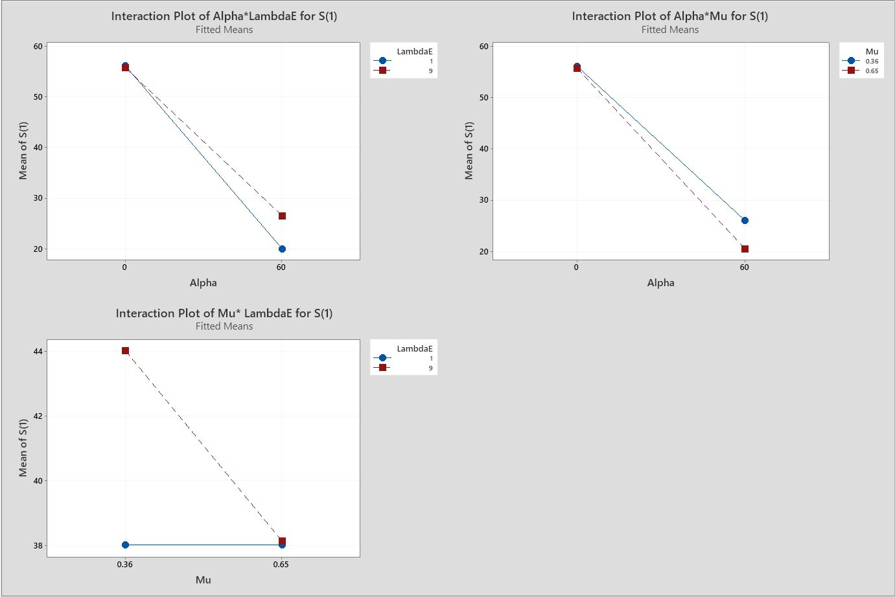
Figure D.1. Significant interaction plots for $s_{1}$

Response $r_{11}$

Model Summary
S | R-sq | R-sq(adj) | R-sq(pred)
0.394826 | 84.88% | 83.59% | 81.90%

Coded Coefficients
Term | Effect | Coef | SE Coef | T-Value | P-Value | VIF
Constant |  | 0.6941 | 0.0349 | 19.89 | < 0.001
$$α_{1}$$ | 0.8283 | 0.4141 | 0.0349 | 11.87 | < 0.001 | 1.00
$$δ_{11}$$ | -0.2495 | -0.1248 | 0.0349 | -3.58 | 0.001 | 1.00
$$δ_{12}$$ | -0.1423 | -0.0711 | 0.0349 | -2.04 | 0.044 | 1.00
$μ_{1}$ | -0.5150 | -0.2575 | 0.0349 | -7.38 | < 0.001 | 1.00
$λ_{11}$ | 1.1723 | 0.5862 | 0.0349 | 16.80 | < 0.001 | 1.00
$λ_{12 }$ | 0.3646 | 0.1823 | 0.0349 | 5.22 | < 0.001 | 1.00
$α_{1}$*$λ_{11}$ | 0.6158 | 0.3079 | 0.0349 | 8.82 | < 0.001 | 1.00
$δ_{11}$*$λ_{11}$ | -0.2052 | -0.1026 | 0.0349 | -2.94 | 0.004 | 1.00
$μ_{1}$*$λ_{11}$ | -0.4128 | -0.2064 | 0.0349 | -5.91 | < 0.001 | 1.00
$λ_{11}$*$λ_{12 }$ | 0.2589 | 0.1295 | 0.0349 | 3.71 | < 0.001 | 1.00

Regression Equation in Uncoded Units
$$r_{11}$$ | =-0.027 + 0.00098 ${ α}_{1}$ + 0.0007 $δ_{11}$ - 0.0356 $δ_{12}$ + 0.003 $μ_{1}$+ 0.2354 $λ_{11}$+ 0.0045 $λ_{12 }$ + 0.002566 ${ α}_{1}*λ_{11}$- 0.00513 $δ_{11}$*$λ_{11}$ - 0.3558 $μ_{1}*λ_{11}$+ 0.00719 $λ_{11}*λ_{12 }$

Figure D.2. Significant interaction plots for $r_{11}$
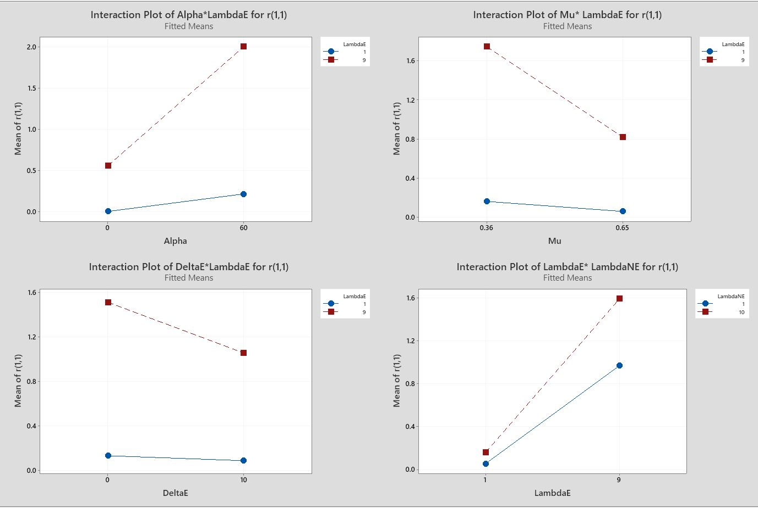

Response $r_{12}$

Model Summary
S | R-sq | R-sq(adj) | R-sq(pred)
0.628683 | 57.73% | 54.11% | 49.40%

Coded Coefficients
Term | Effect | Coef | SE Coef | T-Value | P-Value | VIF
Constant |  | 0.5900 | 0.0556 | 10.62 | < 0.001
$$α_{1}$$ | 0.5861 | 0.2930 | 0.0556 | 5.27 | < 0.001 | 1.00
$$β_{1}$$ | -0.1981 | -0.0991 | 0.0556 | -1.78 | 0.077 | 1.00
$$δ_{11}$$ | -0.2822 | -0.1411 | 0.0556 | -2.54 | 0.012 | 1.00
$$δ_{12}$$ | -0.2984 | -0.1492 | 0.0556 | -2.68 | 0.008 | 1.00
$$μ_{1}$$ | -0.2799 | -0.1400 | 0.0556 | -2.52 | 0.013 | 1.00
$$λ_{11}$$ | -0.2211 | -0.1105 | 0.0556 | -1.99 | 0.049 | 1.00
$$λ_{12 }$$ | 0.7473 | 0.3737 | 0.0556 | 6.72 | < 0.001 | 1.00
$α_{1}$*$λ_{11}$ | -0.7677 | -0.3839 | 0.0556 | -6.91 | < 0.001 | 1.00
$α_{1}$*$λ_{12}$ | 0.2462 | 0.1231 | 0.0556 | 2.22 | 0.029 | 1.00
$β_{1}$*$δ_{11}$ | 0.2935 | 0.1468 | 0.0556 | 2.64 | 0.009 | 1.00

Regression Equation in Uncoded Units
$r_{12}$= 0.673 + 0.02075 ${ α}_{1}$ - 0.1229 $β_{1}$- 0.0576 $δ_{11}$ - 0.0746 $δ_{12}$ - 0.965 $μ_{1}$+ 0.0683 $λ_{11}$ + 0.0557 $λ_{12 }$ - 0.003199 ${ α}_{1}*λ_{11}$+ 0.000912 ${ α}_{1}*λ_{12}$+ 0.01468 $β_{1}*δ_{11}$

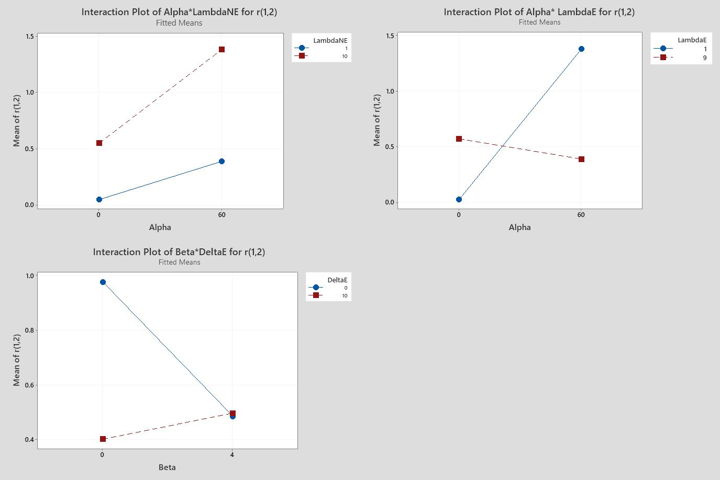
Figure D.3. Significant interaction plots for $r_{12}$

Response $w_{1}$

Model Summary
S | R-sq | R-sq(adj) | R-sq(pred)
0.0874691 | 69.79% | 67.20% | 63.84%

Coded Coefficients
Term | Effect | Coef | SE Coef | T-Value | P-Value | VIF
Constant |  | 0.12509 | 0.00773 | 16.18 | < 0.001
$α_{1}$ | 0.18647 | 0.09324 | 0.00773 | 12.06 | < 0.001 | 1.00
$$β_{1}$$ | -0.02999 | -0.01499 | 0.00773 | -1.94 | 0.055 | 1.00
$δ_{1,1}$ | -0.04745 | -0.02372 | 0.00773 | -3.07 | 0.003 | 1.00
$δ_{1,2}$ | -0.03931 | -0.01966 | 0.00773 | -2.54 | 0.012 | 1.00
$μ_{1}$ | -0.10268 | -0.05134 | 0.00773 | -6.64 | < 0.001 | 1.00
$λ_{1,1}$ | 0.03433 | 0.01716 | 0.00773 | 2.22 | 0.028 | 1.00
$λ_{1,2}$ | 0.08746 | 0.04373 | 0.00773 | 5.66 | < 0.001 | 1.00
$${ α}_{1}*μ_{1}$$ | -0.05096 | -0.02548 | 0.00773 | -3.30 | 0.001 | 1.00
$${ α}_{1}*λ_{1,2}$$ | 0.04162 | 0.02081 | 0.00773 | 2.69 | 0.008 | 1.00
$$β_{1}*δ_{1,1}$$ | 0.03801 | 0.01900 | 0.00773 | 2.46 | 0.015 | 1.00

Regression Equation in Uncoded Units
$w_{1}=$0.1498 + 0.005218${ α}_{1}-$ 0.01700 $β_{1}$ $-$ 0.00855 $δ_{11}- 0.00983 δ_{12} - 0.1784 μ_{1}+ 0.00429 λ_{11}$ $+ 0.00509 λ_{12} - 0.00586 { α}_{1}*μ_{1}+ 0.000154 { α}_{1}*λ_{12}+ 0.001900 β_{1}*δ_{11}$

Figure D.4. Significant interaction plots for $w_{1}$

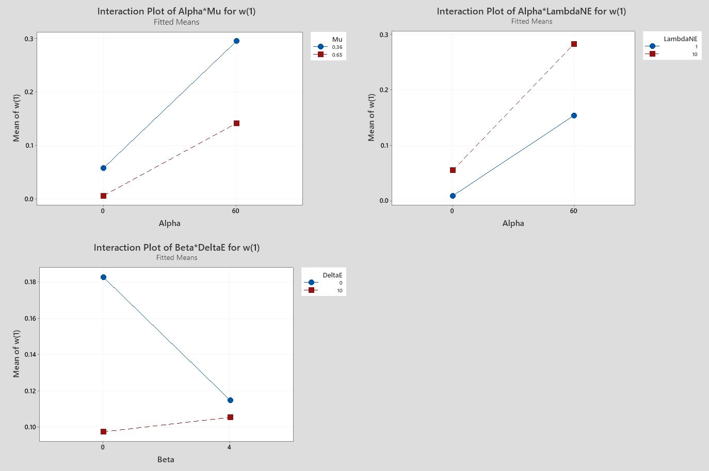
Response $z_{1}$

Model Summary
S | R-sq | R-sq(adj) | R-sq(pred)
0.0866930 | 75.15% | 71.05% | 65.74%

Coded Coefficients
Term | Effect | Coef | SE Coef | T-Value | P-Value | VIF
Constant |  | 0.18861 | 0.00766 | 24.61 | < 0.001
$$γ_{1\overline{i}}$$ | 0.02225 | 0.01113 | 0.00766 | 1.45 | 0.149 | 1.00
$$α_{1}$$ | 0.14602 | 0.07301 | 0.00766 | 9.53 | < 0.001 | 1.00
$β_{1}$ | -0.03066 | -0.01533 | 0.00766 | -2.00 | 0.048 | 1.00
$$δ_{11}$$ | -0.04873 | -0.02437 | 0.00766 | -3.18 | 0.002 | 1.00
$$δ_{12}$$ | -0.04056 | -0.02028 | 0.00766 | -2.65 | 0.009 | 1.00
$$θ_{1\overline{i}}$$ | 0.12642 | 0.06321 | 0.00766 | 8.25 | < 0.001 | 1.00
$$μ_{1}$$ | -0.09382 | -0.04691 | 0.00766 | -6.12 | < 0.001 | 1.00
$$λ_{11}$$ | -0.04142 | -0.02071 | 0.00766 | -2.70 | 0.008 | 1.00
$$λ_{12 }$$ | 0.00740 | 0.00370 | 0.00766 | 0.48 | 0.630 | 1.00
$γ_{1\overline{i}}$*$δ_{12}$ | 0.03588 | 0.01794 | 0.00766 | 2.34 | 0.021 | 1.00
$α_{1}$*$θ_{1\overline{i}}$ | -0.04605 | -0.02303 | 0.00766 | -3.01 | 0.003 | 1.00
$α_{1}$*$μ_{1}$ | -0.05341 | -0.02670 | 0.00766 | -3.48 | 0.001 | 1.00
$α_{1}$*$λ_{11}$ | -0.03084 | -0.01542 | 0.00766 | -2.01 | 0.047 | 1.00
$α_{1}$*$λ_{12}$ | 0.03736 | 0.01868 | 0.00766 | 2.44 | 0.016 | 1.00
$β_{1}$*$δ_{11}$ | 0.03866 | 0.01933 | 0.00766 | 2.52 | 0.013 | 1.00
$θ_{1\overline{i}}$*$λ_{11}$ | -0.06884 | -0.03442 | 0.00766 | -4.49 | < 0.001 | 1.00
$θ_{1\overline{i}}$*$λ_{12}$ | -0.09034 | -0.04517 | 0.00766 | -5.89 | < 0.001 | 1.00
$λ_{11}$*$λ_{12 }$ | 0.03320 | 0.01660 | 0.00766 | 2.17 | 0.032 | 1.00

Regression Equation in Uncoded Units
$$z_{1}$$ | = | 0.1379 - 0.00068$γ_{1\overline{i}}$ + 0.00618 ${ α}_{1}$ - 0.01733 $β_{1}$- 0.00874 $δ_{11}- 0.01911 δ_{12}$ $+ 0.7379 θ_{1\overline{i}} - 0.1394 μ_{1} + 0.00221 λ_{11}$+ 0.00210 $λ_{12 }$ + 0.000897 $γ_{1\overline{i}}*δ_{12}$ - 0.00307 ${ α}_{1}$*$θ_{1\overline{i}}$- 0.00614 ${ α}_{1}$*$μ_{1}- 0.000128 { α}_{1}*λ_{11} + 0.000138 { α}_{1}*λ_{12} + 0.001933 β_{1}*δ_{11}- 0.03442 θ_{1\overline{i}}*λ_{11} - 0.04015 θ_{1\overline{i}}*λ_{12}+ 0.000922 λ_{11}*λ_{12 }$

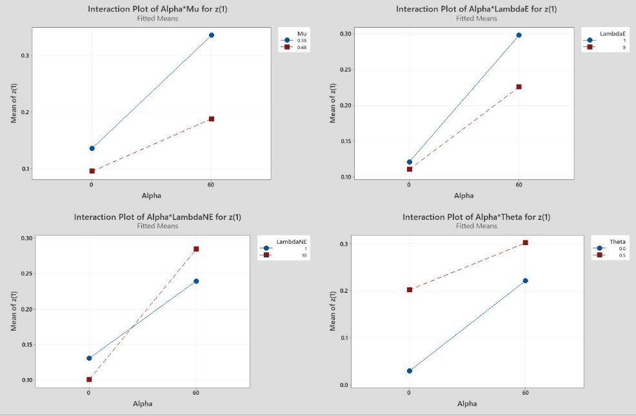
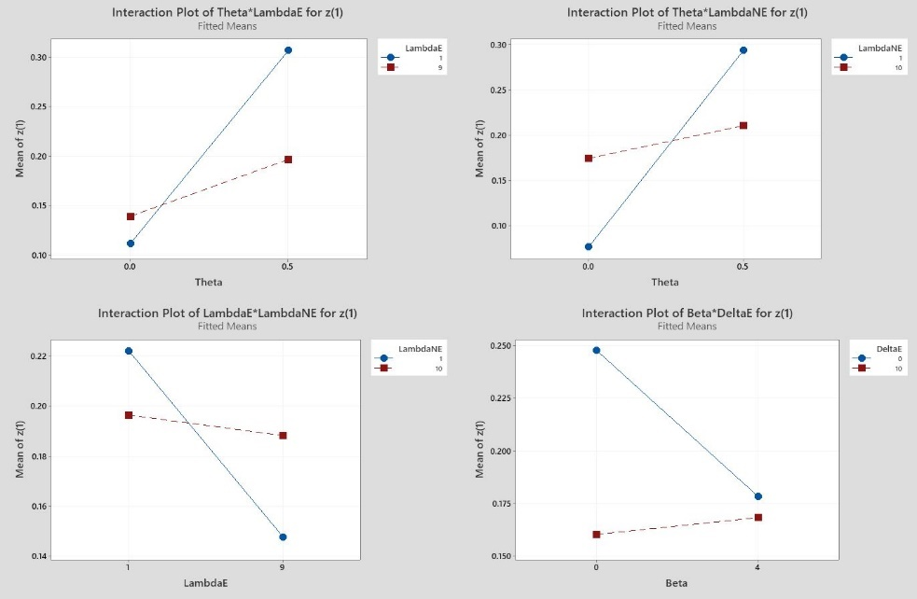
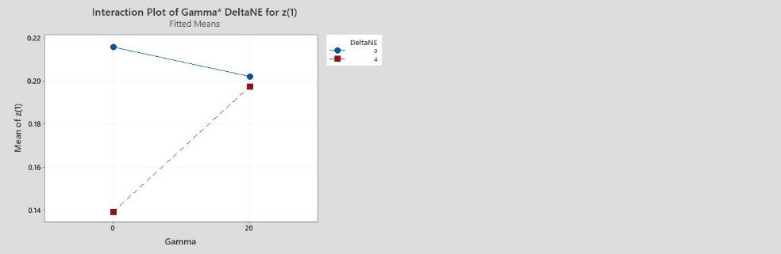

Figure D.5. Significant interaction plots for $z_{1}$

Response $p_{1}$

Model Summary
S | R-sq | R-sq(adj) | R-sq(pred)
0.0585413 | 77.74% | 76.44% | 74.67%

Coded Coefficients
Term | Effect | Coef | SE Coef | T-Value | P-Value | VIF
Constant |  | 0.75187 | 0.00517 | 145.31 | < 0.001
$$α_{1}$$ | 0.12625 | 0.06313 | 0.00517 | 12.20 | < 0.001 | 1.00
$$δ_{11}$$ | -0.02500 | -0.01250 | 0.00517 | -2.42 | 0.017 | 1.00
$$μ_{1}$$ | -0.09750 | -0.04875 | 0.00517 | -9.42 | < 0.001 | 1.00
$$λ_{11}$$ | 0.09000 | 0.04500 | 0.00517 | 8.70 | < 0.001 | 1.00
$$λ_{12 }$$ | 0.09750 | 0.04875 | 0.00517 | 9.42 | < 0.001 | 1.00
$α_{1}$*$μ_{1}$ | 0.02750 | 0.01375 | 0.00517 | 2.66 | 0.009 | 1.00
$λ_{11}$*$λ_{12 }$ | -0.02125 | -0.01062 | 0.00517 | -2.05 | 0.042 | 1.00

Regression Equation in Uncoded Units
 | $$p_{1}$$ | = | 0.7869 + 0.000508 ${ α}_{1}$ - 0.00250 $δ_{11}$ - 0.4310 $μ_{1}+ 0.01450 λ_{11}+ 0.01378 λ_{12 }$ $+ 0.00316 { α}_{1}*μ_{1} - 0.000590 λ_{11}*λ_{12 }$  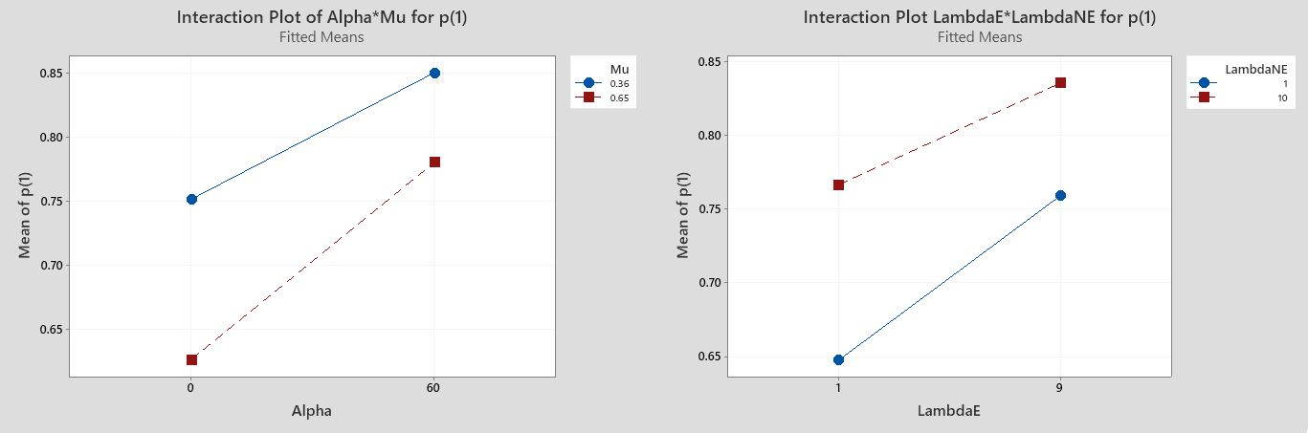

Figure D.6. Significant interaction plots for $p_{1}$

Response $f_{12}+f_{13}$

Model Summary
S | R-sq | R-sq(adj) | R-sq(pred)
0.922728 | 89.68% | 88.89% | 87.86%

Coded Coefficients
Term | Effect | Coef | SE Coef | T-Value | P-Value | VIF
Constant |  | 1.3406 | 0.0816 | 16.44 | < 0.001
$$α_{1}$$ | 2.4672 | 1.2336 | 0.0816 | 15.13 | < 0.001 | 1.00
$$μ_{1}$$ | -0.9860 | -0.4930 | 0.0816 | -6.04 | < 0.001 | 1.00
$$λ_{11}$$ | 1.4362 | 0.7181 | 0.0816 | 8.80 | < 0.001 | 1.00
$$λ_{12 }$$ | 2.6624 | 1.3312 | 0.0816 | 16.32 | < 0.001 | 1.00
${ α}_{1}$*$μ_{1}$ | -0.7719 | -0.3860 | 0.0816 | -4.73 | < 0.001 | 1.00
${ α}_{1}$*$λ_{11}$ | 1.2221 | 0.6111 | 0.0816 | 7.49 | < 0.001 | 1.00
${ α}_{1}$*$λ_{12 }$ | 2.4484 | 1.2242 | 0.0816 | 15.01 | < 0.001 | 1.00
$μ_{1}$*$λ_{12 }$ | -0.9897 | -0.4949 | 0.0816 | -6.07 | < 0.001 | 1.00
$λ_{11}$*$λ_{12 }$ | 1.4174 | 0.7087 | 0.0816 | 8.69 | < 0.001 | 1.00

Regression Equation in Uncoded Units
$f_{12}+f_{13}$ = -0.808 + 0.0106 ${ α}_{1}$ + 3.43 $μ_{1}$ - 0.1898$λ_{11}$ + 0.2099 $λ_{12 }- 0.0887 { α}_{1}*μ_{1} + 0.005092 { α}_{1}*λ_{11} + 0.009068 { α}_{1}*λ_{12 }- 0.758 μ_{1}*λ_{12 } + 0.03937 λ_{11}*λ_{12 }$

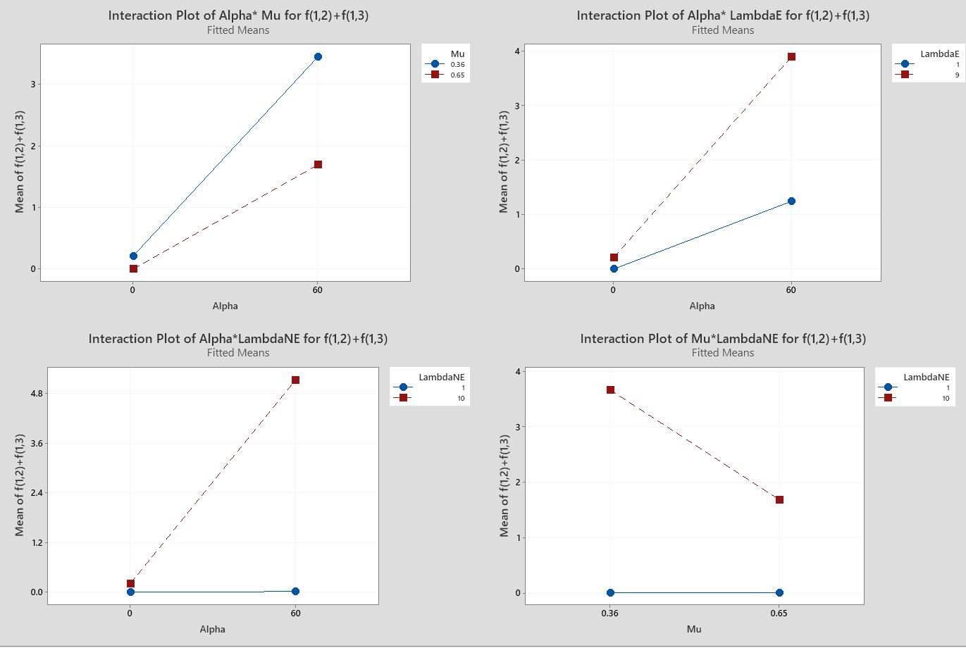
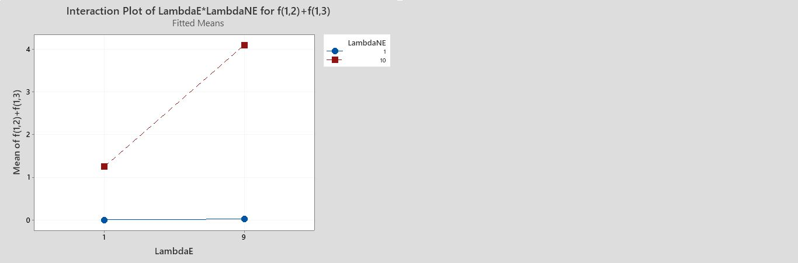
Figure D.7. Significant interaction plots for $f_{12}+f_{13}$

Response $f_{21}+f_{31}$

Model Summary
S | R-sq | R-sq(adj) | R-sq(pred)
0.960552 | 79.31% | 77.54% | 75.23%

Coded Coefficients
Term | Effect | Coef | SE Coef | T-Value | P-Value | VIF
Constant |  | 2.3642 | 0.0849 | 27.85 | < 0.001
$$α_{1}$$ | -2.6216 | -1.3108 | 0.0849 | -15.44 | < 0.001 | 1.00
$$μ_{1}$$ | 0.6784 | 0.3392 | 0.0849 | 4.00 | < 0.001 | 1.00
$$λ_{11}$$ | -1.4609 | -0.7305 | 0.0849 | -8.60 | < 0.001 | 1.00
$$λ_{12 }$$ | -1.5391 | -0.7695 | 0.0849 | -9.06 | < 0.001 | 1.00
$α_{1}$*$μ_{1}$ | -0.3716 | -0.1858 | 0.0849 | -2.19 | 0.031 | 1.00
$α_{1}$*$λ_{11}$ | -0.4109 | -0.2055 | 0.0849 | -2.42 | 0.017 | 1.00
$α_{1}$*$λ_{12}$ | -0.4891 | -0.2445 | 0.0849 | -2.88 | 0.005 | 1.00
$μ_{1}$*$λ_{11}$ | 0.4891 | 0.2445 | 0.0849 | 2.88 | 0.005 | 1.00
$μ_{1}$*$λ_{12 }$ | 0.4109 | 0.2055 | 0.0849 | 2.42 | 0.017 | 1.00
$λ_{11}$*$λ_{12 }$ | 0.3716 | 0.1858 | 0.0849 | 2.19 | 0.031 | 1.00

Regression Equation in Uncoded Units
$f_{21}+f_{31}$ = 5.367 - 0.0036 ${ α}_{1}$ - 0.22 $μ_{1}$ - 0.4009 $λ_{11}$ - 0.3273 $λ_{12 }$- 0.0427 ${ α}_{1}$*$μ_{1}$ - 0.001712 ${ α}_{1}$*$λ_{11}$
- 0.001811${ α}_{1}$*$λ_{12 }$+ 0.422 $μ_{1}$*$λ_{11}$ + 0.315 $μ_{1}$*$λ_{12 }$+ 0.01032 $λ_{11}$*$λ_{12 }$

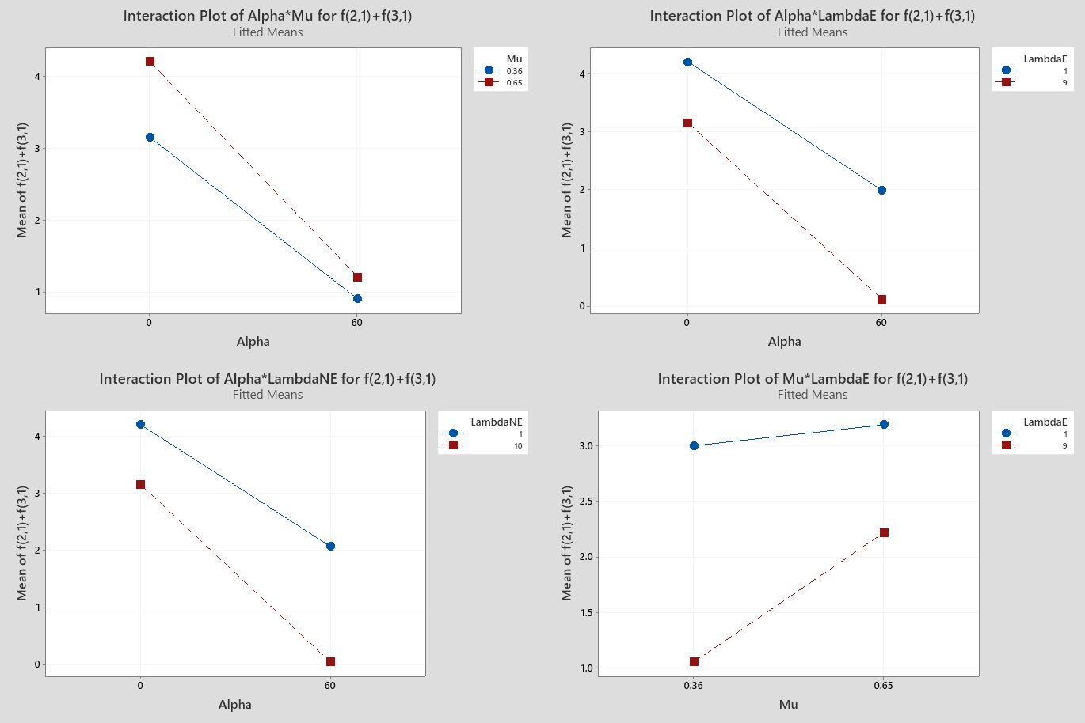
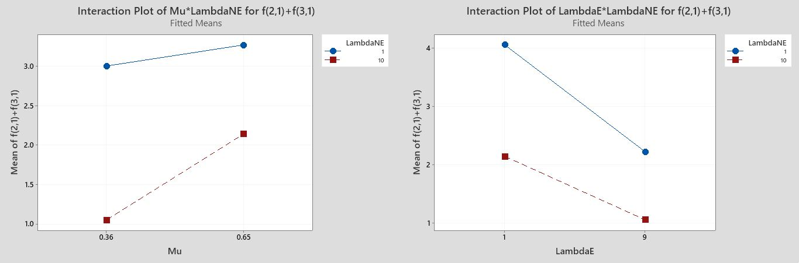
Figure D.8. Significant interaction plots for $f_{21}+f_{31}$

+ : Significance at p=0.05 level and positive effect ++: Significance at p=0.01 level and positive effect +++: Significance at p=0.001 level and positive effect - : Significance at p=0.05 level and negative effect --: Significance at p=0.01 level and negative effect ---: Significance at p=0.001 level and negative effect

